January 7, 2019

Aberdeen school report

Enrollment and Staffing
- 316 students enrolled
K | 1 | 2 | 3 | 4 | 5 | 6 | 7 | 8 | 9 | 10 | 11 | 12
26 | 23 | 27 | 21 | 19 | 21 | 32 | 28 | 28 | 31 | 18 | 25 | 17

upcoming events

School Goals
- Teacher professional book club starting up shortly
- At our next meeting, we will be exploring different ideas we might try to increase family engagement:
  - Family learning walks
  - Elementary family nights
  - Options for Term 2 conferences for high school
  - High school homeroom options

extra-curricular

- Basketball (Jr Boys, 9-12 co-ed)
- Curling
- Yearbook
- CIA
- Jr. Choir

financial report

Home and School – 2020
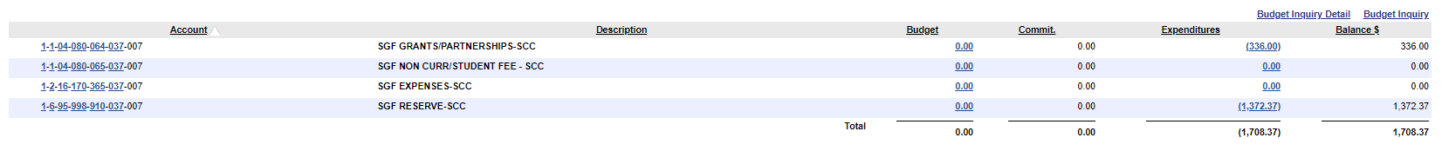

SCC – 2020
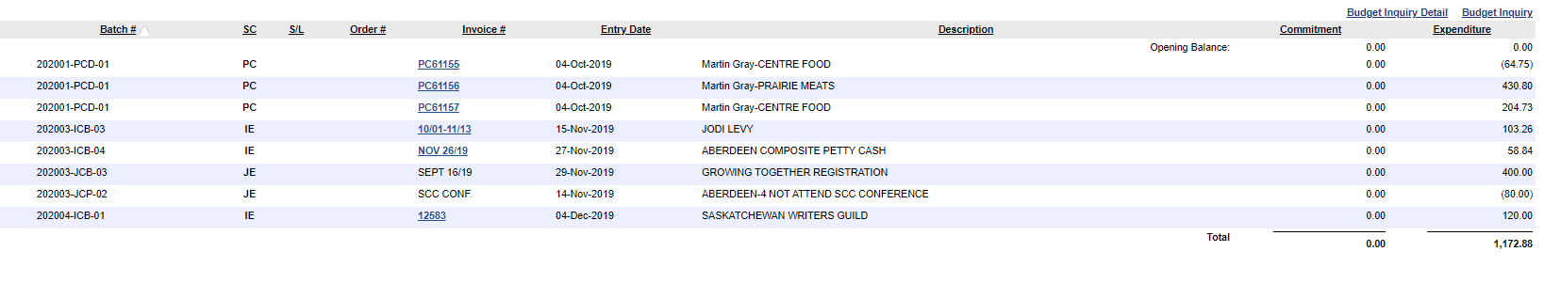

-319.94 for BBQ = 852.94

