ACS Course Selection and Planning Guide
2023-2024

Graduation Requirements (Grade 10 in 2024-2025)

Graduation Requirements (Grade 11 or 12 in 2024-2025)

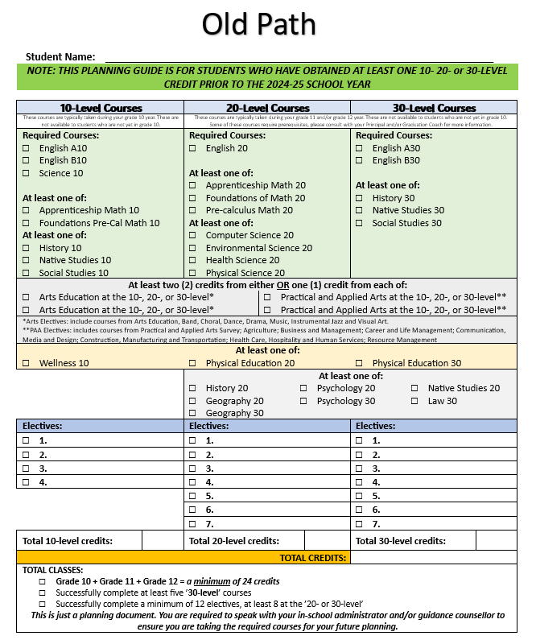

Career and Work Exploration

In Career and Work Exploration 20, students spend 30-50 hours in the classroom and 50-70 hours in the workplace. They expand their awareness of career opportunities and explore options that are available to them and that match their career goals.

In Career and Work Exploration A30 and B30, students spend 20-40 hours in the classroom and 60-80 hours in the workplace. Students have the opportunity to experience career choices and to focus on developing entry level work skills in a workplace setting.

Timetabling of CWEX courses is flexible and we work with individual students to create a plan. Typically, students are scheduled time in a semester to complete the classroom requirements and then we make a plan to complete placement hours within spares and outside of school time. Students interested in taking this course will work with Mrs. Orth to create a schedule that best fits their needs.

Course Descriptions

Grade 10
ENGLISH LANGUAGE ARTS A10:
ELA A10 is organized into two units:

These units are explored through three strands: Composing and Creating, Comprehending and Responding, and Assessing and Reflecting.

ENGLISH LANGUAGE ARTS B10:
ELA B10 is organized into two units:

These units are explored through three strands: Composing and Creating, Comprehending and Responding, and Assessing and Reflecting.

WORKPLACE AND APPRENTICESHIP MATH 10:
This pathway is designed to provide students with the mathematical understandings and critical-thinking skills identified for entry into the majority of trades and for direct entry into the work force. Topics include Unit Pricing & Currency Exchange, Income (gross & net), Length, Area, & Volume, Mass & Temperature, Angles & Parallel Lines, Similarity of Figures, and Trigonometry.

FOUNDATIONS OF MATHEMATICS AND PRE-CALCULUS 10:
This pathway is designed to provide students with the mathematical understandings and critical-thinking skills necessary for the Foundations 20/30 and Pre-Calculus 20/30 Pathways. Topics include Measurement, Trigonometry, Factors and Products, Roots and Powers, Relations and Functions, Linear Functions, and Systems of Linear Equations.

HISTORY 10
This is a continuation of the study of the foundations of western civilization. The course includes political decision-making, economic decision-making, ideology and the decision-making process, international economic relations and international political relations in 14th through 19th century Europe.

SCIENCE 10:
The acquired knowledge and skills the student will gain through the study of sustainability, chemical reactions, motion, and weather dynamics will serve to reinforce and develop the relationship between science, technology, society and the environment as well as aid the student in understanding the world in which they live. Units include:
- Sustainability of Ecosystems: Cultural perspectives, local biodiversity, population dynamics, population stability, human impacts
- Motion: Motion-related technologies, motion of everyday objects, relationship between time, distance, and speed, acceleration
- Chemical Reactions: Common chemical reactions, representations of chemical reactions, organic compound reactions, factors affecting the rates of reactions, acids and bases
- Weather Dynamics: Causes and impact, meteorological data, principles of weather, weather forecasts, global climate change.

WELLNESS 10:
Wellness 10 is designed to provide students with an opportunity to explore and experience a variety of activities in order to encourage them to pursue an active, healthy lifestyle. Students acquire knowledge, develop understanding, and practice attaining and sustaining personal well-being through the five strands of wellness: Physical Activity and Fitness, Stress Management, Leisure, Healthy Eating, and Relationships. A primary goal of Wellness is to have students desire to pursue a lifestyle that is made rich through participation in physical activity, and that values the pursuit of Wellness as a lifelong behavior pattern. This includes making healthy lifestyle choices and finding opportunities to grow and learn in body, mind, and spirit. Goal-Setting will allow students to reward themselves for planning, experiencing, and evaluating activities in such areas as recreation, sport, leisure, community, volunteerism, self-concept, education, fitness, nutrition and skill development. The expectation is for students to come ready to be actively involved. The main goal is to have fun!

Course Descriptions

Grade 11
ENGLISH LANGUAGE ARTS 20:
Prerequisite: English Language Arts A10 and English Language Arts B10
ELA 20 is designed to help students extend their literacy skills and strategies and to become competent and confident users of all six language arts strands through many opportunities to view, listen, read, represent, speak, and write in meaningful contexts. Units include:

HISTORY 20:
Prerequisite: None
History 20 is a comprehensive study of the 20th century, from WWI to present day. This course will focus on a number of themes such as nationalism, totalitarianism, imperialism, militarism, and terrorism. It will also attempt to outline and explain how the important events of our recent past have shaped the world that we live in today. Students will learn and appreciate the past in order to understand the present and influence the future.

WORKPLACE & APPRENTICESHIP MATH 20:
Prerequisite: Workplace & Apprenticeship Math 10
Content in this math pathway is chosen to meet the needs of students intending to pursue careers in the trades and general workplaces. Curriculum outcomes are addressed through activities, projects, and problems set in real-world contexts, enabling students to make connections between school mathematics and the workplace. Real-world problems, especially those related to apprenticeship programs and to employment that students can enter after completing secondary school, include workplace applications of mathematical concepts. Topics include Slope and Rate of Change, Graphical Representations, Surface Area, Volume, and Capacity, Trigonometry of Right Triangles, Scale Representations, Financial Services, and Personal Budgets.

FOUNDATIONS OF MATH 20:
Prerequisite: Foundations of Math and Pre-calculus 10
This pathway is designed to provide students with the mathematical understandings and critical thinking skills identified for post-secondary studies in programs that do not require the study of theoretical calculus. The outcomes of this course are based upon the students’ prior learning and continue to develop their number sense, spatial sense, logical thinking, and understanding of mathematics as a human endeavor. Topics include Inductive and Deductive Reasoning, Properties of Angles and Triangles, Acute and Obtuse Triangle Trigonometry, Statistical Reasoning, Systems of Linear Inequalities, Quadratic Functions, and Proportional Reasoning.

PRE-CALCULUS 20:
Prerequisite: Foundations of Math & Pre-Calculus 10
This pathway is designed to provide students with the mathematical understandings and critical-thinking skills identified for entry into post-secondary programs that require the study of theoretical calculus. Topics include Quadratic Functions & Equations, Radical Expressions & Equations, Rational Expressions & Equations, Absolute Value & Reciprocal Functions, Sequences & Series, Trigonometry, Systems of Equations, Linear & Quadratic Inequalities.

HEALTH SCIENCE 20:

Prerequisite: Science 10
This course will challenge students to look at the health science field from holistic and analytic perspectives to provide a basis for making sound personal health choices. Students will examine the range of philosophies that guide health care and consider ethical decisions within those contexts. Understanding the basic anatomy and physiology of the human body will provide a context for studying the normal and abnormal functioning of various body systems, including the role of nutrition and metabolism. Lastly, students will examine diagnostic tools and procedures and how they are used to inform treatment. Students will also investigate the range of health science careers and post-secondary programs available in Saskatchewan.

PHYSICAL SCIENCE 20:
Prerequisite: Science 10
Do you wonder about how chemistry and physics help industry, agriculture, and pure science research move forward? Physical Science will allow students to investigate scientific concepts in a hands-on, lab-based manner. This course will allow students to investigate the foundations of chemistry, including the mole and quantitative analysis of molecules and chemical reactions, and the characteristics and properties of heat and waves. Students will also have student directed study and career exploration outcomes to help them better understand the career paths related to physical science.

ENVIRONMENTAL SCIENCE 20:
Prerequisite: Science 10
Students will learn how to examine local and global environmental issues from a systems perspective while considering the effects of human actions and a growing global population on the climate and environment, as well as the effects of the environment on human health. They will explore the mechanisms and importance of aquatic and terrestrial ecosystems and the sustainability of past and current practices and technologies humans have developed to live with and within the environment

COMPUTER SCIENCE 20:
Prerequisite: Science 10
This course focuses on the study of computational thinking and software design and allows students to become creators of computer applications. Through hands-on activities, students will develop the fluency necessary to solve a variety of real-world problems. In this course students will learn some basic skills in five major areas related to computer programming. This course is an excellent starting point for students who are considering careers in web development, systems analysis, database management, programming, networking, engineering, gaming and other technology-related industries.

Course Descriptions
Grade 12

ENGLISH LANGUAGE ARTS A30:
Prerequisite: English Language Arts 20
In this course, students will study a variety of themes that focus on Canadian literature and society. There may be some coordination of ELA A30 and History 30. This approach will allow students to analyze how our Canadian literature has been shaped by our physical landscape, as well as our history. Units of study include:
- Canadian Landscapes: Diverse and Dynamic – In this unit, students will examine the various landscapes in Canada including: Natural and Constructed; Psychological and Physical; Historical and Contemporary; and Personal and Societal.
- Canadian Perspectives: Distinct and Rich – In this unit students will examine the various perspectives in Canada including such topics as: The Canadian Identity; Celebrating the Glorious and Acknowledging the Scandalous; Shifting Centres and Blurring Margins; and Understanding Beliefs and Initiating Action.

ENGLISH LANGUAGE ARTS B30:
Prerequisite: English Language Arts 20
In this course, students will explore global and personal issues using a variety of traditional and contemporary world literature. Units of study include:
- The Search for Self – sub themes of this unit include: Identity & Sense of Self, Human Qualities and Ideals, Joy & Inspiration, and Doubt & Fear
- The Social Experience – sub themes for this unit include: Dealing with Universal Issues; Ambition, Power & the Common Good; Social Criticism, Addressing the Issues.

HISTORY 30: Canadian Studies
Prerequisite: None
This history program examines the historical forces between the Aboriginal peoples who have always been here and the many different immigrants who came to make a new life for themselves. Canadians have had to deal with issues stemming from the environment and from working out ways of living with each other. This program examines the current state of these issues and alternative viewpoints for dealing with these issues within Canadian society

FOUNDATIONS OF MATH 30:
Prerequisite: Foundations of Math 20
This pathway is designed to provide students with the mathematical understandings and critical-thinking skills identified for post-secondary studies in programs that do not require the study of theoretical calculus. The outcomes of this course are based upon the students’ prior learning and continue to develop their number sense, spatial sense, logical thinking, and understanding of mathematics as a human endeavor. Topics include Financial Mathematics (investing and borrowing money), Set Theory and Logic, Counting Methods, Probability, Polynomial Functions, Exponential and Logarithmic Functions, Sinusoidal Functions.

WORKPLACE AND APPRENTICESHIP MATH 30:
Prerequisite: Workplace and Apprenticeship Math 20
This pathway is designed for students who may want to pursue post-secondary studies in trades, certified occupations, or direct entry into the workforce. Whether students plan to enroll in college, learn a trade, or enter the workforce after graduating from secondary school, the practical mathematical skills students will learn in this course will support students at work and in their daily life.
Curriculum outcomes are addressed through activities, projects, and problems set in real-world contexts, enabling students to make connections between school mathematics and the workplace. Real-world problems, especially those related to apprenticeship programs and to employment that students can enter after completing secondary school, include workplace applications of mathematical concepts.
Topics include: Linear Relations, Limits to Measurement, Statistics, Probability and Odds, Properties of Geometric Figures, Transformations, Trigonometry, and Owning a Small Business.

PRE-CALCULUS 30:
Prerequisite: Pre-Calculus 20
In this course, students will investigate function properties, transformations, and operations, trigonometric ratios, equations, and identities; as well as permutations, combinations, and the binomial theorem. The use of graphing technology is implemented throughout the course.
This course is a pre-requisite for taking Calculus 30 and is also a good preparation for university and some technology based Saskatchewan Polytechnic courses. Content in this pathway was chosen to meet the needs of students interested in pursuing careers in science-related areas and is also recommended for those pursuing a Bachelor of Commerce degree at University.

CALCULUS 30:
Prerequisite: Pre-Calculus 30
This is an advanced mathematics class aimed at students who will be taking calculus
at university. This course will bring together knowledge from previous math courses and
expand upon it. The course will focus on topics such as function transformations, domains and ranges, limits and continuity, differentiation, graphical applications of derivatives, rates of change, optimization problems, related rates, and differentiation of transcendental functions and applications.

BIOLOGY 30:
Prerequisite: Health Science 20 or Environmental Science 20
This course examines the details of living organisms and involves examination of organisms at various levels from molecular (biochemistry),through to cells and tissues and concluding with organ systems. The study of inheritance rounds out the course. Human systems are studied, including hands-on dissection, with connections to simpler vertebrates and evolution.

CHEMISTRY 30:
Prerequisite: Physical Science 20
Students will connect the theoretical nature of chemical bonds to the properties of ionic, molecular and organic compounds and study what makes these materials suitable for various applications. Students will actively investigate the nature of equilibrium in chemical reactions and apply this to solution chemistry, acid-base reactions, and oxidation-reduction reactions, while studying their impacts on society and the environment. Students will also complete an inquiry activity related to one of these phenomena.

PHYSICS 30:
Prerequisite: Physical Science 20 Physics 30 consists of four main units:
- Forces and Motion – linear, circular, and projectile
- Conservation Laws – momentum and energy
- Fields – gravitational, electric, and magnetic
- Modern Physics – relativistic principles, quantum mechanics, radioactivity, and nuclear technology. There is also a student directed study outcome. Laboratory investigations are regular components of this program.

Course Descriptions
10-12 Electives
*Please note that these options shift each year with student interest and staffing capacity*
.

Computer Aided Drafting and Design 10
Drafting and Computer-Aided Design provides students the opportunity to develop the knowledge, skills and understanding in drafting and computer- aided design. The courses help students to develop an appreciation for drafting and computer-aided design, communicate effectively in a nontraditional environment; develop independent work practices; and make informed career decisions. The Areas of Focus for Drafting and Computer-Aided Design (CAD) 10, 20, 30 are:
- basic functions of CAD software;
- terminology related to drafting;
- reading technical drawings;
- architectural drawings;
- mechanical drawings;
- diversity of perspectives and preferences in architectural and mechanical drafting;
- cost estimation of materials;
- energy efficiency and environmental sustainability; and,
- career exploration.

Financial Literacy 20
The purpose of Financial Literacy is to develop informed consumers with the habits, attitudes, and critical thinking skills necessary to approach financial decisions ethically and with competence and
confidence—both now and in their future lives. Equipping all Saskatchewan students with the ability to
analyze, understand, apply and appreciate the basic and complex topics associated with financial
decision‐making within the context of their economic and cultural environments, benefits students,
their communities, the environment and society as a whole. This curriculum seeks to develop within
students the capacity to make informed financial decisions as they transition through and beyond secondary school and into adulthood.

Visual Arts 10/20/30
Visual Art 10, 20, 30 enables students to engage in artistic investigations to explore their own and others’ ideas and diverse worldviews, experiment with various art practices, techniques and media and work towards development of their personal styles and artistic voices. Students collaborate with peers, teachers and/or community mentors and learn about historic and contemporary work of Saskatchewan, Canadian and International artists.

Psychology 20
Psychology 20 explains the growth and development of human social thought, influence and behaviour by examining biological and environmental aspects of our social nature. The key to this course is looking at what motivates us to act the way we do. Major topics include memory, learning, intelligence, motivation, dreams, gender, group psychology, psychic phenomena and dysfunctional social behaviours.

Psychology 30
The Psychology 30 course covers the stages of human development from pre-natal development through infancy, childhood, adolescence, early and mid-adulthood and old age. It discusses the unique characteristics of individuals at these different stages. Students learn about the development tasks that one must confront in order to grow successfully at each stage.

Media Studies 20
Prerequisite: English Language Arts A 10 and B 10
Media Studies is an optional course offered at the grade eleven level. ELA 10 is a prerequisite. Students explore issues related to the media and popular culture. Reading, writing, listening and speaking skills are an important part of the course. Critical thinking is also emphasized. The overall objective is to assist students to develop an informed and critical understanding of the nature of the media - primarily television, radio, magazines, newspapers, advertising and books.

Phys Ed 20/30
The aim of this course is to develop skills to promote a positive attitude toward a lifetime commitment to physical activity. A variety of sports-related activities will be experienced in order to develop skills. Positive attitudes will focus on self-concept, personal and group safety, social behaviour and relationships with others. The course experiences will aid students in establishing physical, social, and emotional balance in their lives.

PAA A10/20/30
This survey course is a configuration of recommended modules from a minimum of three pure Practical and Applied Arts curricula. Because various combinations of modules can be chosen, the courses will have variable occupational or career pathways to post-secondary education and training or workplace opportunities. The courses will provide opportunities for career development. The following is a list of options that may be included in this course:
- Construction and Carpentry 10, 20,30
- Electrical and Electronics 10, 20, 30
- Welding 10,20,30
- Mechanical and Automotive 10, 20,30

PAA B 10/20/30
This survey course is a configuration of recommended modules from a minimum of three pure Practical and Applied Arts curricula. Because various combinations of modules can be chosen, the courses will have variable occupational or career pathways to post-secondary education and training or workplace opportunities. The courses will provide opportunities for career development. The following is a list of options that may be included in this course:
- Foods 10
- Clothing, Textiles and Fashion 10,30

Robotics 10/20/30

Robotics and Automation 10, 20, 30 focuses on the design, construction, operation and use of autonomous and/or radio-controlled robotic devices, as well as the computer systems necessary for their control, sensory feedback and information processing. Through project based learning, design thinking, and inquiry learning, students will explore the processes and skills needed to design and fabricate physical devices that they will control or automate. Students are able to explore wearable technologies, automation, mobile robotics and animatronics as well as traditional robotic devices. In addition, students will also develop the computational thinking and coding skills necessary to control their robotic or automated devices.

Wildlife Management 20

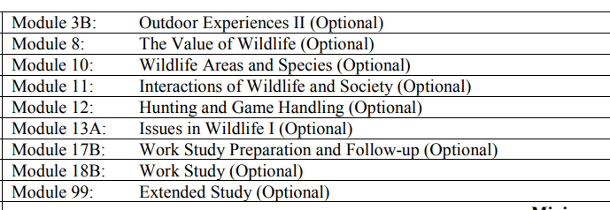

Information Processing 10
Information Processing 10 focuses on eight areas in a personal context: task management, digital citizenship and law, word processing, computer technology, spreadsheets, databases, photography and video production, and design, drawing and painting. Using a variety of technological tools and platforms, students will develop and apply an understanding of information processing to communicate, solve problems and create products in a digital world.

Law 30

Students will develop a clear understanding and appreciation for the Charter of Rights and Freedoms, not only knowing their rights as Canadians but why these rights are so significant.
Criminal law is a major area of focus in Law 30. Students will examine what makes a crime a crime, what is needed to convict someone of a crime, and how criminal court cases are tried in Canada. Throughout this, they will look at a number of current and historical legal cases to help better understand the foundations of Canadian criminal law.
Law 30 is both a Social Science and a Business course. It is with this dual focus that students will examine civil law. This critical aspect of law is both important to us as citizens and as part of the business world. By understanding the law, a business can be better prepared not only to meet the needs of its customers but prevent costly litigation.

Leadership

Students will explore positive psychology, emotional intelligence, problem solving as part of a team and participate in testing, which will allow them to see who they are as learners and leaders.
Students have the potential to become successful leaders through hands-on application, mentorship, inquiry, and project-based learning. This course will provide students with a solid foundation for life, work and citizenship.

Entrepreneurship

Entrepreneurship 30 is designed to help students appreciate and better understand the role of business in our society. Students will develop the entrepreneurial skills required to start, run, and maintain a business enterprise and will learn how businesses function, the structure of the Canadian economic system and the benefits it provides.

Creative Writing

Creative Writing 20 delves into four unique genres of creative prose, fiction, non-fiction, poetry, and script writing. Students will read, dissect, and compose literature in each genre while learning to identify the elements of each form and applying their knowledge to produce original pieces of creative writing.

