ACS Fall Parent Communication Survey Results

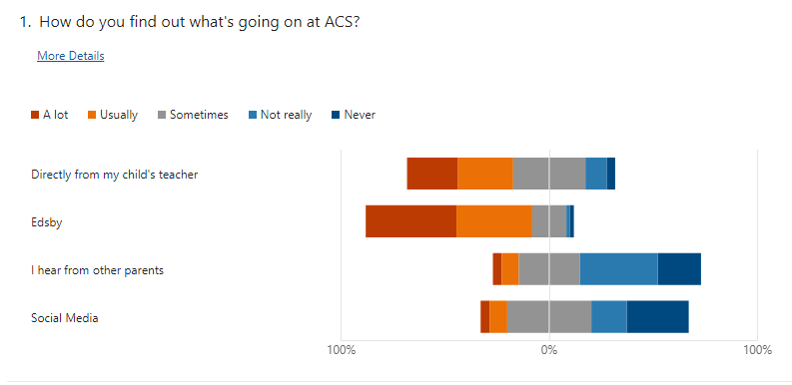

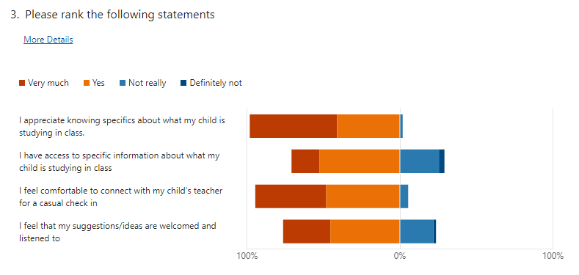

How might we improve our communication with you?
You’re doing a great job already.
Keep using email preferably
Edsby doesn't always notify you when items are added to the top banner of the Edsby App. I feel like there are lots of duplicate communications (which I understand why, but it's a bit redundant). I cannot rely on Edsby (often logs out) so I have to ensure all notifications are turned on, but then I also get emails directly from teachers sometimes. Ideally more notice for things would be given. I find a lot of times the theme days, fundraisers, deadlines are only days away. Overall happy with communication.
I think it’s going well so far.
Sending out the SCC meeting minutes after each meeting would be beneficial for those not able to attend in-person, thank you,
I am very happy with the communication from the school
N/A
Get rid of Edsby and just use a weekly email. Edsby is garbage
If there are any issues or things that need to be worked on that they are communicated as soon as possible to get a handle on them
A bit more notice would be helpful sometimes
regular feedback on how they are doing in class not waiting until interviews
Edsby is not the greatest, I get so many notifications everyday because of teachers and staff adding things that I can’t even keep up to them. But if I turn notifications off, I miss the important messages. Also both my kids have last years class work still in the learning story section.
Direct email if issues
Not a fan of the Edsby app. Wish I could just recieve simple emails. I don't like the emails with a link to a pdf that I have to download then open in another app. I would prefer if all messaging came in the body of simple emails.
I feel like more/better communication on Bullying would be appreciated
Stop using apps. Emails are fine.
I feel communication with teachers through Edsby has been going well. I appreciate when teachers send an overview of what my child is learning.
Communication with teacher and email to good
Weekly or even daily newsletters on Edsby like many other schools do.
Call me anytime
When events or important moments come up at school, let us know. Even through Edsby works
Edsby is working great
Regular phone calls
Daily school announcements on Edsby
None. You are always open for questions, comments and suggestions. Keep up the great work. Thank you.

Student Communication Survey Results

