March 25, 2023

Aberdeen school report

Enrollment and Staffing
- 329
K | 1 | 2 | 3 | 4 | 5 | 6 | 7 | 8 | 9 | 10 | 11 | 12
25 | 44 | 29 | 37 | 25 | 27 | 26 | 18 | 21 | 13 | 24 | 17 | 23

- Staffing Update
  - Always looking for substitute EAs and caretakers
  - Barb Hagele hired as part time admin assistant

upcoming events
- March 27th - Three Piggy Musical (Grade 2)
- March 27th – Heritage Fair
- March 28 – Progress Reports go home for Grade 1-7
- April 11 – Fun Night

Extra-Curricular Activities
- SLT (report provided)
- Kindness Club
- Marafun
- Jr Badminton
- Sr. Badminton

School Goal
We will leverage communication strategies to improve staff confidence in themselves and community confidence in the school.

Lead Indicators
- Create a school community wide communication plan. = clarity of information
- School Communication Plan has been developed based on feedback collected in surveys to parents and students
- Sunday message and Monday huddle feedback from staff
- Continuous reporting pilot

- Provide regular opportunities for informal communication between staff members. = relationship building which supports wellness
- Transparent sharing of professional learning and (bulletin board) to facilitate informal conversations – each staff member contributes evidence at least 3 times per year.
- Intentional activities to improve communication and support relationship building between staff members
- Classroom visits using LF and/or PD budgets

- Increased inputs from community members and organizations= collaboration
- Target improved connection and communication with educational partners (Indigenous partners, SIEC, SaskAbilities PRRC)
- Focus on family-centric communication vs. school centric communication ASK, not TELL.
- Intentional outreach to community members through school projects.
- SCC speaker initiative

Financial Report

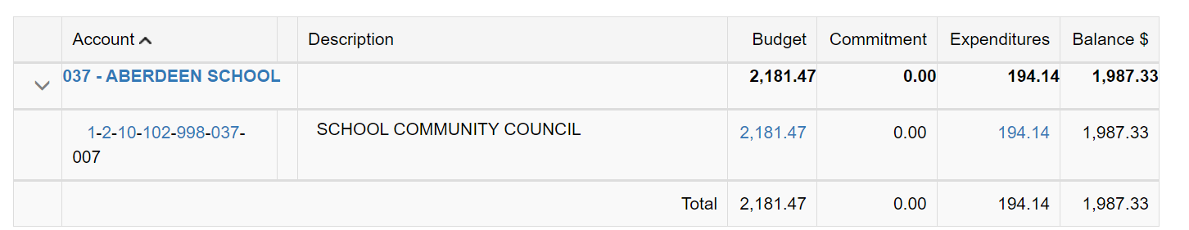

- Missing receipts from book and a muffin

