Grade 1 Learning Framework: June 1 - 5
Mrs. A’s Website: https://blogs.spiritsd.ca/anderson/
Please spend time writing, creating, exploring, and being physically active each day. | This could look like:  Journal Time: – Please write at least 3 – 5 sentences. Take a picture and send it to me!!  Create Something:  Draw a Hippo - https://www.youtube.com/watch?v=RDFjyi5Vbmw&feature=youtu.be  Rock Flower Painting: https://www.youtube.com/watch?v=dZqbwdNkWDg&list=PLuGHF5Zdlxpiug2Sn8oHg6UkKJg12Ucy8  Go outside and find something to draw!!  Be Active:  Check out the SCP Gym Website at: https://blogs.spiritsd.ca/scpgym/. Try some of the cardio, skills, dance, and stretch activities!  Go outside and build a fort, climb something, ride a bike, or go for a walk!!  Explore:  Go outside and find the signs of spring!!
Math: | Jump Math:  Pages 138 - 140:  Please watch these YouTube video before the students work on these pages.  https://www.youtube.com/watch?v=trIeEJgvbD4  https://www.google.com/search?q=teaching+symmetry+to+grade+1&rlz=1C1GCEV_enCA901CA901&oq=teaching+symetry+to+&aqs=chrome.7.69i57j0l7.7304j0j8&sourceid=chrome&ie=UTF-8&safe=active&ssui=on#kpvalbx=_LF3NXo-4Lo3A0PEP25S0gA878  Pages 141:  Please watch my YouTube video before the students work on this page.  https://www.youtube.com/watch?v=fOWZP5M8ysk  Pages 142:  Please watch my YouTube video before the students work on these pages.  https://www.youtube.com/watch?v=kacSOVI6Jvs  Pages 143 – 144:  https://www.youtube.com/watch?v=S4bjcFw-yr4  Pages 145 – 146:  https://www.youtube.com/watch?v=kyUdFyd4sVM  Please work on the IXL math program this week – it has a section on level B called “Positions”, and on level C called “Spatial sense” that I have assigned. It would teach these concepts in a different and fun way!!  Work on the IXL math program:  https://ca.ixl.com/signin
Language Arts: | Work on Headsprouts and Raz-Kids reading!  https://blogs.spiritsd.ca/anderson/language-arts/  Listen to our new book called “Jason and the Escape from Bat Planet”:  Chapter 8: https://www.youtube.com/watch?v=lElTjbmU9oM  Chapter 9: https://www.youtube.com/watch?v=8ukEuvEybi4  Chapter 10: https://www.youtube.com/watch?v=50NLk1LCrNI  Chapter 11: https://www.youtube.com/watch?v=1gcnaPQewCI  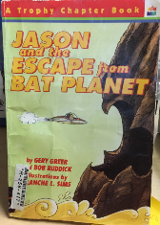  Make a “How To…” writing:  Download another one of the “How to…” mini-book templates that I have attached. Have students think about something that they know how to do. Have them think through the steps of doing that task. Then have them use the template with the words: First, Next, Then, and Last to write the instructions in sentence form and create their own little book.  Watch Mrs. A’s “How to” bake a white cake:  https://www.youtube.com/watch?v=rCyvaDjGOPE  Other “How to” books:  https://www.uniteforliteracy.com/featured/new/book?BookId=1841  https://www.youtube.com/watch?v=REiuXArnqfk
Science: | “I Am Living”  Print off the “I Am Living” craft template and have your students put one together.  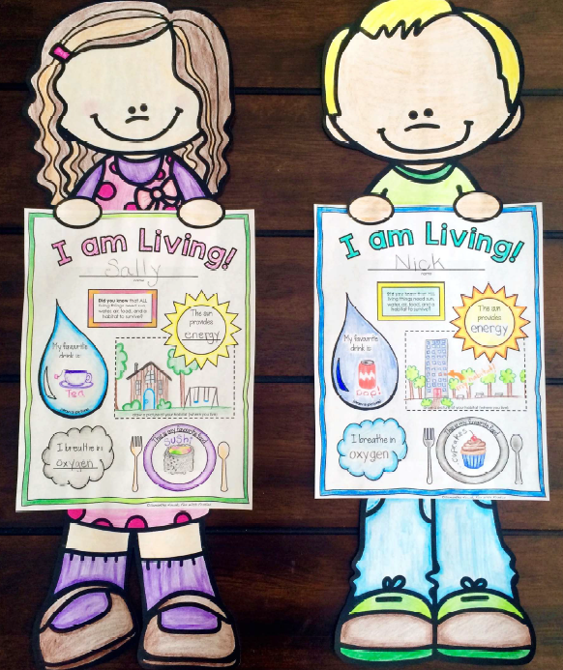  Watch: https://www.youtube.com/watch?v=p3St51F4kE8  https://www.youtube.com/watch?v=tkFPyue5X3Q  https://www.youtube.com/watch?v=Lly75dEbXE8  https://www.youtube.com/watch?v=jm12JKhNnWY  Extra activities for this lesson:  https://mysteryscience.com/secrets/mystery-1/animal-needs-food/115?r=82779895  https://mysteryscience.com/secrets/mystery-2/animal-needs-shelter/134?r=82779895  https://mysteryscience.com/secrets/mystery-3/animal-needs-safety/116?r=82779895  https://mysteryscience.com/secrets/mystery-5/plant-needs-light/132?r=82779895  Some books to read are:  Epic Books: I have assigned some books for the students to read.  https://www.uniteforliteracy.com/unite/plantsandfood/book?BookId=1744  https://www.uniteforliteracy.com/unite/animals/book?BookId=139  https://www.uniteforliteracy.com/biggreen/greenbooks/book?BookId=1656  https://www.uniteforliteracy.com/biggreen/greenbooks/book?BookId=1655
Art: | How to Draw a Ladybug: https://www.youtube.com/watch?v=UmC8rZrs8_0  How to Draw a Frog: https://www.youtube.com/watch?v=8lext2q_k2I
Story Corner: | Some Piggie and Elephant books read by Mrs. A!  “I Am a Frog!” https://www.youtube.com/watch?v=2r_gjQY4v70  “There is a Bird on your Head!” https://www.youtube.com/watch?v=9SOrZUX01ZQ  “Should I Share My Ice-Cream?” https://www.youtube.com/watch?v=brO8EEB84gs

