Terry Fox Run 2021

Terry Fox said, "anything is possible if you try." Inspired by his amazing example, our school is once again proudly taking part in this year's Terry Fox School Run. Students in grades 1-7 will be participating on September 28th. If you wish to donate, pledges can be given to students, brought to the school, or made online at http://www.terryfox.ca/BlaineLakeComposite. All funds go to the Terry Fox Foundation.

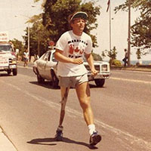 | Please join me in supporting the Terry Fox School Run!  I am proudly committed to raising much-needed funds for cancer research. #tryliketerry  www.terryfox.ca

