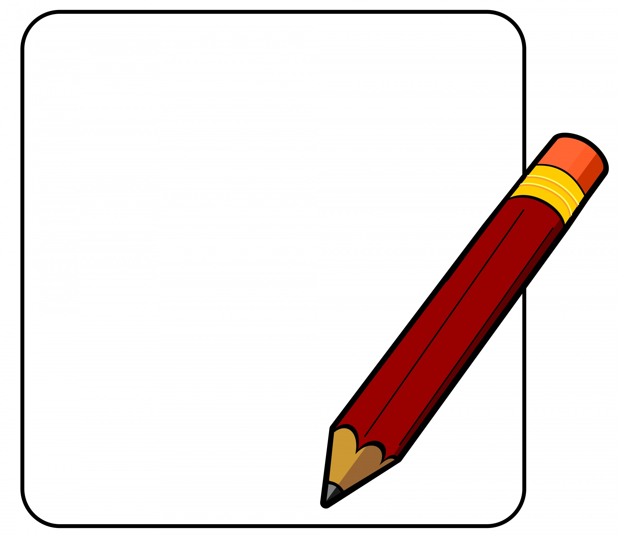

**GRADES 10-12**

**Binders and loose leaf**

**Pens, pencils, erasers**

**Pencil crayons, markers**

**Highlighters**

**Ruler**

**Graph paper**

**Geometry set**

**Scientific calculator**

**Gym clothes – appropriate change of clothes, deodorant,**

**NON-MARKING pair of indoor gym shoes**

**1 box of Kleenex**

**GRADES 8 & 9**

**Binders and loose leaf**

**Subject Dividers**

**Pens, pencils, erasers**

**Pencil crayons, markers, highlighters**

**Glue, scissors, tape**

**Ruler**

**Geometry set**

**Scientific calculator**

**Gym clothes – appropriate change of clothes, deodorant, NON-MARKING pair of indoor gym**

**shoes**

**Water bottle**

**1 box of Kleenex**