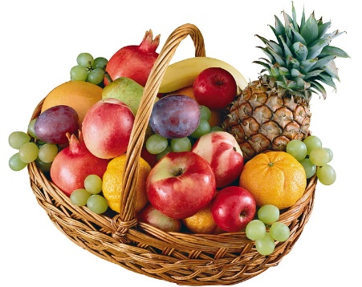
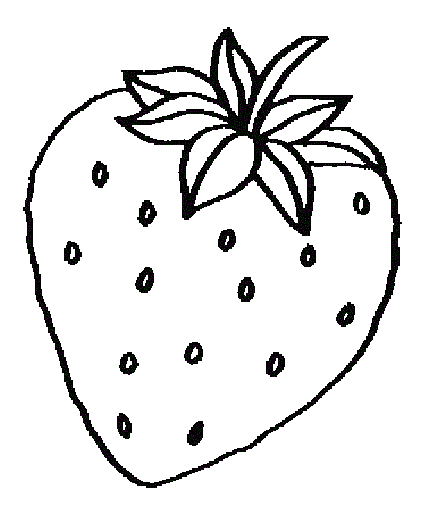
Good Food Box
This Photo by Unknown Author is licensed under CC BY
One of the things we do at our school is a good food box made up of fresh fruits and vegetables. You pay $25 and you receive a good-sized bag at wholesale prices, The value of the groceries is well worth the price You are paying. Our next one is April 7, 2022. You can order as many as you want. We must receive payment and your empty bag or box by March 31, 2022.
If you are interested in trying one, fill out form and send with payment to school by March 31, 2022. Our goal is to reach out to as many school/community families as possible with the increase of grocery costs this is a great value.

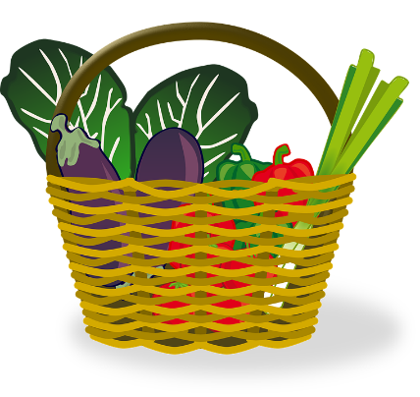
Name:__________________________
Quantity: _______________________
Bag or Box sent: Yes ___ No __

