Dear Care-Givers,
We all know that students that are ready to learn are much more likely to succeed than those who are not in the proper mind set or “zone.” Our goal is to give all of our students the necessary skills to move themselves into the proper zone when they find themselves out of it. When we have students who are ready to learn and have demonstrated key characteristics that we value as a school, we want to be able to celebrate those successes as well. As of October 2nd we will be implementing two new things that will help promote positive behaviours at LAS: The Zones of Regulation and The A-Team.

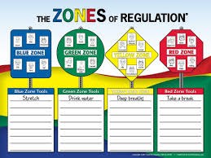
Our first strategy is the Zones of Regulation that will be used from Pre-K to grade 5 and to some extent, in the Middle Years as well. The purpose of the Zones of Regulation is to teach students how to self-regulate. Our goal is to help students get to the point where they are able to identify how they are feeling, what is making them feel that way, how big the problem is and what tool they can use to get them back into a “Ready to Learn” zone. We have included a letter that explains the Zones of Regulation as well as a Zones Visual Chart that we will be using at school that you can feel free to use at home if it fits for your family. Teachers will be sending home updates and information as to how students are doing and will be using the communicator as a tool to relate what zone(s) your child was in during the day. If you would like more information on what Zones might look like in your child’s class, please get in contact with your classroom teacher.

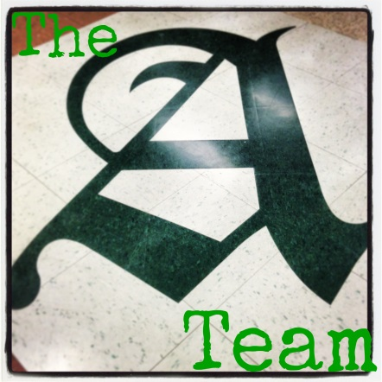
Our second strategy is to celebrate the success of students who are in the “Ready to Learn” zone that demonstrate characteristics that best represent The A-Team. If students are caught doing something good that matches our virtue of the month they will receive a “Catch ‘em” (an A-Team card). This will be a small card that says they were caught doing something good. We would encourage parents that see an A-Team card to ask what the student did to deserve it and talk about why what they did is such a positive example for themselves and their team (The LAS Athletics!). Throughout the month we will have random draws for those students who have received A-Team cards as a bit of a thank you for being such an awesome member of our A-Team.
We are very excited to get going on these plans and would love to have you pop into the school to see the work we are doing around promoting positive behaviour! If you ever have any questions or would like to learn a little more please just have a quick chat with your child’s teacher or myself. I’m really excited to see the work we can do this year!

Thank you for your support!
Leanne Gruending & Staff of LAS

