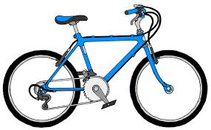Welcome to the LAS SCC Read to Ride Reading Bingo!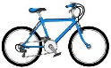

Want to win a bike just by reading? Read as many squares as you can! You can keep your bingo card safe in the plastic envelope in your communicator.
Each time you finish a square ask mom, dad, grandma, uncle or any adult to sign the square to show you have it done.
Bring back your bingo card on October 30th with at least one line completed and you will receive a prize.
Bring back your bingo card on November 13th with at least three lines completed and you will receive a prize.
Everyone who brings back a full card on or before November 27th will receive a prize.
All full cards will go into a grand prize draw for a brand new bike! Bike will be presented to winner December 4th.

Read about a sport you might like to play | Read a picture book | Check the LAS website for updates | Write your own story or poem for someone else to read | Read on a Tuesday!
Read to Mom or Dad | Read a magazine or newspaper article | Read about something that interests you | Read to a buddy, a furry friend or a cuddly toy | Read before bed
Borrow a book from the school library | Read under a blanket – or even in a blanket fort! (Don’t forget the flashlight) | FREE | Read a graphic novel or comic book | Suggest your favorite book for someone else to read
Go for a walk and read the road signs | Read the weather forecast | Read outside (bring an umbrella if it’s raining) | Read a poem | Read a book by Dr. Seuss
Read in a vehicle – better let the grown-up drive! | Read a book with a blue cover | Read the instructions – to a game, a craft, Lego or even a recipe! | Read a book about Canada | Read while having a snack! (But don’t spill on your book)

