Monday, November 26th
What will someone learn because you are in the room today?

Big Idea: what assessment questions are we wrestling with?
Agenda:
- The Thinking Classroom (Shantel & Ellen)
  - Shantel & Ellen will lead us through an activity to get us thinking deeply about our practices
- In the Fishbowl
  - We will have an opportunity to hear from and support three of our colleagues as we participate in a learning fishbowl.
Fishbowl Questions
- We’ve been working through Softening the Edges, and have been invited to think about our current assessment practices. What are some things you are working on?
- As you reflect on the last 3 months and the work you are doing with your assessment, what would you celebrate?
- As you reflect on the last 3 months and the work you are doing with your assessment, what are some things that you are wrestling with?
- Referring to question 3, what are some things you’ve tried that haven’t quite hit the mark the way you had hoped they would?
Audience Feedback:
- As they answer their questions, please take notes to provide feedback:
- What are the participants working on that resonates with you?
- How can you ‘steal’ from their celebration?
- Are your roadblocks similar? If not, quickly jot down what your roadblocks are.
- What advice do you have for the participants?
3 Way Activity:
- In groups of 3, discuss the 4 fishbowl questions and how they apply to your assessment work. Please provide your partner(s) with feedback.

- Round table 10 minutes
  - The Doors (more than just a great band!)
    - Make sure the fire doors (beside the staff room and Brenda’s office) are closed at night if you are the last one out after the caretakers
    - If you are helping students with anything on or behind the stage, please make sure those doors are locked when done. There are some critical files in the back room and a lot of drama costumes back stage
    - If you are in the office (i.e. at noon or later after school) and there is no one in the office, please make sure the door is locked upon leaving. Occasionally there is cash left on Corinne’s desk.
  - Moving classrooms
    - We may be able to move into the relocatable classrooms on December 21st. If they are ready to be occupied, we will be moving Dwayne & Jade to their new rooms, all other elementary classes will stay where they are until the start of the 2019-20 school year.
    - After moving Dwayne & Jade, we will be better able to utilize those rooms for grade 7 & 8 classes. I am currently working on room assignments for after the Christmas break.

2018-19 Waldheim School Professional Staff Book Club
Softening the Edges ~ Katie White
Katie White is a Saskatchewan educator who has worked for the North East School Division (NESD). While at NESD, Katie was a teacher, administrator, and system leader who brings a perspective I’m sure we will all be able to identify with.
At Waldheim School, our over-arching goal is to develop a deeper understanding of every student we work with. This year, we narrow our focus to assessment. How we use assessment to drive learning is something we will continue to discuss this year as we build on the incredible work that has been done at Waldheim School for many, many years.
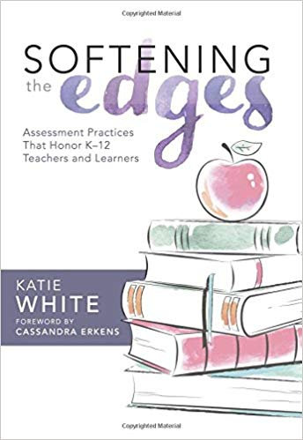
We do this work in an effort to improve our teaching so we can better meet the needs of every learner in our building. It is hoped that this book will prompt you to think about the work you have been doing around assessment for and of learning. Through self-reflection and collegial conversations, we hope that 2018-19 will be your most successful year yet!
Staff Meeting Thoughts:
- Small Group Meetings (K-4, 5-8, 9-12)
  - Chapter assigned to be read
  - All group discussion
    - Predetermined questions
      - Initial thoughts
      - Quotes that resonate
      - Impact
      - Evidence
    - Final Thoughts
      - Round table discussion on reading
- All Staff Meetings
  - Small groups with representation from each small group
    - Discussion:
      - What has been talked about in the small groups?
      - What are the common threads?
      - Impact
      - Evidence
    - Final Thoughts
      - Bring all groups back together with one spokesperson for each group sharing thoughts/questions

