Monday, January 28th, 2019
9 – 12 Staff Learning Meeting

What will someone learn because you are in the room today?

Big Idea: Reporting is a conversation between people who care about students
AGENDA:
- Reporting: It should be ‘sew’ easy
  - Read & discuss
- Chapter 7 discussion
  - What resonated?
  - How are we having conversations with our parents
  - What are you wrestling with?
- Round Table
  - Final exams
  - Progress reports
  - Semester 2 classes
Reporting: It Should be ‘Sew’ Easy
As I was reading chapter 7, Systems of Reporting, I started to think back to a learning experience I got to be a part of a while ago. One Sunday morning, as I was working on my computer, my 7-year-old daughter, Eva, is busy working away on a sewing kit she had received as a gift from her auntie. In the kit were all the materials for her to create her own little stuffed owl. It was pretty cute, but it also requires a lot of side-by-side learning. This is one of those moments when I was in over my head a bit as I am not a master at sewing, not even close!
As she worked on this, I noticed a growing confidence in her and an ability to solve her own problems as she struggled with her kid-safe needle and thread. This whole activity was an example of authentic learning, a kid engaged in an activity that interested her (she’d have given up on Lego much earlier), was stretching her, and has a clearly defined product. My role has gone from helping her set up and demonstrating how to pull the needle and thread through, to a cheerleader on the side.
So, what mark should she get?
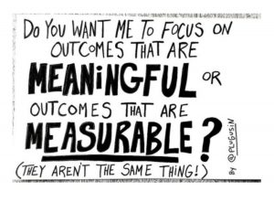
How do I measure what she has learned, and how do I share this with her mom who was at work at the time and was not able to see the process? I could count the number of errors she had made, but would that be an accurate measurement? I could record how long it took her, and then ask her to complete another one, but would that be an accurate measurement? I could find out if any other kids her age had sewn an owl kit like this and set them side by side and see which one looks better, but would that be an accurate measurement?
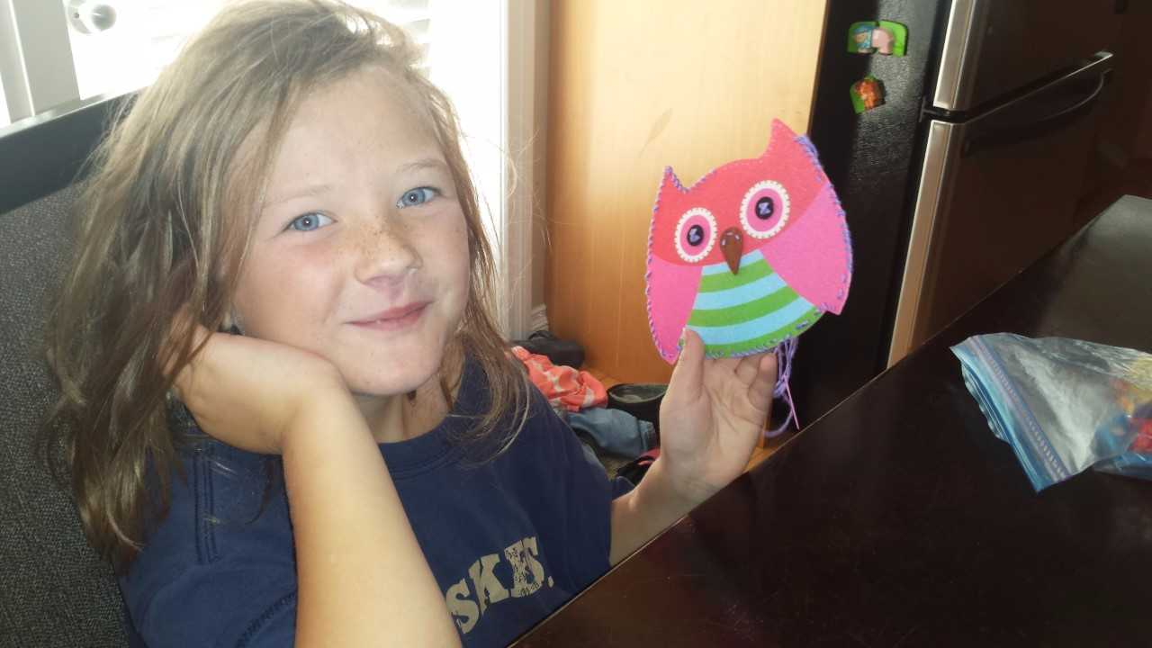
The funny thing is that’s how I used to measure learning when I was teaching subjects, like grade 5 social studies, or senior psychology, and as I reflect, I am sure I wasn’t always measuring what was important. As Eva was working, I asked her, “Eva, what are you learning?” Her response was, “I’m not learning, I’m just sewing”. Interesting. I bet if I had given her a sheet of addition questions or a spelling list she’d be able to formulate a different answer to that question. Has she already been trained to think that if it isn’t readily measurable it’s not really learning? If so, that makes me a little sad.
Discussion questions:
- What are some ways you’ve been able to measure and report the meaningful stuff that may be tough to measure?
- Can you think of times in your class when a student might say, “learning? I’m not learning, I’m………”
As we continue along our learning journey this year, keep asking yourself, am I measuring what’s measurable or what’s meaningful?

Chapter 7: Systems of Reporting
- Hopefully as you read chapter 7 you were thinking about reporting as it relates to your setting. What were some quotes or ideas contained within chapter 7 that resonated with you?

- As you read through the chapter, what caused you to stop and reflect on how you are reporting to students & their families?

- What are some challenges that you are wrestling with right now when it comes to reporting, and how might we support each other?

2018-19 Waldheim School Professional Staff Book Club
Softening the Edges ~ Katie White
Katie White is a Saskatchewan educator who has worked for the North East School Division (NESD). While at NESD, Katie was a teacher, administrator, and system leader who brings a perspective I’m sure we will all be able to identify with.
At Waldheim School, our over-arching goal is to develop a deeper understanding of every student we work with. This year, we narrow our focus to assessment. How we use assessment to drive learning is something we will continue to discuss this year as we build on the incredible work that has been done at Waldheim School for many, many years.
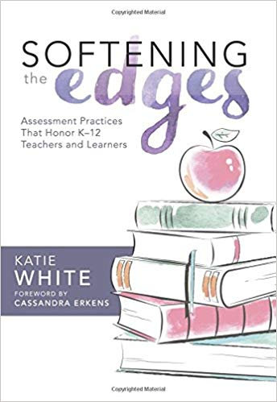
We do this work in an effort to improve our teaching so we can better meet the needs of every learner in our building. It is hoped that this book will prompt you to think about the work you have been doing around assessment for and of learning. Through self-reflection and collegial conversations, we hope that 2018-19 will be your most successful year yet!
Staff Meeting Thoughts:
- Small Group Meetings (K-4, 5-8, 9-12)
  - Chapter assigned to be read
  - All group discussion
    - Predetermined questions
      - Initial thoughts
      - Quotes that resonate
      - Impact
      - Evidence
    - Final Thoughts
      - Round table discussion on reading
- All Staff Meetings
  - Small groups with representation from each small group
    - Discussion:
      - What has been talked about in the small groups?
      - What are the common threads?
      - Impact
      - Evidence
    - Final Thoughts
      - Bring all groups back together with one spokesperson for each group sharing thoughts/questions

