Monday, January 7th, 2019

What will someone learn because you are in the room today?

Big Idea: Shaking off the holiday rust
AGENDA:
- Minute to Win It (Steve)
- Fixes for Broken Grades (Jig Saw Activity)
- Round Table
  - Ski trip/Elementary trip
  - Staffing
  - Relocatable Classrooms
On Saturday, December 15th, I had the chance to listen to one of my favorite local bands at the Bassment in Saskatoon. I’ve heard them several times, but on that night I noticed they had changed two of their songs. In the first song, there was an extended guitar solo where one had not been before, and while it was a subtle difference, it was still there. In the second song the band picked up the tempo, which actually made the song more enjoyable.
I had a chance to speak with the lead singer and a member of the brass section, and I asked, “why the change?” Their response intrigued me. They said that at one of their practice sessions the drummer picked up the pace and the rest of them just fell in time with it. When they were done, they laughed and said, “well that sounded good, we’ll have to do that again!”
This made me think of how we are doing assessment. All of us have been involved with assessment for many years. We all went to public and post-secondary school (if not, we need to chat after the meeting), and we all had assessment ‘done to us’. That leaves a residue that impacts how we ‘feel’ about assessment and I believe it has an impact on how we do our assessment work. Regardless of the mileage on our teacher tires we have developed our own assessment skills, and as we are putting them under closer scrutiny this year, we may have tweaked a thing or two, or we may have completely changed our practices. We have been ‘jamming’ together as a staff for four months, and during this time I think it’s safe to assume that there have been changes. What have you changed? What has stayed the same? What are you still struggling with?
For this meeting, we will be looking at some different beliefs around assessment from Ken O’Connor’s book, A Repair Kit for Grading: 15 Fixes for Broken Grades.
Please see the next page for groups and tasks:
Part 1: Discussing the fix
- Please read your fix, and then discuss.
- We will then move to part 2 after you have had a chance to become experts in your fix.
Group Members | Fix
Cara  Ellen  Trace  Shantel | Fix #6: Don’ include group scores in grades; use only individual achievement evidence.
Jade  Sharlene  Leah  Joanne | Fix #12: Don’t include zeroes in grade determination when evidence is missing or as punishment; use alternatives, such as reassessing to determine real achievement, or use “I” for Incomplete or Insufficient Evidence
Dwayne  Jesse  Mitchell  Bobby-Jo | Fix #3: Don’t give points for extra credit or use bonus points; seek only evidence that more work has resulted in a higher level of achievement.
June  Brittney  Dan  Marla | Fix #1: Don’t include student behaviors (effort, participation, adherence to class rules, etc.) in grades; include only achievement.
Briane  Katharine  Steve  Brenda | Fix #13: Don’t use information from formative assessments and practice to determine grades’ use only summative evidence.

Part 2: Sharing your understanding
- Take turns sharing your fix with the others, taking time to discuss
Cara  Jade  Dwayne  June  Briane | Ellen  Sharlene  Jesse  Brittney  Katharine | Trace  Leah  Mitchell  Dan  Steve | Shantel  Joanne  Bobby-Jo  Marla  Brenda

Part 3: Final Thoughts (large group)

2018-19 Waldheim School Professional Staff Book Club
Softening the Edges ~ Katie White
Katie White is a Saskatchewan educator who has worked for the North East School Division (NESD). While at NESD, Katie was a teacher, administrator, and system leader who brings a perspective I’m sure we will all be able to identify with.
At Waldheim School, our over-arching goal is to develop a deeper understanding of every student we work with. This year, we narrow our focus to assessment. How we use assessment to drive learning is something we will continue to discuss this year as we build on the incredible work that has been done at Waldheim School for many, many years.
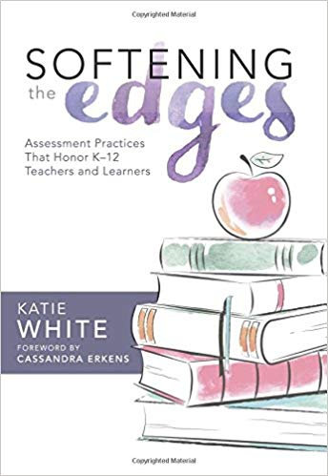
We do this work in an effort to improve our teaching so we can better meet the needs of every learner in our building. It is hoped that this book will prompt you to think about the work you have been doing around assessment for and of learning. Through self-reflection and collegial conversations, we hope that 2018-19 will be your most successful year yet!
Staff Meeting Thoughts:
- Small Group Meetings (K-4, 5-8, 9-12)
  - Chapter assigned to be read
  - All group discussion
    - Predetermined questions
      - Initial thoughts
      - Quotes that resonate
      - Impact
      - Evidence
    - Final Thoughts
      - Round table discussion on reading
- All Staff Meetings
  - Small groups with representation from each small group
    - Discussion:
      - What has been talked about in the small groups?
      - What are the common threads?
      - Impact
      - Evidence
    - Final Thoughts
      - Bring all groups back together with one spokesperson for each group sharing thoughts/questions

