Monday, February 4th, 2019
K - 12 Staff Learning Meeting

What will someone learn because you are in the room today?

Big Idea: Reporting is a conversation between people who care about students
AGENDA:
- Chapter 7 discussion
  - What resonated?
  - How are we having conversations with our parents
  - What are you wrestling with?
- What is Unique?
  - When you think about reporting what do you think is unique to your grade/subject that other’s may not know about?
  - When you hear what others have shared, what does that make you wonder?
- What is Common?
- When you think about reporting what do you think is common regardless of the grade/subject you teach?
- Knowing these things are common, are there common issues that we are wrestling with?
- Can we brainstorm some solutions?
- Round Table:
  - Ski trip / K – 3 Bo-lo-ro-lorama day
  - Other:

Presentations:
With a partner, or alone, share your learning as it relates to how you used assessment this year. Be sure to include:
- How Softening the Edges impacted your assessment work
- Evidence of student impact/learning
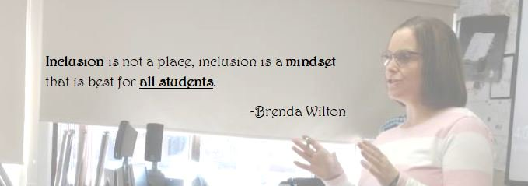
- What your plan was for the year (this can be subject specific, or more of your general approach to all subjects)
- Something new you tried this year (this is wide open)
- How your assessment practices informed students & parents (beyond progress reports)?

Guidelines:
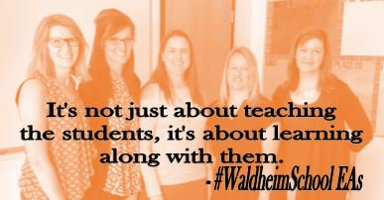
- Try to fall between 10 – 15 minutes
- Try to think about what others will learn because you were presenting
- Your presentation can be as interactive as you wish
- Please try to include a little bit of feedback from parents and/or students

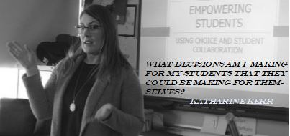
2018-19 Waldheim School Professional Staff Book Club
Softening the Edges ~ Katie White
Katie White is a Saskatchewan educator who has worked for the North East School Division (NESD). While at NESD, Katie was a teacher, administrator, and system leader who brings a perspective I’m sure we will all be able to identify with.
At Waldheim School, our over-arching goal is to develop a deeper understanding of every student we work with. This year, we narrow our focus to assessment. How we use assessment to drive learning is something we will continue to discuss this year as we build on the incredible work that has been done at Waldheim School for many, many years.
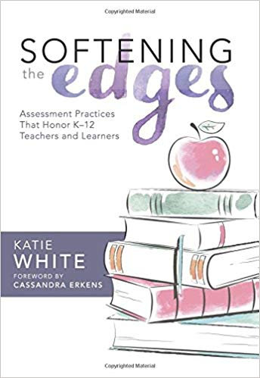
We do this work in an effort to improve our teaching so we can better meet the needs of every learner in our building. It is hoped that this book will prompt you to think about the work you have been doing around assessment for and of learning. Through self-reflection and collegial conversations, we hope that 2018-19 will be your most successful year yet!
Staff Meeting Thoughts:
- Small Group Meetings (K-4, 5-8, 9-12)
  - Chapter assigned to be read
  - All group discussion
    - Predetermined questions
      - Initial thoughts
      - Quotes that resonate
      - Impact
      - Evidence
    - Final Thoughts
      - Round table discussion on reading
- All Staff Meetings
  - Small groups with representation from each small group
    - Discussion:
      - What has been talked about in the small groups?
      - What are the common threads?
      - Impact
      - Evidence
    - Final Thoughts
      - Bring all groups back together with one spokesperson for each group sharing thoughts/questions

