Biology 30 Animal System Project

In this project, your group task will be to teach the rest of the class about the topic that you choose. To teach the class you should have some type of presentation (multimedia, video, role play, etc.) and some sort of key point informational document that can be given to all other students. Please note that these projects will make up your course information on each of these topics, so you should try to be sure to meet the objectives for each topic in the list below.

- Describe the functions and functioning of nervous systems

- Describe the structure of a neuron.

Neuron:
- information processing units of the brain responsible for receiving and transmitting information
Dendrites:
- tree-like extensions at the beginning of a neuron
- helps increase surface area of cell body
- covered in synapses
- receives information
- transmits information using electrical stimulation to the soma
Synapse:
- substance that allows a neuron to pass an electrical current to another cell
- crucial to function of the neuron
Soma:
- where signals from dendrites are joined and passed on
- doesn’t play active part in transmission of signal
- Keeps neuron functional (maintains it)
Nucleus:
- “architect” of cell
- Contains genes
Axon Hillock:
- Located at end of the soma
- Controls firing of neuron
- If the strength of the signal is greater than the axon hillock’s threshold limit, then it will fire a signal down to the axon
Axon:
- Elongated fiber that extends from the cell body to terminal endings
- Transmits neural signal
- The larger the axon→the faster it transmits the information
- (Some) are covered with a fatty substance called myelin
- Most neurons only have 1 axon
Terminal Buttons:
- Located at the end of neuron
- Sends signal to other neurons
- Also has synapses at end
- Neurotransmitters are used to carry the signal across the synapse
Neurotransmitters:
- Chemical messenger
- Carries, boosts, and modulates signals between neurons and other cell
Myelin Sheath:
- Fat containing cells that insulate/protect the axon from electrical activity
- Increases rate of signals
Nodes of Ranvier:
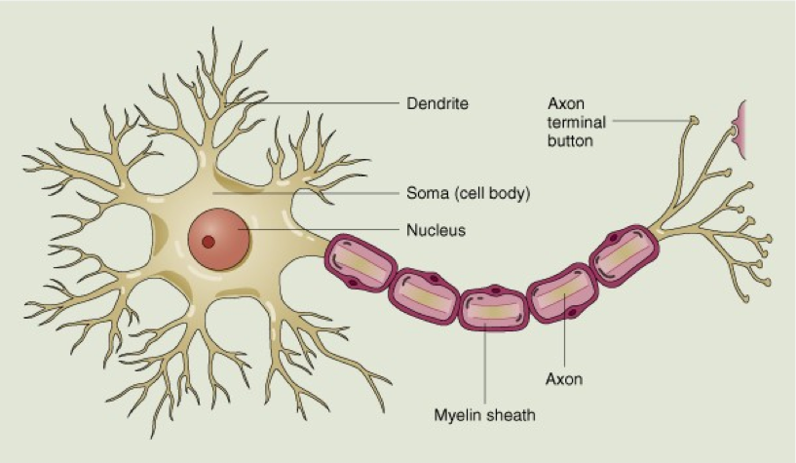
- Gaps formed between myelin cells
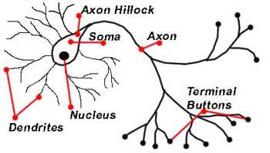

- Explain how neurons transmit impulses within and between themselves.
- Compare the complexity of nervous systems in the planaria, earthworm, and human.

Nervous System- the part of the body that controls voluntary or involuntary movements and sends signals to the body.
2 PRIMARY FUNCTIONS- one sensory receptor allows the body to monitor its environment around them and detect changes, like changes in temperature. Secondly the nervous system regulates the internal environment, controlling heart rate, and measuring nutrient levels.
Every nervous system carries out the same function the complexity varies between organisms.
VERTEBRATES- this system has two main divisions: the central nervous system, consisting of the brain and spinal cord; and the peripheral nervous system, the autonomic or involuntary nervous system. These systems can contain a trillion neurons.
INVERTEBRATES- don’t have distinctive peripheral and central regions. Much less complex, only contain as few as 305 neurons. These organisms typically do not have a backbone. I.e.) insects, worms, jellyfish, spiders.
EARTH WORMS- This organism is an invertebrate. Neuron cells grouped into clusters are called ganglia. The earthworm has a simple but sensitive nervous system. The brain is connected to the ventral nerve cord that runs down the length of its body. At each segment ganglia will branch off, connecting every segment to the brain. Every segment has to be coordinated to control the muscle contractions that cause movement. This make the earthworm very sensitive to light, touch, moisture, chemicals, temperature, and vibrations.
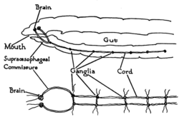

Planarians- This organism is an invertebrate. The nervous system of a planarian resembles a ladder. It has two nerve cords with a brain at the anterior end. Transverse cords that connect the two cords keep the movements of the two sides coordinated.
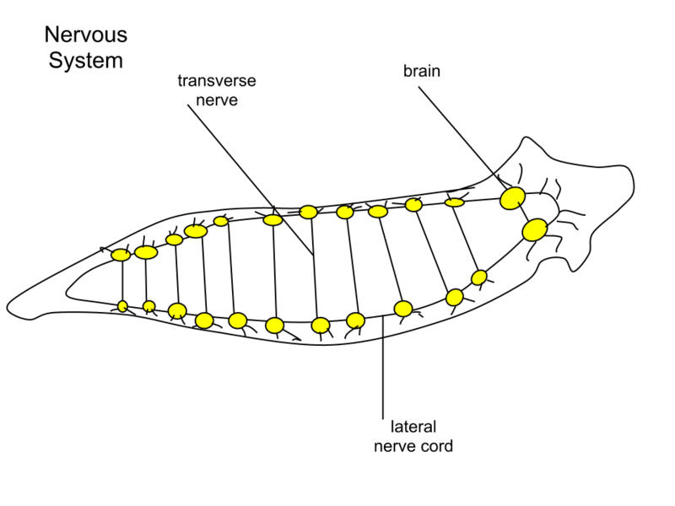
Humans- Humans have a vertebrate system, more complex. Has a larger number of neurons and a bigger nervous system. Has a more complex brain, have three regions: hind brain, midbrain, and forebrain. The hindbrain controls the coordination of motor reflexes and regulation of blood pressure and heart rate. The midbrain is dedicated to visual processing and some motor control. The forebrain integrates all incoming sensory information and directing a response.
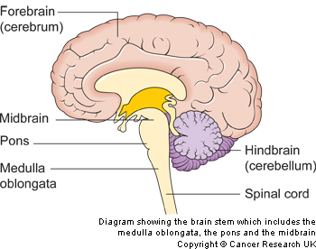

- Contrast the functions of the central nervous system and the peripheral nervous system in humans.

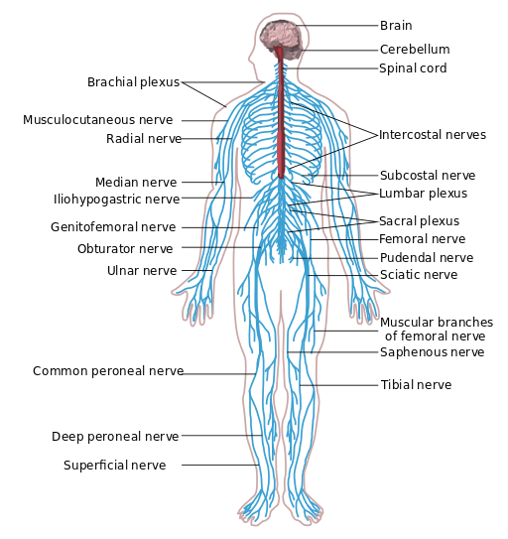
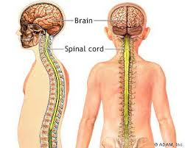
The central nervous system the peripheral nervous system

Includes nerves outside of the spinal cord and the brain.
Connects the central nervous system to the limbs and organs.
Not protected by and bones or spine.
Runs out from the spine.
Acts as a transporter from the brain to every part of your body.

Consists of the spine and the brain.
Moves the information from the peripheral nervous system to the brain.
Protected either by the spine or the skull.
Only way to connect the brain to the rest of your body.
Uses small electrical charge.

- Compare the structure of the brains of reptiles and humans.

Comparing the Structure of the Brain in Reptiles and Humans
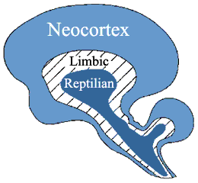

There is a theory that states that the human brain evolved from reptiles. This theory developed by Paul MacLean, is called the Triune Brain Theory. According to him, the three separate brains developed in sequence through the course of evolution and now work together in the human skull.
Of these three brains, the reptilian brain is the oldest. The reptilian brain controls the body’s main functions such as heart rate, breathing, body temperature and balance. The main parts found in the reptilian brain are what is found in a reptile’s brain; which is where the name reptilian comes from. The reptilian brain consists of the brainstem and the cerebellum.
The limbic brain, appeared in the first mammals to ever live. This part of the brain records memories and behaviours that produce agreeable and disagreeable involvements. The limbic brain is responsible for our emotions. The main structures of this part of the brain are the hippocampus, amygdala, and the hypothalamus. This part of the brain is the key method that allows us to make base our judgements; this has an impact on influence on our behaviour.
Next is the neocortex brain; it was assumed to have evolved from primates and concluded in the human brain. The neocortex brain has two cerebral hemispheres that play a huge part in the neocortex brain. They are responsible for the human development of language, thought, imagination, and consciousness. What is great about the neocortex is that it has almost endless learning abilities. It has also empowered human cultures to develop over time.

http://thebrain.mcgill.ca/flash/d/d_05/d_05_cr/d_05_cr_her/d_05_cr_her.html

- Explain how the human endocrine system influences body development and maintenance

- Describe the general structure of hormones.
-Steroid hormones are fat-soluble molecules made from cholesterol. Among these are the three major sex hormones groups: estrogens, androgens and progesterones. Males and females make all three, just in different amounts. Steroids pass into a cell's nucleus, bind to specific receptors and genes and trigger the cell to make proteins.

-Amino acid derivatives, such as epinephrine, are water-soluble molecules derived from amino acids (the building blocks of protein). These hormones are stored in endocrine cells until needed. They act by binding to protein receptors on the outside surface of the cell. The binding alerts a second messenger molecule inside the cell that activates enzymes and other cellular proteins or influences gene expression.

-Insulin, growth hormone, prolactin and other water-soluble polypeptide hormones consist of long chains of amino acids, from several to 200 amino acids long. They are stored in endocrine cells until needed to regulate such processes as metabolism, lactation, growth and reproduction.

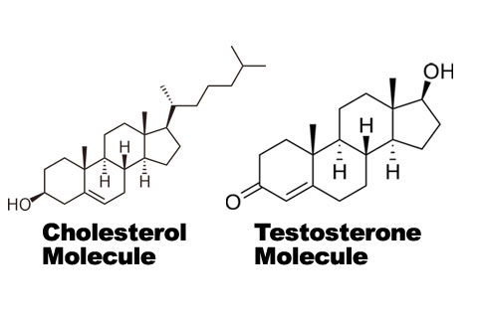
Many more examples of hormone structures in booklet from first Bio unit.

- Describe the influence of the pituitary gland on body processes and on other glands.
- Discuss the relationship between insulin and the body's control of blood sugar levels in the two forms of diabetes.
Type 1
- The body does not produce insulin and must be provided by injects or a pump
- Regulate sugar in your bloodstream
- Storage of excess glucose for energy
- Glucagon important to maintaining the body’s sugar and fuel balance
Type 2
- Body produces insulin but does not use it properly, so it requires pills or injections
- Fat, liver, and muscle cells do not respond correctly to insulin
- Blood sugar does not get into these cells to be stored for energy.

- Outline the functions of hormones produced by several other glands.
- Thyroid Gland
  - Butterfly shaped gland located in the neck
  - Produced three major hormones:
    - Calcitonin
      - Reduces the concentration of calcium ion levels in the blood by aiding it in being absorbed by the matrix of bones
    - Triiodothyronine (T3)
- T3 and T4 world together and regulate the body’s metabolic rate
- More T3 and T4 leads to increased cellular activity and energy usage

    - Thyroxin (T4)
- Parathyroid Glands
  - 4 small masses of glandular tissue
  - Found on the back of the thyroid gland
  - Produces the parathyroid hormone (PTH)
    - Increases the levels of calcium ions in the blood by breaking down the calcium in the bone matric
    - Also tells kidneys to return calcium ions that it filtered out into the blood stream
- Thymus Gland
  - Soft, triangular-shaped organ
  - Found in the chest behind the sternm
  - Produces Thymosins
    - Helps train and develop T-lyphocytes during fetal development and childhood
    - Becomes inactive during puberty and is slowly replaced by adipose tissue throughout life
- Pancreas
  - A large gland
  - Located in the abdominal cavity behind and below the stomach
  - Considered to be a heterocrine gland because it contains both endocrine and exocrine tissue
  - 2 types of Langerhans islets
    - Alpha
      - Produce the hormone glucagon
        - Responsible for raising blood glucose levels
        - Glucagon triggers muscle and liver cells to break down Glycogen to release glucose into the blood stream
    - Beta
      - Produces insulin
        - Lowers blood sugar levels
        - Triggers the absorption of glucose from the blood into cell where it is added to glycogen molecules for storage
- Pineal Gland
  - Is a small pinecone shaped gland that is located in the brain
  - Produces melatonin
    - Regulates the human sleep-wake cycle AKA the circadian rhythm
  - Production of melatonin inhibited by light, and is more active in low light or darkness
  - Increased melatonin production at night cause humans to feel drowsy
- Suprarenal (Adrenal) Glands
  - Are roughly triangular glands
  - Are directly above the kidneys
  - Two Parts
    - Adrenal cortex
      - Produces three cortical hormone classes
        - Glucocorticoids
          - Main functions include the breakdown of proteins and lipids into glucose
          - Also reduces inflammation and immune response
        - Mineralocorticoids
          - Regulate the mineral ion concentration in the body
        - Androgens
          - Include testosterone
          - Are produced at low levels in adrenal cortex
          - Regulate growth and activity of cells receptive to male hormones
    - Adrenal medulla
      - Produces the hormones epinephrine and norepinephrine
        - Both help to increase the flow of blood to the brain and muscles
        - Improves the “flight-or-flight” response
        - Also work to increase heart rate, breathing rate, and blood pressure, while decreasing the flow of blood to and function of organs that are not involved in responding to emergencies

Check out this link for interactive pictures and more information on all the glands in the human body
http://www.innerbody.com/image/endoov.html

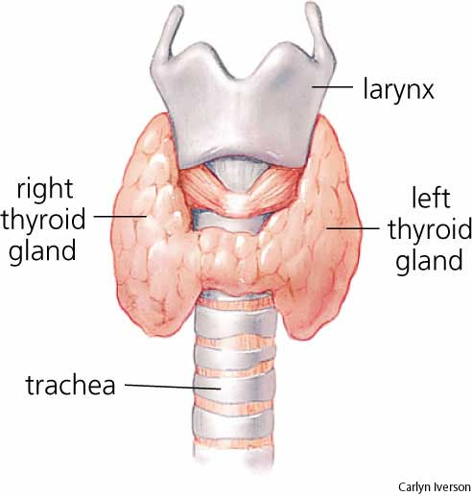
THYRIOD GLAND
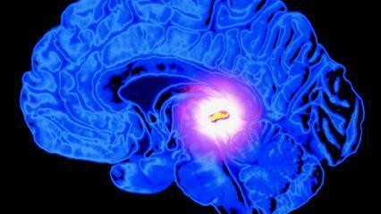
PINEAL GLAND

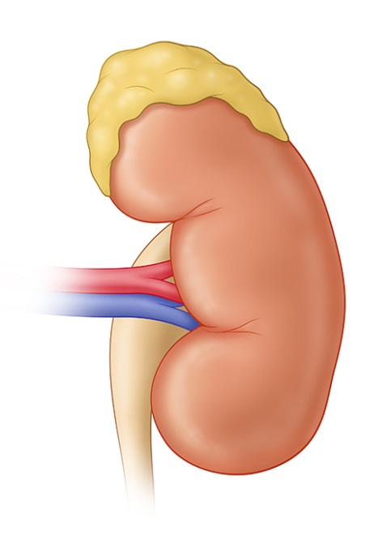
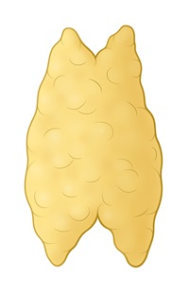
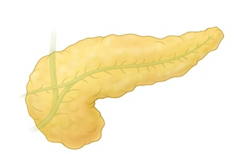
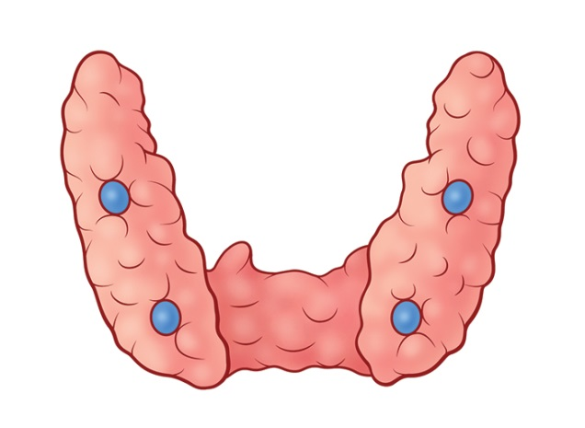
SUPERARENAL (ADRENAL) GLANDS
THYMUS
PANCREAS
PARATHYRIOD GLANDS

References
Anawalt, B., Kirk, S., & Shulman, D. (Eds.). (2013, May 1). Endocrine Glands and Types of Hormones. Retrieved December 4, 2014, from http://www.hormone.org/hormones-and-health/the-endocrine-system/endocrine-glands-and-types-of-hormones
Kai, N. (2012, August 22). Foods that Feed The Pineal Gland. Retrieved December 5, 2014, from http://consciouslifenews.com/wp-content/uploads/2012/08/Pineal-Gland-Third-Eye-Stargate-buddy-huggins-426x240.jpeg
Taylor, T. (n.d.). Endocrine System. Retrieved December 4, 2014, from http://www.innerbody.com/image/endoov.html

- Describe how nutrients and oxygen are moved to the body cells.

- Review the principles of diffusion and active transport.

Diffusion

- Random motion of Kinetic energy is the process which molecules spread from areas of high concentration, to low areas of concentration
- When the molecules are throughout a space, it’s at equilibrium
- The molecules are in one spot starting out but whit time eventually move and spread out within the object

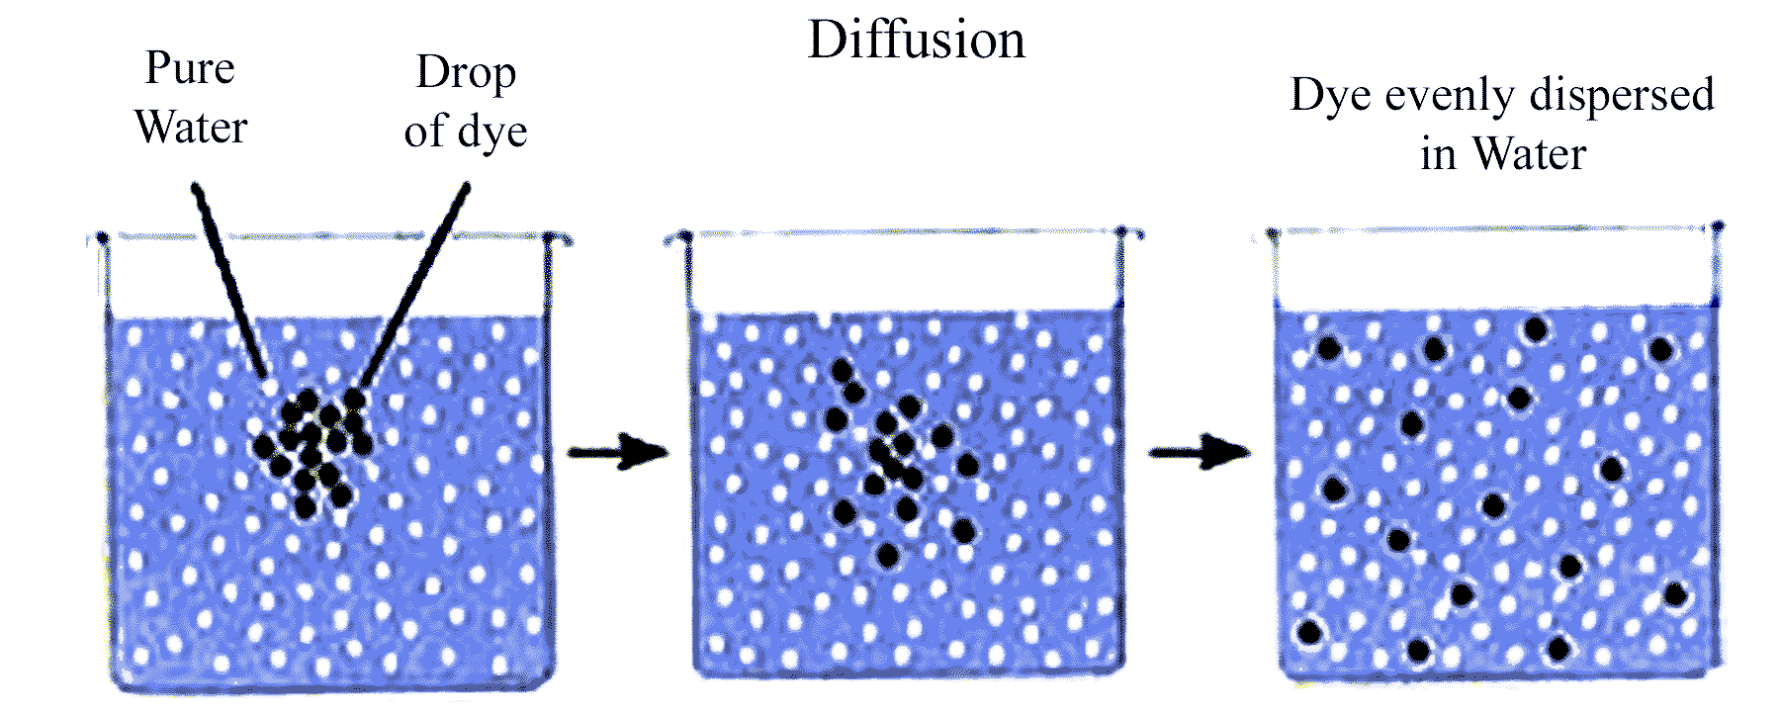

Active Transport

- It’s a movement of molecules that are across the cell membrane in the direction of their concentration ramp
- Active transport is when molecules go from a low area of concentration to a high area of concentration
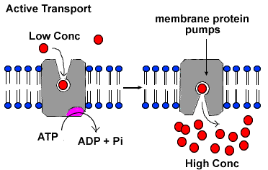

- Contrast passive transport systems, as in the cnidaria, with active transport systems, such as the human blood circulation system.
- Compare open circulation systems, as in the grasshopper, with the closed systems of vertebrates. – On the website

- Compare the efficiencies of hearts with one, two, three, and four chambers.

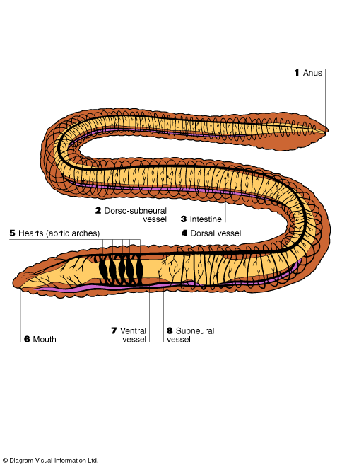
- Aortic Arches (earthworms(annelids) and Sea Cucumbers (echinoderms)
- The muscular arteries joining the dorsal and ventral work as a single chambered heart meaning that as soon as blood enters, it is pumped back out.
- There is no holding place, only continued movement and pumping.

http://www.sas.upenn.edu/~rlenet/Earthworms.html
Diagram bigger on this website

- 2 Chambered (fish)
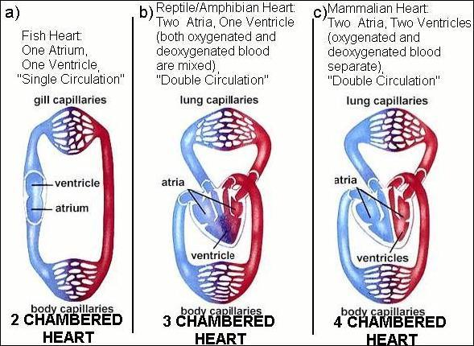
- Blood enters the heart through the sinus venosus (large vein), to the atrium, and then to the ventricle. From the ventricle, the blood is pumped out to the body through a large artery towards the gills. First capillaries are at the gills, second at the body cells and tissues.
- This is single circulation because the blood passes through the entire body before it reaches the heart again.
- The result is that the blood can be oxygen poor, decreased fluid pressure and a low efficiency of oxygenated blood delivery.
http://www.ideacenter.org/contentmgr/showdetails.php/id/113
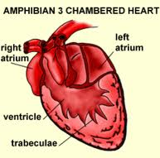
Diagram bigger on this website

- 3 Chambered (Amphibian and Reptile)
- First level of double circulation, the blood is pumped out to one loop where it goes through capillaries in the lungs for oxygen exchange, and then returns to the heart to be pumped out to the body.
- The heart now has two atriums; the right receives blood from the body, the left from the lungs.
- There is only one ventricle, all blood is mixed in the ventricle before being pumped to the lungs or the body. The result is an increase in fluid pressure, an increase in oxygen rich blood as well as efficiency in oxygen delivery.

http://education-portal.com/academy/lesson/three-chambered-heart-definition-anatomy-quiz.html#lesson

- 4 Chambered ( birds and mammals)
- These hearts are again double circulation and highly efficient because there are two atriums and two ventricles. Oxygen rich blood does not mix with oxygen poor blood. Blood goes from the right atrium, to the right ventricle, to the lungs, to the left atrium and finally to left ventricle. From the left ventricle it gets pumped to the body.
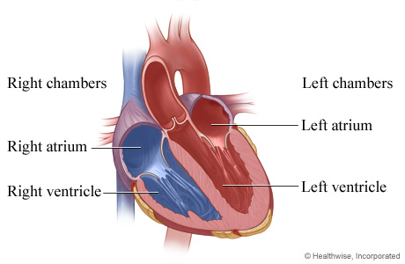
- The result is an increase in fluid pressure, an increase in oxygen rich blood and in the efficiency of delivery.
- Considered the most efficient system.

http://www.webmd.com/heart/chambers-of-the-heart
Diagram bigger on this website

- Describe the blood circulation pattern and vessels in the mammalian systems
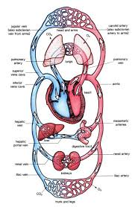
The circulatory system consists of 3 parts:
- Blood-composed of tissues in plasma fluid
- Blood vessels that carry blood
- A pumping organ, Heart.
Mammal circulatory system is divided into 2 parts, pulmonary and systemic.
Pulmonary carries deoxygenated blood from the heart to the surface in the lungs.
The blood is reoxygenated in the lungs and then pumped back into the heart.
Systemic circuit carries oxygenated blood throughout the body to all the cells using the arteries. It also pumped the deoxygenated blood back to the heart through veins.
This system works because it uses the 2 ventricles to power each circuit.
Look at the picture for the pattern uses.
Blood Vessels- They are hollow, tube-like vessels that move the blood throughout the body. Blood Vessels are divided into 3 different types: arteries, capillaries, and veins.
Arteries replicate elastic vessels. They are in charge of carrying blood away from the heart.
Capillaries are the thinnest blood vessels. The job of capillaries is to take the blood from the arteries to the capillaries.
Veins after going through the capillaries and venules they go through veins. Veins take the blood back to the heart. They have a low pressure inside the vein and can only carry the blood at a slow pace. They use valves that close to keep the blood flowing in the right direction.

Sites
http://www.tutorvista.com/content/biology/biology-iv/circulation-animals/components-circulatory-system.php#
http://www.google.ca/url?sa=i&rct=j&q=&esrc=s&source=images&cd=&cad=rja&uact=8&ved=0CAYQjB0&url=http%3A%2F%2Fwww.elateafrica.org%2Felate%2Fbiology%2Ftransportanimals%2Ftransportinanimalsintro.html&ei=u2GSVPHrHYf9yQTK7oG4BA&bvm=bv.82001339,d.aWw&psig=AFQjCNFRSHzIpWKjuJ3g3LZbrCtytcOtiw&ust=1418965804235852

- Explain the functioning of the human circulation system.

- Describe the functions of the heart, lungs, kidneys, and liver in the circulation system .
Functions of the Heart – The heart is a muscular pump. Its main function is to propel blood throughout the body. It usually beats 60-100 times per minute but can pump faster if necessary.
Functions of the Lungs – The chest contains two lungs, one on the right and one on the left. The purpose of the lungs are to bring oxygen into the body and remove carbon dioxide. Oxygen is the gas that provides energy to the body.
Functions of the Kidney – The kidneys are two bean shaped organs that reside against the back muscles on either side of the spine. The kidneys remove waste from the blood, balance body fluids and form urine.
Functions of the Liver – The liver is the second largest organ in the body, only second to the skin. The liver performs many functions related to digestion, metabolism, immunity and the storage of nutrients within the body.
Function of the Circulatory System – the circulatory system transports blood and oxygen from the lungs to various tissues of the body. The heart pumps blood around the body. The circulatory system aids the immune system.

- Describe the ABO and Rh typing systems for human blood.
Describe ABO and Rh typing for human blood.
Blood Transfusion
Blood Types
Your blood is identified by certain markers called antigens which are attached to your red blood cells and in the plasma that allow your body to recognize blood as its own. If other blood types enter your body, your immune system recognizes this and sees it as a threat. Your body will then attack the different blood type and a transfusion reaction happens.
ABO blood type systems

The ABO blood system consist of four blood types, type A, type B, Type O, and type AB blood types. People with type A blood have antibodies in their blood that are against type B blood and people with type B blood have antibodies in their blood that are against type A blood. People with type AB blood do not have any antibodies against type A or type B blood. Type O blood has antibodies for type A and type B blood. This means if a blood type has antibodies against a blood type it will attack that blood type if it enters the body. Type O blood is recessive so it can be given to any of the blood types A, B, or O. Mismatches with the ABO and Rh types is very dangerous and usually life threatening. These blood types are inherited from previous generations.
Rh systems

The Rh blood system is the second most important blood system in the human body. The Rh blood system consist of fifty defined blood antigens. The five antigens that are found in this system are D, C, c, E, and e. Your blood type can either be Rh positive or Rh negative. This only refers to the D antigen. If you do not have a D antigen in your blood then you are Rh negative. If you have a D antigen then you are Rh positive. Rh positive and negative have antibodies as well. If a person with Rh positive blood receives Rh negative blood nothing will happen because the D antigen is the dominate antigen. However if a person with Rh negative blood receives Rh positive blood then a transfusion reaction happens which means the Rh negative blood will attack the Rh positive blood. These transfusion reaction are very dangerous and can even be life threatening.

Minor blood types

There are over 100 known blood types. Most of them are not that important and have little effect on Transfusion reactions.

References
http://www.webmd.com/a-to-z-guides/blood-transfusion-blood-types
http://anthro.palomar.edu/blood/ABO_system.htm
http://en.wikipedia.org/wiki/Rh_blood_group_system

- Consider the role of the blood in the immune system and the effect of the human immunodeficiency virus on the T4 cells of the blood.
Role of the blood in the immune system
The immune system is significant to the body. It recognizes and protects the body from bacteria, viruses, and materials that appear detrimental
- Has certain types of white blood cells
- White blood cells include chemicals and protein
- A few of these attack foreign materials in the body and some work together to aid the immune system
Lymphocytes are types of white blood cells. Within the Lymphocytes there are B and T type
- B lymphocytes are cells that make antibodies.
- T lymphocytes attack antigens, release chemicals, and help control the immune response.
Roles Lymphocytes perform
- Lymphocytes decipher the difference between your own body tissues and substances that are not commonly found in the body.
- When B cells and T cells form, some of them will multiply and produce memory for the immune system
- When this takes place, the immune system will be able to respond faster and will be more effective the next time the body is exposed to the same antigen
- In other words this will prevent the individual from contracting a sickness
The effect of the human immunodeficiency virus on the T4 cells of the blood.
- HIV is a harmful virus that attacks the white blood cells of the immune system. HIV causes the immune system to weaken and as a result the body cannot defend itself against numerous bacteria, viruses and other germs.
- HIV stands for “human immunodeficiency virus”
- With the HIV virus, the number of T helper cells that are in the blood will gradually reduce and after a number of years the immune system will be weakened
- From this taking place AIDs will develop.
- AIDS stands for “acquired immune deficiency syndrome”
- It is where the HIV virus has killed so many T helper cells and as a result the immune system can no longer decipher and react to attacks from infections
http://www.patient.co.uk/health/hiv-and-aids
http://www.netdoctor.co.uk/diseases/facts/hiv_aids.htm
http://www.nlm.nih.gov/medlineplus/ency/article/000821.htm

Natasha

- Research the use of artificial hearts, heart transplants, and circulation machines used during open-heart surgery.
The heart
- It is a simple organ
- Muscles pumping blood throughout the body
- Veins bring the deoxygenated blood back to the heart and the arteries pump the oxygenated blood throughout the body
- But it is hard to imitate using synthetic material and power supplies.

*Question*: research the use of artificial hearts, heart transplants, and circulation machines used during open-heart surgery

Use of Artificial heart
- The prosthetic device that is implanted to replace the original heart.
- It’s kind of like a cardiac pump( external device used to provide function for heart and lungs)
- The cardiac pump is not connected to both blood circuits
- The pump lasts for a few hours but the artificial heart could last up to 17 months!
- Artificial heart is trying to bring our medical procedures up to date and more modern
- Benefit: lower the need for heart transplants and donors.
www.sciencedaily.com/articles/a/artificial_heart.htm
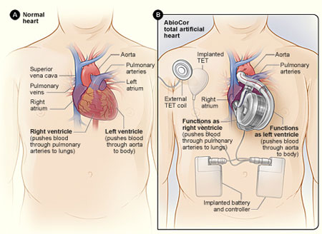
Use of heart transplants:
- The surgeon removes a diseased heart and replaces it with a donor heart
- The donor must be declared brain-dead in order to take the heart
- If someone were to need heart transplant, a doctor needs to know 110% if the procedure is needed.(failure could result in death)
- The reason: heart transplant is done to replace a failing heart this is not treatable.

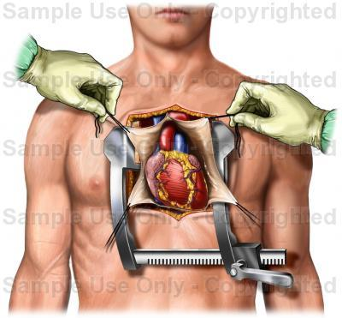

Use of circulation machines in open heart surgery
- Cardiopulmonary Bypass Machine(CPB)
- Cardiopulmonary Bypass: bypass of the heart and lungs as in open heart surgery
- This machine makes the blood go throughout the body while the heart is going under surgery
- Before the blood returns to the heart, it goes through a heart-lung machine(it pumps oxygen) before it returns to the arterial circulation
- This machine pumps blood for the heart and supplies oxygen to the red blood cells

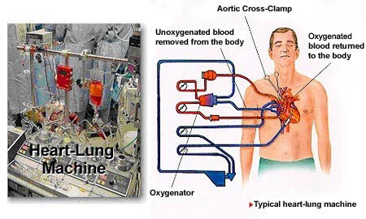
- Discuss respiration by relating the activity to the physical structure like the lungs and blood and the cells fed by the blood.

- Compare reproductive strategies among animal phyla.

- Contrast the advantages and disadvantages of asexual reproduction with those of sexual reproduction.
Advantages of Asexual Reproduction: It takes less energy and is time efficient as there is no need for a partner.
Disadvantages of Asexual Reproduction: If the organism has a genetic disease the offspring will also have it. There is also very little genetic variation.
Advantages of Sexual Reproduction: There is variation in the offspring. The organism gets more protection because of two parents.
Disadvantages of Sexual Reproduction: Requires two organisms and is less time efficient. More energy is required.
Reference
http://www.diffen.com/difference/Asexual_Reproduction_vs_Sexual_Reproduction

- Compare external fertilization with internal fertilization.
External Fertilization
External Fertilization is the act of fertilizing (conception) of a sperm cell with an egg cell in a closed area rather than inside the body. External fertilization occurs mostly in wet environments and requires both male and female to release their gametes into their surroundings. For External fertilization to occur, water is needed. An advantage to external fertilization is that it results in a large amount of offspring. The disadvantage of that being that environmental hazards like predators greatly reduce the chance of survival.
Fish and amphibians like frogs are examples of animals that produce using external fertilization.
*Gametes: reproductive cells are sex cells that unite during sexual reproduction to form a cell, known as a zygote. In humans, male gametes are sperm and in females, ova or eggs.
Internal Fertilization
Internal Fertilization is the act of fertilizing a sperm cell with an egg cell in the body, or within an egg that is outside the body. Animals like reptiles or birds fertilize their young in a protective shell that resists water loss and damage. This step of protection is taken a step further in mammals, as the embryo develops within the mother.
Examples of Internal:
Humans, Birds, Reptiles.
The only difference between humans and birds being that humans fertilize the embryo inside the body, rather than the embryo coming out of the body in a protective shell.

- Describe fertilization in the earthworm.

a special slimy substance is produced by the clitellum (some call this the sex band) the slime forms a tube around the earthworm. Then he crawls backwards into his tunnel and the slime tube slips forward off of his body. As it does, it passes over the male and female openings, the eggs (from the parent) and the sperm (from the mate) are released from the body. Fertilization takes place outside of the body, but within the protection of the slime tube. Once free in the soil, the slime tube dries, shrinks and forms a protective covering over the eggs. It is now called a cocoon.

Taken from - http://zannr.hubpages.com/hub/Earthworms-and-Reproduction

- Compare the amniotic egg of reptiles and birds with the structures which form in the uterus of a pregnant mammal.

- Discuss human reproductive strategies.

- Describe the production of semen in humans.
Semen is a liquid that has sperm cells. Semen has other liquids that helps keep sperm alive. You will learn how semen is made in the male reproductive system. Sperm is made by the testes and takes up 2 to 5 percent of semen volume. The sperm makes its way through the reproductive system and gets washed with liquids. After it is done this process, sperm is kept in the epididymis. When the sperm is mature, it moves through the ductus, which is a long tube, and stored in the ampulla. In the ampulla, oxygen is removed and fructose feeds the sperm. When ejaculation occurs, fluids from the prostate gland and seminal vesicles are added to the sperm to dilute the amount of sperm. The fluids provide a place for the sperm to live in. The seminal vesicles produce 60 percent of the fluid in semen. The prostate gland makes 30 percent of the fluid. For the sperm to move, there is potassium and magnesium, some oxygen, proper temperature and a slightly alkaline pH of 7-7.5. Sulfate helps keeps the sperm from expanding. Each ejaculation contains 200 to 300 million sperm cells.
For a more in depth look into semen, you click on the link below.
http://www.britannica.com/EBchecked/topic/533862/semen
Check out this video link below which shows the production of semen.
http://www.pennmedicine.org/encyclopedia/em_DisplayAnimation.aspx?gcid=000120&ptid=17

- Describe the human female reproductive cycle from ovulation to either menstruation or implantation.
Menstruation begins the first day of a lady’s period, which can last 3-7 days; & within the first couple of days, there are period pains. This is due to hormones causing the womb to shed the lining that had built up in a previous menstrual cycle. At the start of a period, follicle-stimulating hormone (FSH) which is produced by the pituitary gland in your brain & is main hormone in stimulating your ovaries to produce eggs. Follicles are the fluid-filled cavities in a woman’s ovaries, & they each contain one undeveloped egg. FSH stimulates follicles to make them develop & start to produce the hormone estrogen.
When a number of follicles initially begins to develop, & usually one becomes “dominant” & that egg matures. All the while, estrogen builds up & increases in a woman’s body to make sure that the lining of the womb is thick with nutrients & blood (in case a woman’s egg is fertilised, this allows it to have the proper nutrients to grow). In ovulation, there is a rise in luteinising hormone; this causes the dominant follicle to rupture & release the egg from the ovary from which it enters the fallopian tube.
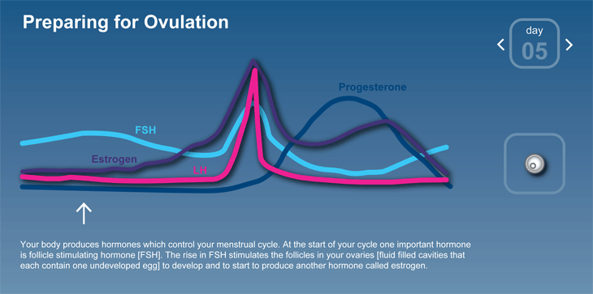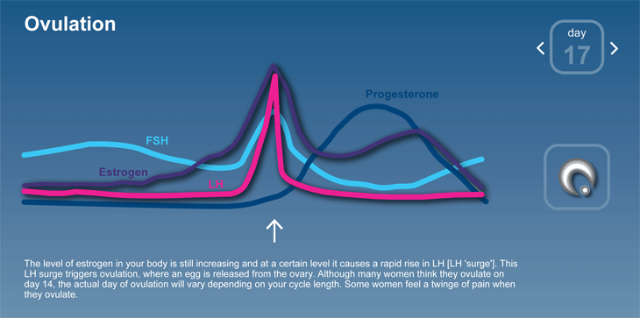
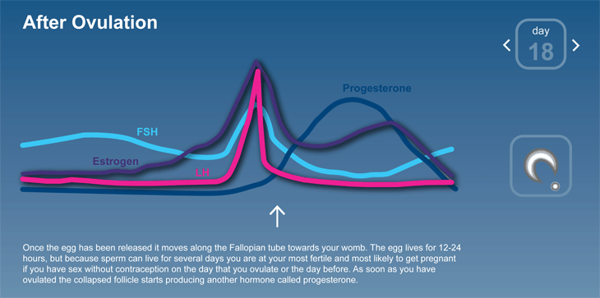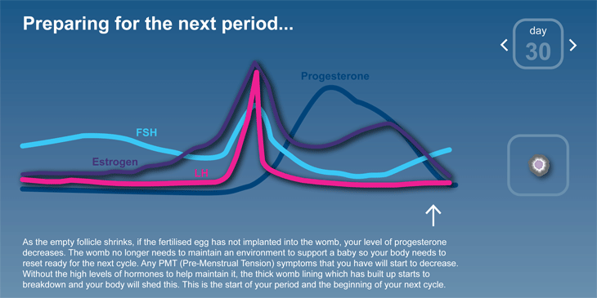

- Trace the major developmental events from implantation of a fertilized egg to the birth of a human baby.
Conception:
- egg gets released from the ovary
- sperm penetrates the egg
- genetic makeup is complete, which includes sex
- within 24 hours, egg starts forming into many cells
- within three weeks, baby’s first nerve cell is formed

First Trimester (1st, 2nd, and 3rd months):
- brain spinal cord and other organs begin to form
- baby’s heart begins to beat
- toes and fingers begin to take shape
- mouth, lower jaw, and throat are developed
- facial features continue to develop
- digestive tract, and sensory organs begin to develop
- embryo begins to move
- baby is fully formed
- teeth are beginning to form
- gender is still difficult to distinguish
- 3-4inches long by the end of the trimester
- 1 ounce in weight by the end of the trimester

Second Trimester (4th, 5th, and 6th months):
- ability to move and hear
- eyelids, eyebrows, eyelashes, nails, and hair are formed
- teeth and bones are becoming denser
- baby can suck its thumb, yawn, stretch, and make faces
- nervous system is starting to function
- reproductive organs are fully enveloped
- can tell if you are having a boy or girl
- by the end of the second trimester, baby is about 12 inches long and weighs about 2 pounds.

Third Trimester (7th, 8th, and 9th months)
- open their eyes
- changes positions frequently
- baby might starting kicking more
- most internal systems are well developed
- lungs are nearly fully developed
- baby’s reflexes are coordinated
- baby changes position to prepare itself for labor and delivery
- baby drops down to mothers pelvis
- head to usually facing down towards the birth canal
- by the end of the third trimester, baby would b around 46-51cm
- would weigh around seven pounds

Different Delivery Methods:

- Vaginal delivery
  - most common and safest type
      - sometimes they can cup your babies head, and help guide it through the birth canal
- Vacuum delivery
  - a plastic cup is applied to the baby’s head by suction and the doctor gently pulls the baby from the birth canal
- Caesarean delivery ( C-section)
  - this is needed if:
      - your baby is not in the head down position
      - your baby is too large to pass through the pelvis
      - your baby is in distress

If you would like to see the pictures of the different stages… Open the link :)

http://www.webmd.com/baby/ss/slideshow-fetal-development
- Identify the biofeedback mechanisms which are important in the regulation of the female reproductive cycle.
- Describe how the use of the hormones found in birth control pills alters the reproductive cycle.
Monophasic pills have a constant dose of both estrogen and progestin in each of the hormonally active pills throughout the 21-day cycle. These pills are least likely to cause side effects. The hormones used in birth control pills thicken cervical mucus (making it harder for the sperm to reach the egg) and alter the uterine lining which ultimately stops the egg from implanting itself.
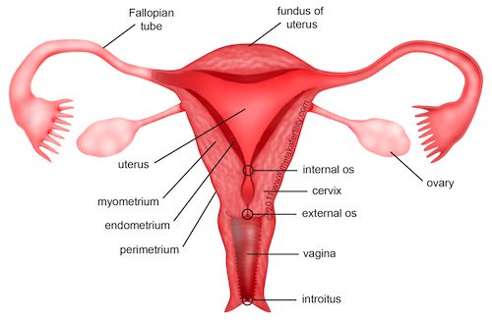

Birth Control Pills: Effects on the Reproductive System

Multiphasic pills
- contains differing doses of hormones, compared to monophasic, in the active pills
- They further differentiated by biphasic and triphasic
- Thought to emulate the body’s natural menstrual cycle and contain fewer hormones when the doses are averaged over the course of a cycle
- Tend to lower the total hormone dosage a woman receives throughout each pill pack
- The amount of progestin increases after the first third of the cycle to mimic the natural estrogen: progesterone ratio changes that occur in the menstrual cycle
- They are also designed to more naturally mimic the female body's menstrual cycle

Effects
- Alters part of the woman's reproductive system by preventing ovulation and implantation
- The hormones will prevent the release of an egg from the woman's ovaries
- Questionable whether hormonal birth control can affect fertility, birth control can cause temporary infertility to some women
- Women who use a combination birth control pill with estrogen and progestin may experience temporary infertility for two to three months after she stops taking the pills
- Can cause birth defects
- Increased risk of ectopic pregnancy (fertilized egg implants outside the uterus)
- menstrual changes, such as lighter periods or missed periods, longer periods, or bleeding or spotting between periods

- Discuss the relationship between the diet and health of the mother and the development of the fetus.
- Investigate some technologies related to reproduction, such as in vitro fertilization, use of fertility drugs, birth control, amniocentesis, genetic screening of prospective parents, sperm banks, etc.
In vitro fertilisation (IVF)-
-A process in which the egg is fertilized by the sperm outside of the body in a lab
-It is processed within 2-6 days
-Placed back into the women's uterus with the intention of pregnancy.
Fertilization Drugs-
-Fertility drug are to help enhance the chances of getting pregnant
-These drugs stimulate follicle development in the ovary's.

