How are nutrients and oxygen moved to the body cells?
A quick review of some key concepts:
- Active Transport – transport requiring energy to occur
- Passive Transport – transport not requiring energy to occur
- Diffusion – movement from high concentration to low concentration, not requiring energy
- Osmosis – a type of diffusion, only occurs with water
Why do we need a system to move things around the body?
- Transportation of nutrients, gasses, wastes, water
- Maintenance of proper internal environment
- Protection against disease
Three types of Circulatory Systems
- No Circulatory System (simple organisms like a hydra)
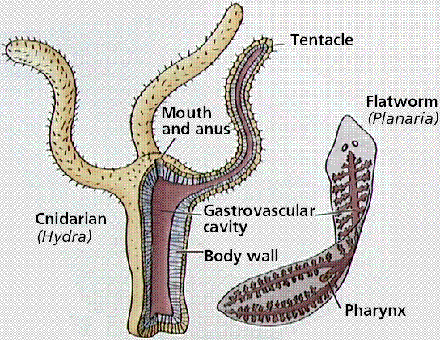
http://www.emc.maricopa.edu/faculty/farabee/biobk/biobookcircsys.html
Some very small organisms have almost all of their body cells in direct contact with the environment around them. Generally, they are only two to three cells thick and use simple diffusion to transport. Their size is greatly limited due to the fact that they need to keep contact with the outside environment. A hydra brings seawater in and allows it to circulate through the body contacted the cells allowing it to be a little larger.
- Open Circulatory System (Mollusks like snails and clams, Arthropods like shrimp and grasshoppers)
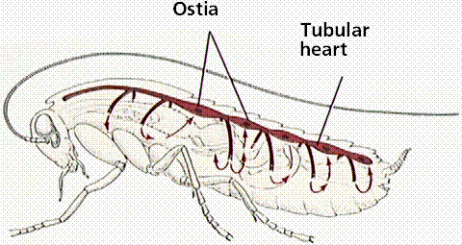Grasshopper
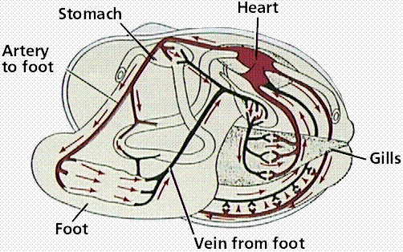Clam
http://www.emc.maricopa.edu/faculty/farabee/biobk/biobookcircsys.html
In an open system, hemolymph (blood) circulates through open ended vessels to the body cavity. It is pumped from the heart, in the grasshopper found at the rear, through arteries and then released into the body cavity to pick wastes, drop off necessities. It is not highly efficient, because the blood circulates freely, meaning it may not always get to where it needs to with what it needs at that time. Again, generally restricts the size of the animal.
- Closed Circulatory System (mammals, reptiles, birds, amphibians, fish)
In general, the blood is always contained within the system because it is pumped from the heart, through muscular arteries, capillaries, veins and back to the heart. How are the arteries, capillaries and veins all different from each other?
A closed system increases blood pressure, allows much quicker circulation of the blood and increases the efficiency of delivery. While there are differences in the type of heart that can be found in the circulatory system, the basic operation is the same.
Different hearts for closed circulatory systems
- Aortic Arches (Earthworms (annelids) and Sea Cucumbers (Echinoderms))
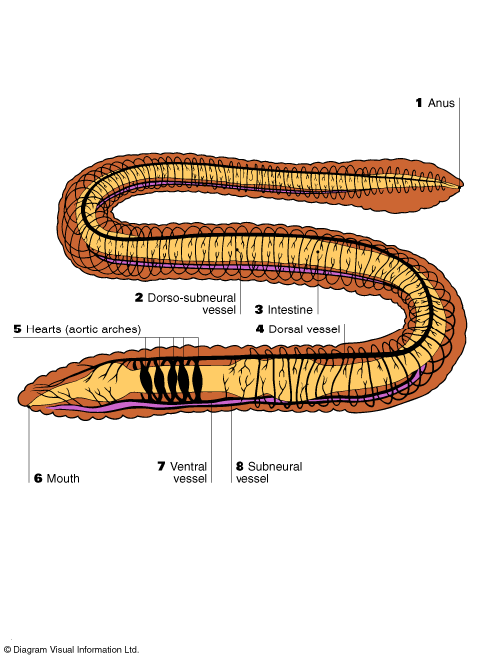
http://www.sas.upenn.edu/~rlenet/Earthworms.html
The muscular arteries joining the dorsal and ventral vessel work as a single chambered heart meaning that as soon as blood enters, it is pumped back out. There is no holding place, only continued movement and pumping.

- 2 Chambered (fish)
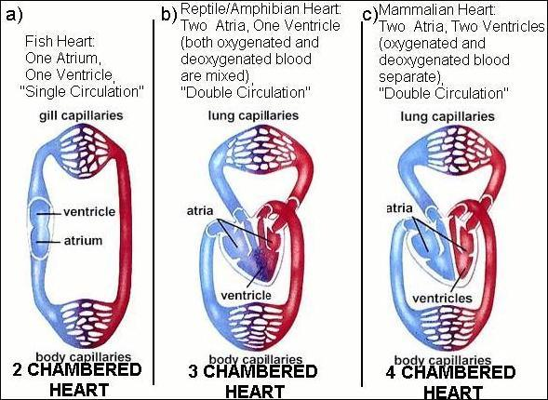
http://www.ideacenter.org/contentmgr/showdetails.php/id/1113
Blood enters the heart through the sinus venosus (large vein), to the atrium, and then to the ventricle. From the ventricle, the blood is pumped out to the body through a large artery towards the gills. First capillaries are at the gills, second at the body cells and tissues. This is known as single circulation because the blood passes through the entire body before it reaches the heart again. The result is that the blood can be oxygen poor, decreased fluid pressure and a low efficiency of oxygenated blood delivery.
- 3 Chambered (Amphibian and Reptile)
This is the first level of double circulation because the blood is pumped out to one loop where it goes through capillaries in the lungs for oxygen exchange, and then returns to the heart to be pumped out to the body. The heart now has two atriums, the right receives blood from the body, the left from the lungs. There is only one ventricle, so all blood is mixed in the ventricle before being pumped to either the lungs, or the body. The result is an increase in fluid pressure, an increase in oxygen rich blood as well as efficiency in oxygen delivery.

- 4 Chambered (birds, mammals)
These hearts are again double circulation and highly efficient because there are two atriums and two ventricles, so oxygen rich blood does not mix with oxygen poor blood. Blood goes from the right atrium, to the right ventricle, to the lungs, to the right left atrium and finally to left ventricle. From the left ventricle it gets pumped to the body. The result is an increase in fluid pressure, an increase in oxygen rich blood and in the efficiency of delivery. This is considered to be the most efficient system.
The Human Heart
Info taken from: http://www.biologycorner.com/anatomy/circulatory/notes_ch13_cardiovascular.html
Some basic terms to know about the heart:
Systemic Circulation – delivers blood to all body cells and carries away waste
Pulmonary Circulation – eliminates carbon dioxide and oxygenates blood (lung pathway)
Arteries - carry blood away from the heart
Veins - return blood to the heart
Heart Size – about 14 cm x 9 cm (the size of a fist)
Coverings of the heart
Pericardium encloses the heart (like a bag) (visceral, parietal)
Pericardial cavity – contains fluid for the heart to float in, reducing friction
Wall of the Heart – has three layers
Epicardium – outer layer, reduces friction
Myocardium – middle layer, mostly cardiac muscle
Endocardium – inner layer, blood vessels and Purkinje fibers
The following diagram shows the flow of blood through the heart.
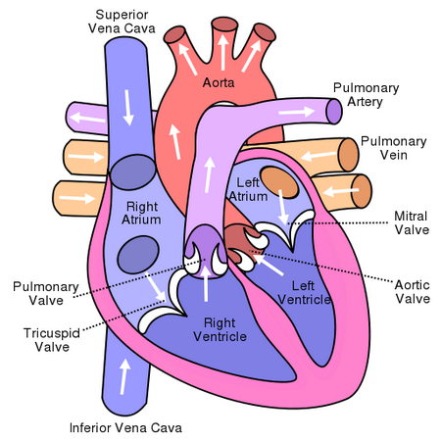

Path of Blood Through the Heart
Quick Overview
1. Deoxygenated blood enters right atrium through the vena cava
2. Blood moves into the right ventricle
3. Blood goes out the pulmonary arteries and heads to the lungs
4. Blood returns from the lungs and enters the left atrium
5. Blood moves into the left ventricle
6. Oxygenated blood moves out of the left ventricle through the aorta and to the body
Please answer the following questions:
- When did artificial hearts first get used? How do they look compared to the real thing? Can you draw a diagram and compare the two?
- How do circulation machines that are used during surgery work? Why are they used?
- Complete investigation 15.3.

