Mutations - changes in the genetic code
Point mutation: a single point in the sequence is changed. For instance a G is changed to an A.
Compare this to reading a sentence
Cats eat big rat. --> point mutation --> Cats eat big hat
The sentence is still almost recognizeable, the protein changed in this case might still function.
FRAMESHIFT MUTATION - a point mutation that involves a substitution or deletion, which results in a a shift in the reading frame.
Cats eat big rat --> add an additional letter A, and the reading frame changes
Aca tse atb igr at - this protein does not resemble the original and will probably not be functional
Chromosomal Mutations
Deletion (A)
Inversion (B)
Translocation (C)
Duplication (D)
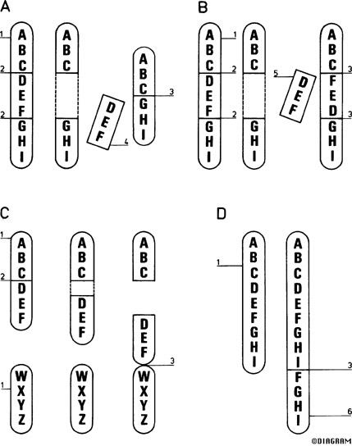

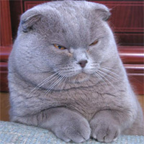
The Scottish Fold cat is a breed created from a single mutation that controls ear shape in cats.

Human Chromosomes
Karyotype = picture or pattern of chromosomes arranged in homologous pairs & organized by size (See fig. 14-1 p. 341)
Humans have 46 chromosomes
2 of these are sex chromosomes
XX = female XY = male
The other 44 chromosomes are known as autosomes

Human Traits
To study inheritance, biologists use pedigree charts
Shows relationships within a family
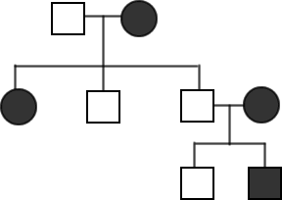
Many traits are strongly influenced by environmental factors (ex: height,personality)

Human Genes = Human genome
Our complete set of genetic info
Includes tens of thousands of genes
Genes controlling blood types were 1st genes to be identified
Most common ones are the ABO & the Rh blood groups ( + and - )

Human Genetic Disorders – Your task will be to write a quick description of each of these disorders with a focus on the cause, effects, and changes to life. You do not need to write more than 2 or 3 sentences for each one.
Recessive
Phenylketonuria (PKU)
Tay - Sachs disease recessive
Albinism
Dominant
Achondroplasia
Huntington's disease
Codominant
Sickle-cell disease
heterozygous is resistant to malaria

