Nucleic Acids
Please complete the DNA vs RNA Map Assignment.
Central Dogma – DNA to RNA Video (first video is suggested!)
http://www.bozemanscience.com/science-videos/2012/5/6/transcription-and-translation.html

The Structure of DNA
Chargaff analyzed the amounts of the four nucleotides found in DNA (Adenine, Thymine, Guanine, Cytosine) and noticed a pattern.
1. The amount of A, T, G, C varies from species to species
2. In each species, the amount of A = T, and the amount of G = C ---- Base Pair Rule
Bases come in two types: pyrimidines (cytosine and thymine) and purines (guanine and adenine)
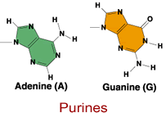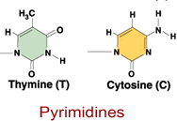
Rosalind Franklin and Wilkins spent time taking X-ray diffraction pictures of the DNA molecule in an attempt to determine the shape of the DNA molecule.
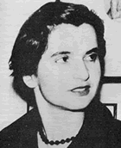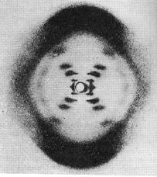
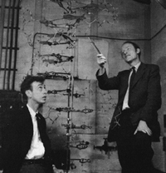
Watson and Crick are credited with finally piecing together all the information previously gathered on the molecule of DNA. They established the structure as a double helix - like a ladder that is twisted. The two sides of the ladder are held together by hydrogen bonds.
Watson & Crick Model of DNA
The sugar (deoxyribose) and phosphates make up the "backbone" of the DNA molecule.
The phosphate is attached to the 5' carbon (the 5 is a number given to sugar molecules). The DNA strand has a free phosphate on th 5' end, and a free sugar on the 3' end - these numbers will become important later.
Adenine always pairs with Thymine | Guanine always pairs with Cytosine
Side1:: A A T T G G C C A G A T A C
Side2:: T T A A C C G G T C T A T G
DNA is composed of subunits called nucleotides, strung together in a long chain -- Each nucleotide consists of: a phosphate, a sugar (deoxyribose), and a base
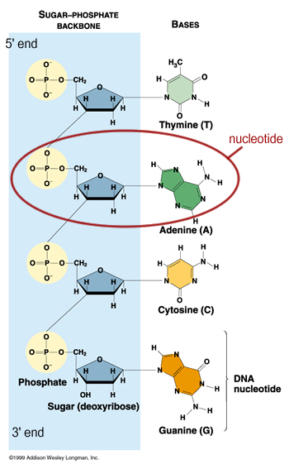
More Images:
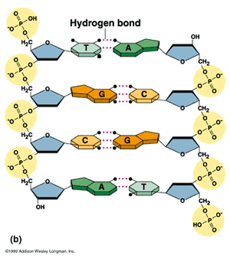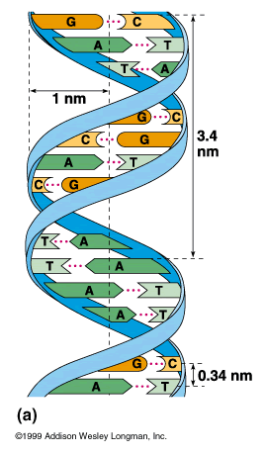

This DNA molecule is not represented well. What is wrong with it?
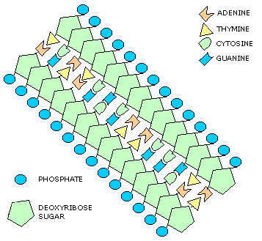
(answer: the sugar molecules are not antiparallel ^)

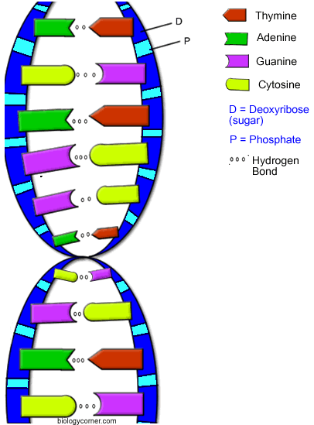

Here the 5' end and the 3' end are seen again, each side of the ladder has an opposite orientation. One side of the ladder as a free sugar (the 3'end) the other side has a free phosphate (the 5'end). This arrangement is called: ANTI-PARALLEL
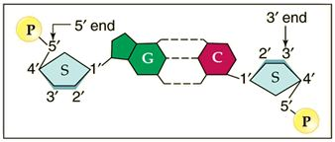

DNA Replication

http://www.biologycorner.com/APbiology/DNA/13-3_replication.html
-the process by which DNA makes a copy of itself
-occurs during interphase, prior to cell division
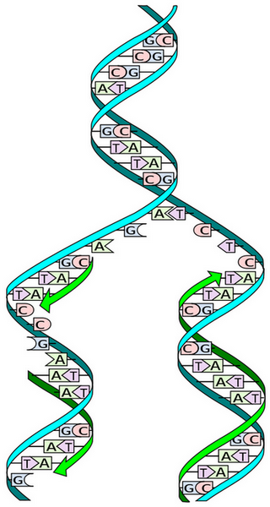
Steps of DNA replication
1. DNA helicase (enzyme) unwinds the DNA. The junction is called a replication fork.
2. DNA polymerase adds the complementary nucleotides and binds the sugars and phosphates. DNA polymerase travels from the 3' to the 5' end. The DNA is called the template strand.
3. DNA polymerase adds complementary nucleotides on the other side of the ladder. Traveling in the opposite direction.
4. One side is the leading strand - it follows the helicase as it unwinds.
5. The other side is the lagging strand - its moving away from the helicase (in the 5' to 3' direction).
Replication is called semi-conservative, because one half of the original strand is always saved, or "conserved"
Problem: it reaches the replication fork, but the helicase is moving in the opposite direction. It stops, and another polymerase binds farther down the chain.
This process creates several fragments, called Okazaki Fragments, that are bound together by DNA ligase.
6. During replication, there are many points along the DNA that are synthesized at the same time (multiple replication forks). It would take forever to go from one end to the other, it is more efficient to open up several points at one time.
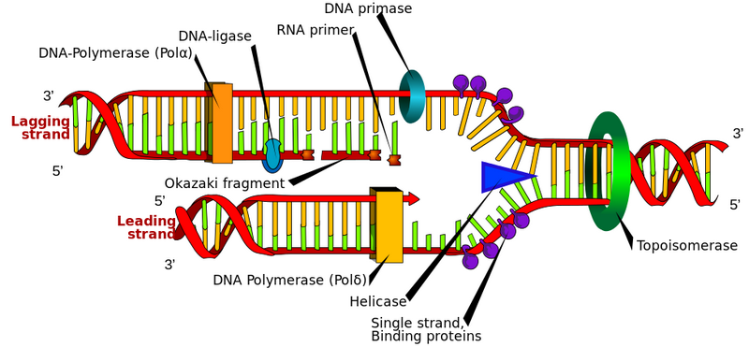
Replication Errors – can cause a genetic MUTATION
-- PROOFREADING by the polymerase prevents mismatches
-- DNA REPAIR ENZYMES can repair damaged DNA also
Additional Resources
Animation of Replication (stolaf.edu)
Animations of Replication (mcgraw-hill)
Replication Tutorial (wiley.com)
Replication Fork (mcb.harvard.edu)

DNA Coloring - Transcription & Translation
Transcription
RNA, Ribonucleic Acid is very similar to DNA. RNA normally exists as a single strand (and not the double stranded double helix of DNA). It contains the same bases, adenine, guanine and cytosine. However, there is no thymine found in RNA, instead there is a similar compound called uracil.
Transcription is the process by which RNA is made from DNA. It occurs in the nucleus. Label the box with the x in it near the nucleus with the word TRANSCRIPTION and proceed to color the bases according to the key below
Thymine = orange
Adenine = dark green
Guanine = purple
Cytosine = yellow
Uracil = brown
Color the strand of DNA dark blue (D) and the strand of RNA light blue (R). Color the nuclear membrane (E) gray.
Translation
Translation occurs in the cytoplasm, specifically on the ribosomes. The mRNA made in the nucleus travels out to the ribosome to carry the "message" of the DNA. Here at the ribosome, that massage will be translated into an amino acid sequence. Color the ribosome light green (Y) and note how the RNA strand threads through the ribsosome like a tape measure and the amino acids are assembled. The RNA strand in the translation area should also be colored light blue, as it was colored in the nucleus.
Label the box with the X in the translation area with the word TRANSLATION.
Important to the process of translation is another type of RNA called Transfer RNA (F) which function to carry the amino acids to the site of protein synthesis on the ribosome. Color the tRNA red.
A tRNA has two important areas. The anticodon, which matches the codon on the RNA strand. Remember that codons are sets of three bases that code for a single amino acid. Make sure you color the bases of the anticodon the same color as the bases on your DNA and RNA strand - they are the same molecules!
At the top of the tRNA is the amino acids. There are twenty amino acids that can combine together to form proteins of all kinds, these are the proteins that are used in life processes. When you digest your food for instance, you are using enzymes that were originally proteins that were assembled from amino acids. Each tRNA has a different amino acid which link together like box cars on a train. Color all the amino acids (M) pink.
Questions:
1. How many different kinds of bases can be found on DNA _____
2. What base is found on RNA but not on DNA? _____________
3. How many bases are in a codon? ______ In an anticodon? ____________
4. How many amino acids are attached to a single transfer RNA? _______
5. Transcription occurs in the _________; translation occurs in the ____________.
6. The process of making RNA from DNA is called ___________________ and it occurs in the ___________________
7. The process of assembling a protein from RNA is called _________________ and it occurs in the _____________________

On the back of your colored pages, be sure to write down and take note of the key steps!
Be sure to also complete the Transcription and Translation worksheet as well!
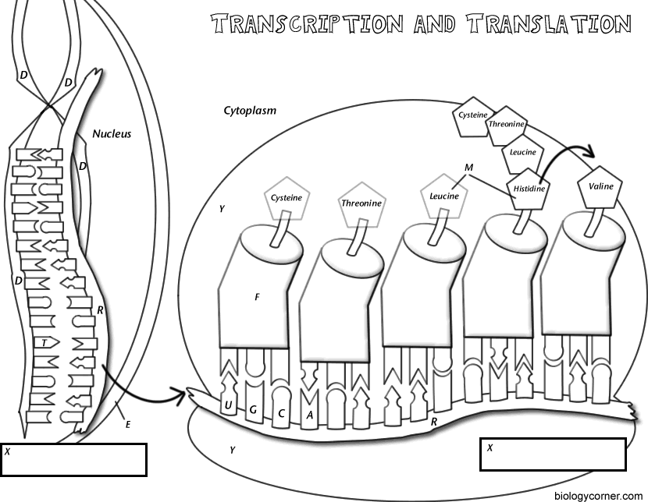

DNA Building Assignment
Your Job:
􀂄 to recreate a DNA molecule with the material of your
choice.
􀂄 You may decide on the DNA base pairing code
􀂄 You must include a legend that explains what each aspect
is represented by
You Need to Include:
􀂄 the Nitrogen Bases (Adenine, Thymine, Guanine and
Cytosine)
􀂄 the Hydrogen bonds
􀂄 the Phosphate molecules
􀂄 the pentose (5-C sugar)
The Requirements:
􀂄 must have at least 10 pairings
DNA Building Assignment Evaluation
Names: _________________ Mark:___________
Model has:
_____ Phosphate Molecules (1)
_____ Pentose Sugar (1)
_____ Nitrogen Bases ( A-T and G-C) (2)
_____ Hydrogen Bonds (1)
_____ Has at least 10 pairings (1)
_____ Clearly labeled legend (2 marks)
TOTAL = 8

