Proteins and Amino Acids
Some quick notes on proteins:
- Proteins are the most complex of all organic compounds.
- Proteins are large molecules.
- Small proteins are called peptides.
- There are 20 kinds of amino acids.
- Amino acids combine to form a protein.
- When amino acids combine to form proteins water is removed.
- All living things depend on proteins for life.
- Enzymes are made of protein.
http://www.bozemanscience.com/048-enyzmes

Metabolic Pathways & Enzymes
Draw a model of an enzyme
Enzyme - protein molecule that functions as a catalyst to speed reactions
Substrate - reactants in the enzymatic reaction, this is what an enzyme attaches to
Energy of Activation =
Properties of Enzymes:
Enzymes are made of proteins.
They speed up chemical reactions inside the cytoplasm.
They are needed only in small amounts
They remain unchanged after each reaction and can therefore be reused
Each enzyme is specific for a substrate
Induced Fit Model - substrates and enzymes fit together like a lock and key.
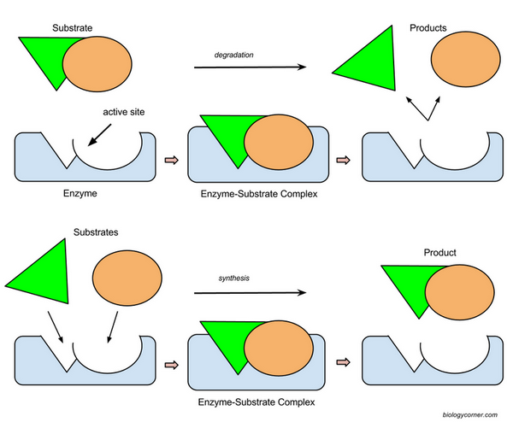
Siamese cats have an enzyme that works at lower temperatures only, causing the nose and ears to become a darker color than the rest of the body.
In your own words, explain the difference between synthesis and degradation:

Factors Affecting Enzymatic Speed
1. Substrate concentration
2. Temperature & pH *
3. Enzyme concentration
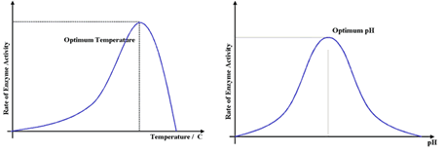
Enzymes can be denatured - they change shape so much that they are no longer effective. High temp or pH can cause denaturation.

Enzymatic Inhibition -
Competitive Inhibition and Noncompetitive Inhibition
**Both are forms of feedback inhibition
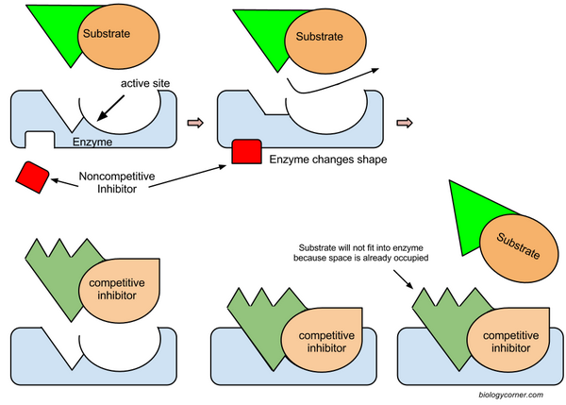
Some inhibitors are NOT reversible - poisons like cyanide, lead poisoning all affect enzymes
QUESTION: What type of inhibition is pictured below?
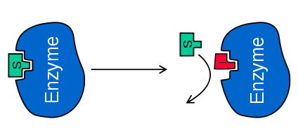
Some questions:

- How are amino acids related to proteins? How are peptide bonds related to amino acids?
- Give six examples of amino acids.
- What is a dehydration synthesis?
Amino acids are joined to each other by a process called dehydration synthesis. In this process a hydroxide ion (OH-) group is removed from one amino acid and joins with a hydrogen ion (H+) from another amino acid. The two ions bond, forming water (hence the term dehydration)to form a dipeptide bond. As the amino acids produce long chains, they become known as a polypeptide chain.

ENZYME PRACTICE (1.2.5)
1. Label the diagram
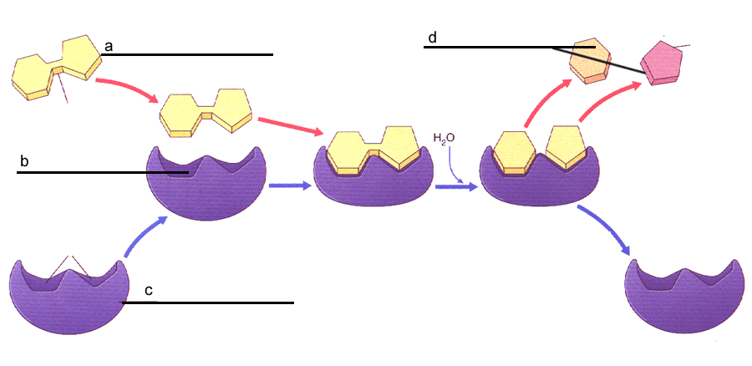
2. Answer true of false to the following statements:
a. _______ Enzymes interact with specific substrates
b. _______ Enzymes change shape after a reaction occurs
c. _______ Enzymes speed up reactions.
d. _______ One enzyme can be used for many different types of chemical reactions.
e. _______ Enzyme reactions can be slowed or halted using inhibitors.
3. Circle the correct effect.
a. Raising the temperature slightly will [ increase | decrease | not change ] the rate of reaction
b. Boiling temperature will [ increase | decrease | not change ] the rate of reaction.
c. Changing the pH toward the optimal pH will [ increase | decrease | not change ] the rate of reaction.
d. Introducing a competitive inhibitor will [ increase | decrease | not change ] the rate of reaction.
4. Place a check mark next to the things that are expected to INCREASE the rate of an enzymatic reaction
a. _______ Add more enzyme
b. _______ Add more substrate
c. _______ Adjust pH to optimal level
d_______ Add a non competitive inhibitor
e._______ Freezing

