Lesson 9 – Respiration
http://www.bozemanscience.com/science-videos/2012/5/6/cellular-respiration.html
Cellular respiration is the enzymatic breakdown of glucose (C₆H₁₂O₆) in the presence of oxygen (O₂) to produce cellular energy (ATP):
C₆H₁₂O₆ + 6O₂ -->6 CO₂ + 6H₂O + 36 ATP (it is 38 ATP in plants)

This formula shows the net reactants and products of this process! It must be known!

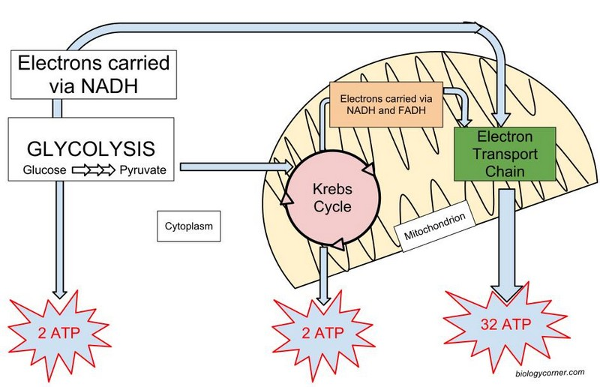

1.Glycolysis:
a) 6 carbon glucose is split into two 3 carbon pyruvates
b) anaerobic - proceeds whether or not O₂ is present ; O₂ is not required
d) net yield of 2 ATP per glucose molecule
e) net yield of 2 NADH per glucose ---> sent to the ETC in mitochondria
The pyruvic acid diffuses into the inner compartment of the mitochondrion where a transition reaction occurs that serves to prepare pyruvic acid for entry into the next stage of respiration, this converts them an acetyl CoA which enters the Kreb's cycle.
If oxygen is not present, pyruvate is converted to lactic acid in the cytoplasm -- anaerobic respiration

2. Citric Acid or Krebs Cycle
a)occurs in the inner mitochondrial matrix
b) an aerobic process; will proceed only in the presence of O2
c) net yield of 2 ATP per glucose molecule
d) net yield of 6 NADH and 2 FADH₂ (NAD+ is reduced to NADH, FAD+ is reduced to FADH)
e) in this stage of cellular respiration, the oxidation of glucose to CO₂ is completed. See Graphic on Citric Acid Cycle

3. Electron Transport System:
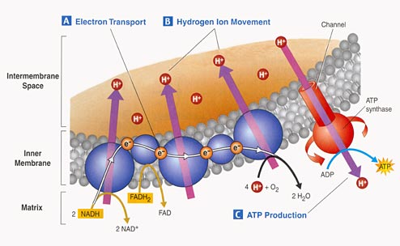
- consists of a series of enzymes on the inner mitochondrial membrane
b) electrons are released from NADH and from FADH₂ and as they are passed along the series of enzymes, they give up energy which is used to fuel a process called chemiosmosis, which drives the process of ATP synthesis using an enzyme called ATPase.
c) net yield of 32 ATP per glucose molecule
d) 6 H₂O are formed when the electrons unite with O₂* at the end of electron transport chain.
* Note: This is the function of oxygen in living organisms!

Please copy down the diagram summarizing respiration.
Please complete the respiration review.

