BI30-LI2 Examine the processes and patterns of biological evolution and the significance of evolution as a key unifying theme in biology.

a. Describe the key elements (i.e., common ancestry and descent with modification), processes (e.g. natural selection and genetic drift), and patterns (e.g., phylogenetic trees and cladograms) of biological evolution. (K, STSE, A)
b. Explain the principle of common descent, including the concept of the Last Universal Common Ancestor (LUCA), and its importance in understanding evolutionary relationships among organisms. (K)
c. Identify the strengths and weaknesses of key contributions to the field of evolutionary biology (e.g., Vesalius, Harvey, Malthus, Lamarck, Wallace, Wegener, Margulis, and Gould). (K, STSE)

Create a quick time line showing when each of these scientists made their contribution to the understanding of evolution. Be sure to also write a short description of their contribution.

d. Examine how Darwin’s observations informed the development of the Theory of Natural Selection as a mechanism of evolution. (K, STSE)

Who was Darwin? What is Evolution?

These notes are taken and adapted from: http://www.biologycorner.com/APbiology/evolution/ch17.html
Before Darwin, the world view was determined by theological beliefs:
- The Earth is young
- Each species was specially created and perfect
- Variations are imperfections
- Observations are to substantiate world view
In the 1700’s, some Scientists began to challenge the world view and look for reasons, or new explanations for the way things were. Here are some of those contributions:
- Carolus Linnaeus (1707-1778) and Taxonomy
a. Taxonomy is the science of classifying organisms; taxonomy had been a main concern of biology.
b. Carolus Linnaeus was a Swedish taxonomist.
1) Linnaeus developed a binomial system of nomenclature (two-part names for each species [e.g., Homo sapiens]).
2) He developed a system of classification for all known plants.
3) Like other taxonomists of his time, Linnaeus believed in the ideas of
a) special creation-each species had an "ideal" structure and function; and
b) fixity of species-each species had a place in the scala naturae, a sequential ladder of life.
- Georges Louis Leclerc
a. Georges Louis Leclerc, known by his title, Count Buffon (1707-1788), was a French naturalist.
b. He wrote on the natural history of all known plants and animals, provided evidence of descent with modification.
d. His writings speculated on influences of the environment, migration, geographical isolation, and the struggle for existence.
- Erasmus Darwin
a. Erasmus Darwin (1731-1802) was Charles Darwin's grandfather.
b. He was a physician and a naturalist whose writings on both botany and zoology contained many comments that suggested the possibility of common descent.
c. He based his conclusions on
1) changes undergone by animals during development,
2) artificial selection by humans
3) the presence of vestigial organs
d. Erasmus Darwin offered no mechanism by which evolutionary descent might occur.
- Cuvier and Catastrophism
a. George Cuvier (1769-1832), a French vertebrate zoologist, was the first to use comparative anatomy to develop a system of classifying animals.
b. He founded the science of paleontology-the study of fossils-and suggested that a single fossil bone was all he needed to deduce the entire anatomy of an animal.
c. To explain the fossil record, Cuvier proposed that a whole series of catastrophes (extinctions) and repopulations from other regions had occurred.
d. Catastrophism is the term applied to Cuvier's explanation of fossil history: the belief that catastrophic extinctions occurred, after which repopulation of surviving species occurred, giving an appearance of change through time.
- Lamarck's Acquired Characteristics
a. Lamarck (1744-1829) was the first to state that descent with modification occurs and that organisms become adapted to their environments.
b. Lamarck, an invertebrate zoologist, held ideas at odds with Cuvier's.
c. Lamarck mistakenly saw "a desire for perfection" as inherent in all living things.
d. Inheritance of acquired characteristics was Lamarck's belief that organisms become adapted to their environment during their lifetime and pass these adaptations to their offspring.
e. Experiments fail to uphold Lamarck's inheritance of acquired characteristics
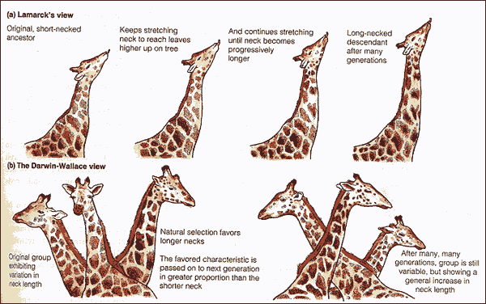
Charles Darwin
http://www.bozemanscience.com/science-videos/2012/5/6/evidence-of-evolution.html
1. His nature was too sensitive to pursue medicine; he attended divinity school at Cambridge.
2. He attended biology and geology lectures and was tutored by the Reverend John Henslow.
3. Henslow arranged his five-year trip on the HMS Beagle; Darwin was an observant student of nature. In 1831, Charles Darwin, a 22-year-old naturalist, accepted a position aboard the ship HMS Beagle that began a voyage around the world; it provided Darwin with many observations.
Some of Darwin’s most important work was done at the Galapagos Islands:
http://www.youtube.com/watch?v=TzAvFtQv3oQ&feature=player_detailpage

Darwin’s Arrival
http://www.youtube.com/watch?v=KUshLAzXJm4&feature=player_detailpage

The Finches
http://www.youtube.com/watch?v=l25MBq8T77w&feature=player_detailpage
B. Geology and Fossils
1. Observed massive geological changes were caused by slow, continuous processes.
a. Darwin took Lyell's book, Principles of Geology, on the voyage of the HMS Beagle.
b. In contrast to catastrophists, Hutton proposed that the earth was subject to slow but continuous geological processes (e.g., erosion and uplifting) that occur at a uniform rate, a theory called uniformitarianism.
c. Fossils of huge sloths and armadillo-like animals suggested modern forms were descended from extinct forms with change over time; therefore species were not fixed. (glyptodont, mylodon)
C. Biogeography
1. Biogeography is the study of the geographic distribution of life forms on earth.
2. Patagonian hares replaced rabbits in the South American grasslands.
3. The greater rhea found in the north was replaced by the lesser rhea in the south.
4. Comparison of the animals of South America and the Galápagos Islands caused Darwin to conclude that adaptation to the environment can cause diversification, including origin of new species.
5. The Galápagos Islands
a. These volcanic islands off the South American coast had fewer types of organisms.
b. Island species varied from the mainland species, and from island-to-island.
c. Each island had a variation of tortoise; long and short necked tortoises correlated with different vegetation.
d. Darwin's Finches
1) Finches on the Galápagos Islands resembled a mainland finch but there were more types.
2) Galápagos finch species varied by nesting site, beak size, and eating habits.
3) One unusual finch used a twig or thorn to pry out insects, a job normally done by (missing) woodpeckers (Darwin never witnessed this finch behavior).
4) The variation in finches posed questions to Darwin: did they descend from one mainland ancestor or did islands allow isolated populations to evolve independently, and could present-day species have resulted from changes occurring in each isolated population?
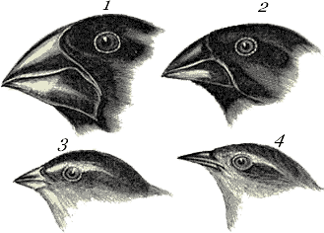
D. Natural Selection and Adaptation
1. Darwin decided that adaptations develop over time; he sought a mechanism by which adaptations might arise.
2. Natural selection was proposed by both Alfred Russel Wallace and Darwin as a driving mechanism of evolution caused by environmental selection of organisms most fit to reproduce, resulting in adaptation.
3. Because the environment is always changing, there is no perfectly-adapted organism.
4. There are three preconditions for natural selection.
a. The members of a population have random but heritable variations.
b. In a population, many more individuals are produced each generation than the environment can support.
c. Some individuals have adaptive characteristics that enable them to survive and reproduce better.
5. There are two consequences of natural selection.
a. An increasing proportion of individuals in succeeding generations will have the adaptive characteristics.
b. The result of natural selection is a population adapted to its local environment.
6. Natural selection can only utilize variations that are randomly provided; therefore there is no directedness or anticipation of future needs.
7. Extinction occurs when previous adaptations are no longer suitable to a changed environment.
E. Organisms Have Variations
1. In contrast to the previous worldview where imperfections were to be ignored, variations were essential in natural selection.
2. Darwin suspected, but did not have today's evidence, that the occurrence of variation is completely random.
3. New variations are as likely to be harmful as helpful.
4. Variations that make adaptation possible are those that are passed on from generation to generation.
5. Darwin could not state the cause of variations because genetics was not yet established.
F. Organisms Struggle to Exist
1. Malthus proposed that human populations outgrow food supply and death and famine were inevitable.
2. Darwin applied this to all organisms; resources were not sufficient for all members to survive.
3. Therefore, there is a constant struggle for existence; only certain members survive and reproduce.
G. Organisms Differ in Fitness
1. Organisms whose traits enable them to reproduce to a greater degree have a greater fitness.
2. Darwin noted that humans carry out artificial selection.
a. Early humans likely selected wolf variants; produced the varieties of domestic dogs.
b. Many crop plant varieties can be traced to a single ancestor.
d. Evolution by artificial or natural selection occurs when more fit organisms reproduce and leave more offspring
H. Organisms Become Adapted
1. An adaptation is a trait that helps an organism be more suited to its environment.
2. Unrelated organisms living in the same environment often display similar characteristics.
3. Because of differential reproduction, adaptive traits increase in each succeeding generation.
I. On the Origin of Species by Darwin
1. After the HMS Beagle returned to England in 1836, Darwin waited over 20 years to publish.
2. He used the time to test his hypothesis that life forms arose by descent from a common ancestor and that natural selection is a mechanism by which species can change and new species arise.
3. Darwin was forced to publish Origin of Species after reading a similar hypothesis by Alfred Russel Wallace.

Natural Selection Videos

- http://www.bozemanscience.com/science-videos/2011/6/26/001-natural-selection.html Basic description of what Natural Selection is
- http://www.bozemanscience.com/science-videos/2011/6/26/002-natural-selection-examples.html Shows some current examples – still going on!

e. Explore historical and contemporary impacts of natural and human-influenced environmental and climatic changes (e.g., ice ages, plate tectonics, habitat destruction and fragmentation) on the evolution of organisms. (K, STSE)
f. Provide examples of specific selective pressures that have driven the evolution of a particular species. (K)
g. Explain how geographic, temporal, and behavioural isolation influence speciation. (K)
h. Identify large-scale patterns and processes in evolution (e.g., punctuated equilibrium vs. gradualism, convergent evolution, coevolution, adaptive radiation, mass-extinction, and the evolutionary arms race). (S, K)

Complete the Peppered Moth Simulation
Population Genetics and Evolution
1. It was not until the 1930s that population geneticists were able to apply the principles of genetics to populations and thus to recognize when evolution had occurred.
2. A population is all of the members of a single species occupying a certain area at the same time.
3. Evolution that occurs within a population is called microevolution.
4. Population genetics studies the variation in alleles in a gene pool.
5. The gene pool is the total of all the alleles in a population; it is described in terms of gene frequencies.
6. Industrial Melanism
a. The case of the peppered moths provides a case study in a shift in phenotype frequencies under selection.
b. With birds acting as a selective agent, the light colored moths were reduced while dark-colored moths were better adapted to survive on the darkened trees
Please note that according to The Hardy–Weinberg principle both the allele and the genotype frequencies in a population remain constant—that is, they are in equilibrium—from generation to generation unless specific disturbing influences are introduced. Those disturbing influences include non-random mating, mutations, selection, limited population size, "overlapping generations", random genetic drift, gene flow and meiotic drive. It is important to understand that outside the lab, one or more of these "disturbing influences" are always in effect. That is, Hardy–Weinberg equilibrium is impossible in nature. Genetic equilibrium is an ideal state that provides a baseline against which to measure change. (http://en.wikipedia.org/wiki/Hardy%E2%80%93Weinberg_principle)
Check out the video:
http://www.bozemanscience.com/science-videos/2012/5/6/microevolution.html
A. Causes of Microevolution
1. Genetic Mutations
a. Many traits in organisms are polymorphic, i.e., two or more distinct phenotypes are present in the population due to mutated genes.
b. Analysis of Drosophila enzymes indicates they have multiple alleles at least at 30% of their gene loci.
c. In humans, freckles are an example of polymorphism, as are the ABO blood types.
d. Mutations can be beneficial, neutral, or harmful; a seemingly harmful mutation that requires Daphnia to live at higher temperatures becomes advantageous when the environment changes.
B. Gene Flow
1. Gene flow (gene migration) is the movement of alleles among populations by migration of breeding individuals.
2. Gene flow can increase variation within a population by introducing novel alleles
3. Continued gene flow decreases diversity among populations, causing gene pools to become similar.
4. Gene flow among populations can prevent speciation from occurring.
C. Nonrandom Mating
1. Random mating involves individuals pairing by chance, not according to genotype or phenotype.
2. Nonrandom mating involves inbreeding and assortative mating.
3. Inbreeding is mating between relatives to a greater extent than by chance.
a. Inbreeding does not change the allele frequencies.
b. However, inbreeding decreases the proportion of heterozygotes.
c. In human populations, inbreeding increases the frequency of recessive abnormalities.
4. Assortative mating occurs when individuals mate with those that have the same phenotype.
5. Sexual selection occurs when males compete for the right to reproduce and the female selects males of a particular phenotype. (guppies, lions)
D. Genetic Drift
1. Genetic drift refers to changes in allele frequencies of a gene pool due to chance, more often in small populations
2. Genetic drift occurs when founders start a new population, or after a genetic bottleneck with interbreeding.
a. The bottleneck effect prevents most genotypes from participating in production of the next generation.
1) The bottleneck effect is caused by a severe reduction in population size due to a natural disaster, predation, or habitat reduction.
2) The bottleneck effect causes a severe reduction in the total genetic diversity of the original gene pool.
3) The cheetah bottleneck causes relative infertility because alleles were lost due to intense inbreeding when populations were reduced in earlier times.
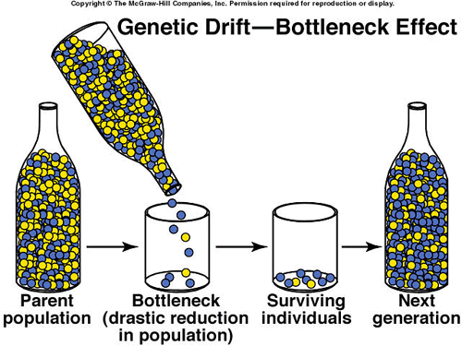
b. The founder effect is an example of genetic drift where rare alleles or combinations occur in higher frequency in a population isolated from the general population.
1) This is due to founding individuals containing a fraction of total genetic diversity of the original population.
2) Which particular alleles are carried by the founders is dictated by chance alone.
3) As an example, dwarfism is much higher in a Pennsylvania Amish community due to a few German founders.
Natural Selection - the process that results in adaptation of a population to the environment.
1. Natural selection requires
a. variation (i.e., the members of a population differ from one another),
b. inheritance (i.e., many of the differences between individuals in a population are heritable genetic differences),
c. differential adaptedness (i.e., some differences affect how well an organism is adapted to its environment), and
d. differential reproduction (i.e., better adapted individuals are more likely to reproduce).
2. Fitness is the extent to which an individual contributes fertile offspring to the next generation.
3. Relative fitness compares the fitness of one phenotype to another.
A. Types of Selection.
1. Directional selection occurs when an extreme phenotype is favored; the distribution curve shifts that direction.
a. A shift to dark-colored peppered moths from light-colored correlated with increasing pollution.
b. Drug-resistant strains of bacteria are a serious health threat and represent this type of selection.
c. Increases in insecticide-resistant mosquitoes and resistance of the malaria protozoan Plasmodium to medications are also examples of directional selection.
d. The gradual increase in the size of the modern horse, Equus, correlates with a change in the environment from forest-like conditions to grassland conditions.
2. Stabilizing selection occurs when extreme phenotypes are eliminated and the intermediate phenotype is favored.
a. The average number of eggs laid by Swiss starlings is four or five.
b. If the female lays more or less than this number, fewer survive.
c. Genes determining the physiology of yolk production and behavior are involved in clutch size.
3. Disruptive selection occurs when extreme phenotypes are favored and can lead to more than one distinct form.
a. British snails (Cepaea nemoralis) vary because a wide range causes natural selection to vary.
b. In forest areas, thrushes feed on snails with light bands.
c. In low-vegetation areas, thrushes feed on snails with dark shells that lack light bands.
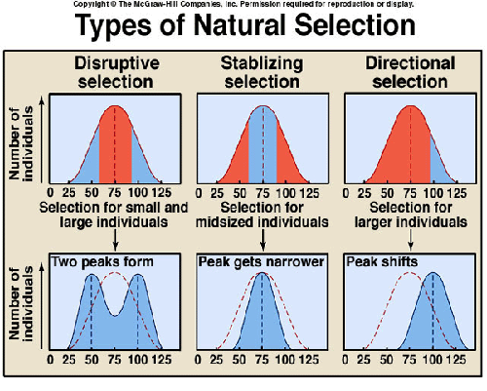
B. Maintenance of Variations
1. Populations always show some genotypic variation; populations that lack variation may not be able to adapt to new conditions.
2. The following forces promote genetic variation.
a. Mutation creates new alleles and genetic recombination still combines these alleles.
b. Gene flow among small populations introduces new alleles.
c. Natural selection, such as disruptive selection, itself sometimes promotes variation.
3. Sickle-Cell Disease
a. In sickle-cell disease, heterozygotes are more fit in malaria areas because the sickle-cell trait does not express unless the oxygen content of the environment is low; but the malaria agent causes red blood cells to die when it infects them (loss of potassium).
b. Some homozygous dominants are maintained in the population but they die at an early age from sickle-cell disease.
c. Some homozygotes are maintained in the population for normal red blood cells, but they are vulnerable to malaria.
Macroevolution
Macroevolution refers to any evolutionary change at or above the species level.
Video here:
http://www.bozemanscience.com/science-videos/2011/6/26/007-speciation-and-extinction.html
Speciation is the splitting of one species into two or more species or the transformation of one species into a new species over time; speciation is the final result of changes in gene pool allele and genotypic frequencies.
A. What is a Species?
1. Linnaeus separated species based on morphology, i.e., their traits differed; Darwin saw that similar species are related by common descent.
2. Ernst Mayr (1942) developed the biological species concept: a species is a group of actually or potentially interbreeding populations that are reproductively isolated from other such groups.
3. The biological definition of a species says that the members of one species interbreed and have a shared gene pool, and each species is reproductively isolated from every other species.
4. Gene flow occurs between populations of one species but not between populations of different species.
5. Biochemical genetics uses DNA hybridization techniques to determine relatedness of organisms; the phylogenetic species concept uses DNA/DNA comparisons.
B. Reproductive Isolating Mechanisms
1. For two species to be separate, gene flow must not occur between them.
2. A reproductive isolating mechanism is any structural, functional, or behavioral characteristic that prevents successful reproduction from occurring.
3. Prezygotic ("before formation of a zygote") isolating mechanisms are anatomical or behavioral differences between the members of two species that prevent mating or make it unlikely fertilization will take place if mating occurs.
a. Habitat isolation occurs when two species occupy different habitats, even within the same geographic range, so that they are less likely to meet and to attempt to reproduce.
b. Temporal isolation occurs when two species live in the same location, but each reproduces at a different time of year, and so they do not attempt to mate.
c. Behavioral isolation results from differences in mating behavior between two species.
d. Mechanical isolation is the result of differences between two species in reproductive structures or other body parts, so that mating is prevented.
e. Gamete isolation includes incompatibility of gametes of two different species so they cannot fuse to form a zygote; an egg may have receptors only for the sperm of its own species or a plant stigma prevents completion of pollination.
4. Postzygotic ("after formation of a zygote") isolating mechanisms prevent development of a hybrid after mating has taken place.
a. Zygote mortality is when hybrids (offspring of parents of two different species) do not live to reproduce.
b. Hybrid sterility occurs when the hybrid offspring are sterile (e.g., mules).
c. In F2 fitness, the offspring are fertile but the F2 generation is sterile.
C. Modes of Speciation
1. Allopatric speciation occurs when new species result from populations being separated by a geographical barrier that prevents their members from reproducing with each other.
b. While geographically isolated, variations accumulate until the populations are reproductively isolated.
c. First postzygotic isolation occurs, then prezygotic reproductive isolation occurs.
2. Sympatric speciation would occur when members of a single population develop a genetic difference (e.g., chromosome number) that prevents them from reproducing with the parent type.
a. The main example of sympatric speciation is in plants.
b. Failure to reduce chromosome number produces polyploid plants that reproduce successfully only with polyploids.
c. Backcrosses with diploids are sterile.
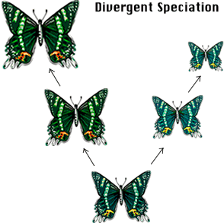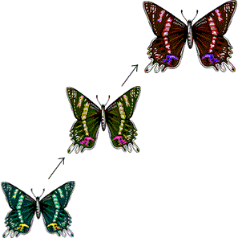
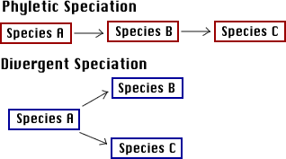
D. Adaptive Radiation
1. Adaptive radiation is a rapid development from a single ancestral species of many new species.
2. The case of Darwin's finches illustrates the adaptive radiation of 13 species from one founder mainland finch.
3. On the Hawaiian Islands, a wide variety of honeycreepers descended from one goldfinchlike ancestor; Hawaii is also the home of the silversword plants that radiated from ancestral tarweeds.
Environmental impacts:
What is Pangea? Continental Drift?
Plate tectonics is the study of the lithosphere, the outer portion of the earth consisting of the crust and part of the upper mantle. The lithosphere is divided into about a dozen large plates which move and interact with one another to create earthquakes, mountain ranges, volcanic activity, ocean trenches and many other features. Continents and ocean basis are moved and changed in shape as a result of these plate movements.
The sequence of maps show how a large supercontinent, known as Pangaea was fragmented into several pieces, each being part of a mobile plate of the lithosphere. These pieces were to become Earth's current continents. The time sequence show through the maps traces the paths of the continents to their current positions..
In the early 1900's Alfred Wegener proposed the idea of Continental Drift. His ideas centered around continents moving across the face of the earth. The idea was not quite correct - compared to the plate tectonics theory of today - but his thinking was on the proper track. In addition, a variant spelling of Pangaea is "Pangea". It appears in some textbooks and glossaries, however, Pangaea is the current preferred spelling.

How would an ice age, destruction of habitat or even a change in climate influence natural selection and evolution for an organism? Can you think of a specific example? Please write a page describing the impact that geology, or we, have had on the organism and how it has changed to be successful, or why it could not be successful. What is the impact on the organism? Please be sure to cite your information.

b. Explain the principle of common descent, including the concept of the Last Universal Common Ancestor (LUCA), and its importance in understanding evolutionary relationships among organisms. (K)
i. Critique common misconceptions regarding biological evolution. (K)
j. Examine evidence to support biological evolution, including the fossil record, radioactive dating, comparative embryology, and homologous and analogous structures. (K)

The Evidence of Evolution

1. Fossils Evidence
a. Transitional forms reveal links between groups.
- Archeopteryx is an intermediate between reptiles and birds.
- Eustheopteron is an amphibious fish.
- Seymouria is a reptile-like amphibian.
- Therapsids were mammal-like reptiles
- Ambulocetus was the ancestor of modern whales
- Various hominid species that existed prior to homo sapiens
b. The fossil record allows us to trace the history of the modern-day horse Equus
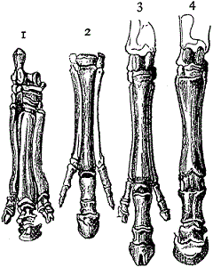
.Hoof Credit: Clipart ETC

2. Biogeographical Evidence
A. Biogeography studies the distribution of plants and animals worldwide.
- Darwin observed South America had no rabbits; he concluded rabbits originated elsewhere.
- Biogeography explains the abundance of finch species on the Galápagos Islands lacking on the mainland.
- Explains the presence of marsupials in Australia
What are some marsupials only found in Australia?
What is the one type of Marsupial found on other continents?

3 . Anatomical Evidence
A. Organisms have anatomical similarities when they are closely related because of common descent.
--- Homologous structures in different organisms are inherited from a common ancestor.
--- Analogous structures are inherited from unique ancestors and have come to resemble each other because they serve a similar function.
B. Vertebrate forelimbs contain the same sets of bones organized in similar ways, despite their dissimilar functions.
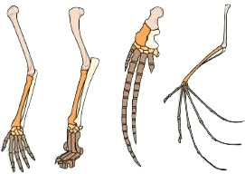
C. Vestigial structures are remains of a structure that was functional in some ancestors but is no longer functional in the organism in question.
--- Most birds have well-developed wings; some bird species have reduced wings and do not fly.
--- Humans have a tailbone but no tail.
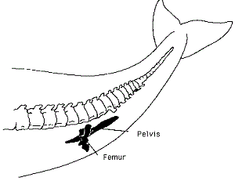

4. Embryological development
A. During development, all vertebrates have a post-anal tail and paired pharyngeal pouches.
-- In fishes and amphibian larvae, the pouches become gills.
-- In humans, the pouches becomes the middle ear; tonsils, and glands

5. Biochemical Evidence
a. Almost all living organisms use the same basic biochemical molecules, e.g., DNA, ATP, enzymes.
b. Organisms utilize the same DNA triplet code and the same 20 amino acids in their proteins.
c. These similarities can be explained by descent from a common ancestor.
d. Life's vast diversity has come about by only a slight difference in the same genes.
Is Natural Selection evidence of Evolution?

Pace of Evolution
1. Phyletic gradualism - slow process with many transitional forms
2. Punctuated equilibrium - speciation occurs rapidly, transitional links not evident, explains lack of fossils
3. Living fossils (horseshoe crab, coelacanth) support punctuated equilibrium

Summary
Because it is supported by so many lines of evidence, evolution is no longer considered a hypothesis. Evolution is one of the great unifying theories of biology, similar in status to the germ theory of disease in medicine. In science, a theory is supported by a large number of observations or a large amount of experimental evidence

Review Questions
1. What scientific observations and research influenced Darwin?
2. List the steps involved in natural selection. How does a population change over time? What environmental factors push these changes?
4. Summarize the various kinds of evidence for evolution (i.e., that all living organisms descended from a common ancestor)
5. In terms of evolution, what does "fitness" mean?
6. In science, an important part of a theory is that it is falsifiable
What observations could refute the hypothesis that an adaptation evolved by natural selection?
What observations could refute the theory of evolution?
7. A scientific theory stands or falls according to how well it is supported by the facts, not according to who believes it. Do you think higher education students should be encouraged to *believe* evolution?

Complete the Evolution mind map.

