BI30-OL2 Explore how the dynamic nature of biological classification reflects advances in scientific understanding of relationships among organisms

a. Describe your own understandings of how to classify living things. (K, A)
b. Consider First Nations, Métis, Inuit, and other cultural perspectives on relationships among living things. (STSE, A)
c. Explore the strengths and limitations of historical and contemporary (i.e., taxonomy) systems of classifying living things. (K, A, STSE)
d. Research the contributions of scientists, including Carl Linnaeus, in developing universally accepted conventions for the naming of organisms (i.e., binomial nomenclature). (K, S, STSE)
e. Identify the characteristics of each major taxonomic rank (e.g., domain, kingdom, phylum, class, order, family, genus, and species) used in biological classification. (K, STSE)

http://www.biologycorner.com/bio1/notes_taxonomy.html

Taxonomy - the science of classifying
Common Names
spider monkey | sea monkey
gray wolf | firefly
mud puppy | horned toad
black bear | jellyfish
ringworm | crayfish
sea horse | *these names do not always give accurate clues for what the organism is
*Common names can be confusing and names can vary by region.

Why Classify?
About 1.5 million species named
2-100 million species yet to be discovered
Taxonomy =science of classifying organisms
--groups similar organisms together
--assigns each a name
Naming Organisms:
Organisms have common & scientific name -all organisms have only 1 scientific name
-usually Latin or Greek
-developed by Carolus Linnaeus
This two-word naming system is called

Binomial Nomenclature
-written in italics (or underlined)
-1st word is Capitalized --Genus
-2nd word is lowercase ---species
Examples: Felis concolor, Ursus arctos, Homo sapiens, Panthera leo , Panthera tigris
The scientific name is always italicized or underlined. Genus is capitalized. Species is not. Scientific names can be abbreviated by using the capital letter of the genus and a period: Example. P. leo (lion)
Members of the same genus are closely related.
Only members of the same species can interbreed (under natural conditions)
Some hybrids do occur under unnatural conditions: Ligers are crosses between tigers and lions.
Linneaus - devised the current system of classification, which uses the following schema
Kingdom
Phylum/Division
Class
Order
Family
Genus
Species
Examine how these animals are organized into the different groups:
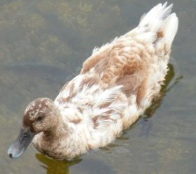 | Human | Cougar | Tiger | Pintail Duck
Kingdom | Animalia | Animalia | Animalia | Animalia
Phylum/Division | Chordata | Chordata | Chordata | Chordata
Class | Mammalia | Mammalia | Mammalia | Aves
Order | Primate | Carnivora | Carnivora | Anseriformes
Family | Homindae | Felidae | Felidae | Anatidae
Genus | Homo | Felis | Panthera | Anas
Species | sapiens | concolor | tigris | acuta

18-2 Modern Evolutionary Classification
- Linnaeus grouped species mainly on visible similarities & differences
- Today, taxonomists group organisms into categories that represent lines of evolutionary descent (phylogeny)
- Evolutionary relationships among a group of organisms can be shown on a cladogram (see 18-7 p. 452)
Similarities in DNA and RNA
- DNA & RNA is similar across all life forms
- Genes of many organisms show important similarities at the molecular level
- DNA shows evolutionary relationships & helps classify organisms

The Six Kingdoms and Domains
 | number of Cells | energy | cell type | examples
archaebacteria | unicellular | some autotrophic, most chemotrophic | prokaryote | "extremophiles"
eubacteria | unicellular | autotrophic and heterotrophic | prokaryote | bacteria, E. coli
fungae | most multicellular | heterotrophic | eukaryote | mushrooms, yeast
plantae | multicellular | autotrophic | eukaryote | trees, grass
animalia | multicellular | heterotrophic | eukaryote | humans, insects, worms
protista | most unicellular | heterotrophic or autotrophic | eukaryote | ameba, paramecium, algae

Using Dichotomous Keys
A dichotomous key is a written set of choices that leads to the name of an organism. Scientists use these to identify unknown organisms.
Consider the following animals. They are all related, but each is a separate species. Use the dichotomous key below to determine the species of each.
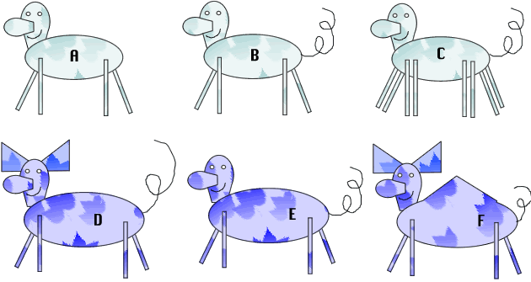
1. | Has green colored body ......go to 2
 | Has purple colored body ..... go to 4
2. | Has 4 legs .....go to 3
 | Has 8 legs .......... Deerus octagis
3. | Has a tail ........ Deerus pestis
 | Does not have a tail ..... Deerus magnus
4. | Has a pointy hump ...... Deerus humpis
 | Does not have a pointy hump.....go to 5
5. | Has ears .........Deerus purplinis
 | Does not have ears ......Deerus deafus

Please complete Classification Taxonomy and Interpreting Graphics Taxonomy.

f. Create and use dichotomous keys to gain insights into the challenges of biological classification. (K, S)
g. Model phylogenetic relationships using cladograms to demonstrate how scientific understanding of evolution informs contemporary biological classification. (K, S)
h. Examine the dynamic nature of biological classification with respect to increasing understandings of the relationship among organisms (e.g., changes to the domain model due to the increased understanding of diversity among prokaryotes). (K, STSE)
i. Discuss the challenges of classifying protists as one example of the limitation of current classification systems. (K, A)
j. Propose alternative systems of classification that more accurately reflect our changing understanding of relationships among organisms. (K, S)

Please complete the Dichotomous Key Using Smiley Faces, Cladogram Analysis and the Taxonomy Project.

