Classification (Bi 30 OL2 a-e)
1. There are six kingdoms, give an example for each kingdom
Animal _________________________ Plant ____________________ Fungi ________________________
Eubacteria ______________________ Archaebacteria____________________ Protists _________________
2. Into what kingdom would each of the following be classified:
a) unicellular prokaryotes that live in dust ________________________________
b) unicellular eukaryotes that live in pond water _____________________________
c) multicellular eukaryotes that live all over the planet and consume food ___________________________
d) unicellular prokaryotes that live in volcanic ash and other inhospitable environments _____________________
e) multicullular eukaryotes that have cell walls and are heterotrophic ______________________________
f) multicullular eukaryotes that have cell walls and are autotrophic ______________________________
Scientific Name ....Common Name
Panthera onca ...... Jaguar
Felis concolor ..... Mountain lion
Panthera leo ........Lion
Felis catus .........House cat
Canis lupus......... Wolf
Panthera tigris .... Tiger
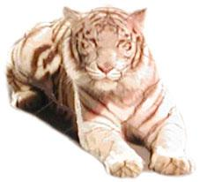
3. Based on the chart, which two animals are most closely related to the tiger:_________________________________
4. Would you expect an animal with the name Rania concolor to look similar to a mountain lion? Why or why not?
_______________________________________________
5. Which animal is most closely related to the house cat? ______
6. Organisms that below to the same class, must belong to the same : (check)
____ Order _____Phylum ____Kingdom ___ Family
7. Fill in the blanks:
Kingdom --> ______________ --> Class --> _______________
--> _________________ --> Genus --> _______________
8. In each pair, circle the one that you would expect to find the most individual species:
kingdom and genus, phylum and kingdom, phylum and class, class and family,order and class, order and phylum, genus and species

