Endocrine System

Introduction
1. Made up of glands that produce and secrete hormones(chemical messengers)
2. Regulation of growth, metabolism, sexual development
3. Responses to stress and injury
4. Internal balance of body systems (homeostasis)
BIG IDEA
Major Glands
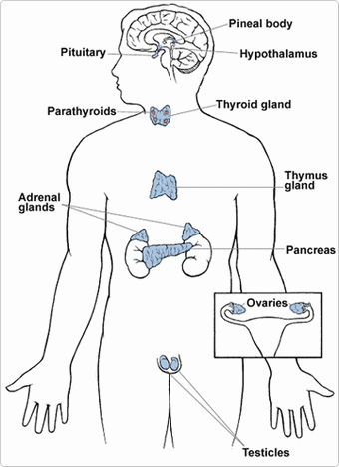
1. Hypothalamus
2. Pituitary
3. Thyroid
4. Parathyroid
5. Adrenals
6. Pineal Body
7. Reproductive organs (ovaries and testes
8. Pancreas
Using the notes at the following link, please complete the Endocrine Systems Concept Map by labelling the gland and the hormones it secretes.
http://www.biologycorner.com/anatomy/endocrine/notes_endocrine_system.html

Digestive System
Please use the link below to write a quick description of the digestive system and how food is digested.
http://kitses.com/animation/swfs/digestion.swf

