Lab: Measuring Blood Pressure
Blood pressure is measured in millimeters of mercury (mm Hg). A typical blood pressure is 120/80 mm Hg, or "120 over 80." The first number represents the pressure when the heart contracts and is called the systolic blood pressure. The second number represents the pressure when the heart relaxes and is called the diastolic blood pressure.
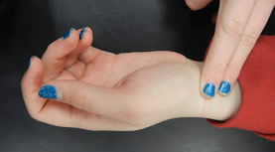
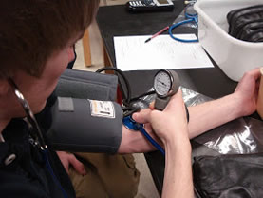
Materials: Sphygmomanometer (blood pressure cuff)
1. Deflate the air bladder of the cuff and place it around the upper arm so it fits snugly. If you’re right handed, you should hold the bulb/pump in your left hand to inflate the cuff. Hold it in the palm so your fingers can easily reach the valve at the top to open and close the outlet to the air bladder.
2. Put the head of the stethoscope just under the edge of the cuff, a little above the crease of the person’s elbow.
3. Inflate the cuff with brisk squeezes of the bulb. Watch the pressure gauge as you do it, you should go to around 150 mmHg or until the pulse is no longer heard. At this point blood flow in the underlying blood vessel is cut off by pressure in the cuff.
4. At around 150, slightly open the valve on the air pump (held in your left hand). This part takes practice, it’s important that you don’t let the air out too suddenly.
5. Now, pay attention to what you hear through the stethoscope as the needle on the pressure gauge falls. You will be listening for a slight “blrrp” or something that sounds like a “prrpshh”. The first time you hear this sound; note the reading on the gauge. This value is the systolic blood pressure.
6. The sounds should continue and become louder in intensity. Note the reading when you hear the sound for the last time. This is the diastolic blood pressure.
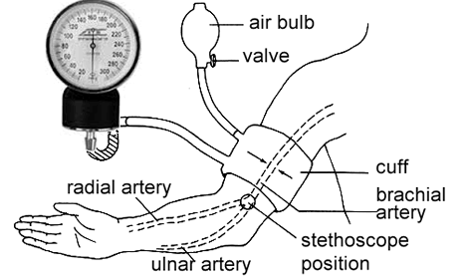

Measuring Heartbeat Using a Stethoscope
Auscultation of the heart means to listen to and study the various sounds arising from the heart as it pumps blood. These sounds are the result of vibrations produced when the heart valves close and blood rebounds against the ventricular walls or blood vessels. The heart sounds may be heard by placing the ear against the chest or by using a stethoscope. Two major sounds can be heard:
- First heart sound. Produced at the beginning of systole when the atrioventricular (AV) valves close and the semilunar (SL; the aortic and pulmonary) valves open. This sound has a low-pitched tone commonly termed the “lub” sound of the heartbeat.
- Second heart sound. Occurs during the end of systole and is produced by the closure of the SL valves, the opening of the AV valves, and the resulting vibrations in the arteries and ventricles. Owing to the higher blood pressures in the arteries, the sound produced is higher pitched than the first heart sound. It is commonly referred to as the “dub” sound.
*Measure your heart rate and the heart rate of 2 test subjects over a 30 second period. Multiply by 2 to get your heart rate.

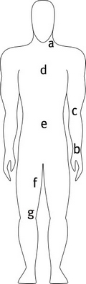
Measuring Pulse
You should know that your "pulse" refers both to the physical thump created in your arteries by the contraction of your heart muscles and the number of these thumps your heart causes per minute. You have seven pulse points--places where arteries come close to your skin--on your body:
a. carotid arteries (located on your neck)
b. radial arteries (on your wrists)
c. brachial arteries (on your arms)
d. aortic arch (by your heart)
e. abdominal aorta (near your stomach)
f. femoral arteries (on your thighs)
g. popliteal arteries (near your knees)

Measure Using Your Radial Artery
To find your radial artery (the most common point from which people take pulses), hold one hand straight out, elbow bent, palm relaxed and facing up. Raise your thumb slightly skyward, as if holding an apple or a tennis ball, to create a small pocket under your thumb at the top of your wrist where you will place the tips of your index and middle finger. (Don't use your thumb--it's also got a pulse and could cause counting confusion.)
* Count the beats for 30 seconds and multiply by two. This is your pulse rate:______________

Measure Using Your Carotid artery
Neck pulse points are stronger and more accessible. The carotid is located just below your jaw in the groove where your head and neck meet, on either side of your windpipe. Use your index and middle fingertips to feel around in the groove for a pulsation.
*Measure the pulse rate of two test subjects using either the carotid or brachial artery. What is your pulse rate at the carotid? _________
*Complete data tables for yourself and one other test subject.
Names:

DATA TABLE – HEART RATES
 | Test 1 | Test 2 | Average for all Subjects
Pulse Rate (radial)
Pulse Rate (carotid)
Stethoscope
Average for Individual Subjects

DATA TABLE – BLOOD PRESSURE
 | Subject 1 | Subject 2
Blood Pressure (test 1)
Blood Pressure (test 2)

Analysis Questions:
1. Compare the systole to diastole.

2. What equipment is used to measure heart rate?
To measure blood pressure?

3. Why is using your thumb to measure pulse not ideal?

4. In your own words, describe how to use a blood pressure cuff (sphygomomanometer).

