THE NERVOUS SYSTEM

Introduction
A. Neurons = masses of nerve cells that transmit information to other nerves, tissues or cells (nerve impulses)
1. ___________________ - contains the nucleus and two extensions
2. ___________________ - shorter, more numerous, receive information
3. _________ - single, long fiber which conducts impulses away from the cell
Look at Picture below!
Neuroglial Cells (neuroglia)
- supportive tissue of the nervous system (more numerous than neurons). Five types
1. Microglial Cells
2. Oligodendrocytes
3. Astrocytes
4. Ependymal Cells
5. Schwann cells
*Myelin Sheaths
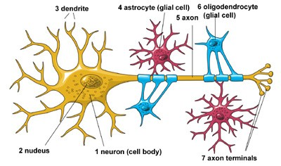

B. The nervous system is divided into two parts:
1. Central Nervous System (CNS) - brain and spinal cord
2. Peripheral Nervous System (PNS) - peripheral nerves through the body
- includes 31 pairs of spinal nerves
- includes 12 pairs of cranial nerves

9.2 Three Basic Functions
1. Sensory Function -
2. Integrative Function -
3. Motor Function -
- Homeostasis. Motor neurons.
- Somatic Nervous System (skeletal muscles)
- Autonomic Nervous System (smooth muscles, glands)

Types of Nerves
Sensory Nerves – conduct impulses into the brain or spinal cord
Motor Nerves – carry impulses to muscles of glands
Mixed Nerves - contain both sensory and motor nerve

Nerve Pathways
Reflex arc – simple pathway, includes only a few neurons
Reflex Behavior – automatic, subconscious responses to stimulu
Knee-jerk reflex =
Withdrawal reflex =
