Name ___________________________________ Block ________
Homologous Structure Lab
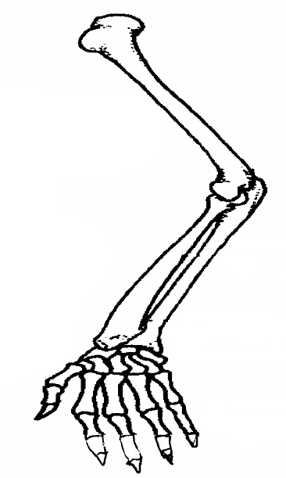
Background Information: An organism’s body structure is its basic body plan, such as how its bones are arranged. Fishes, amphibians, reptiles, birds, and mammals, for example, all have a similar body structure- an internal skeleton with a backbone. Hence, scientist classify all five groups of animals together as vertebrates. It can be then assumed, that these groups all inherited similarities in structure from an early vertebrate ancestor that they shared. Similar structures that related species have inherited from a common ancestor are called homologous structures. Information from homologous structures, similarities in DNA, similarities in early development, and the fossil record are all used by scientists as evidence for evolution and to determine if organisms share a common ancestor.
- Looking at the picture of the human arm shown below, based on the structure,
what activities is the human arm adapted for to do well?
humerus
____________________________________________
____________________________________________
____________________________________________
radius
Color the arm based on the color code shown
ulna
to the right
metacarpals
Key:
Humerus- red Carpals- yellow
Radius- green Metacarpals- brown
Ulna- blue Phalanges- orange

carpals

phalanges
Choose 2 limbs from other organisms and color the bones based on the key.
Species 1______________________ | Species 2_________________________
In the table shown below, list 2 similarities and 2 differences among the human’s limb and the 2 homologous structures you selected
Name of Species | Similarities to human bones | Differences to human bones
Species 1:

Species 2:

In the table shown below, explain how the organism uses the limb, and how they are specifically adapted for their function
Name of Species | How is the limb used? | How is the limb well adapted for its function
Species 1:

Species 2:

Questions:
Define homologous structures: _________________________________________________________________
___________________________________________________________________________________________.

Explain how homologous structures are used to show evolutionary relationships. _________________________
______________________________________________________________________________________________________________________________________________________________________________________.

Of the types of evidence that we discussed (hint: look at notes), which type of evidence do you think is most accurate in showing evolutionary relationships. Explain your answer.

_________________________________________________________________________________________________________________________________________________________________________________________________________________________________________________________________________________.
HOMOLOGOUS STRUCTURE LAB
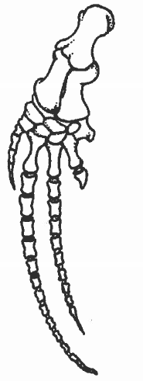
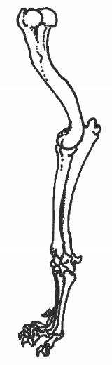
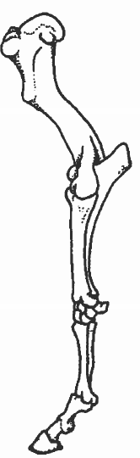

Horse
Cat
Whale

HOMOLOGOUS STRUCTURE LAB
