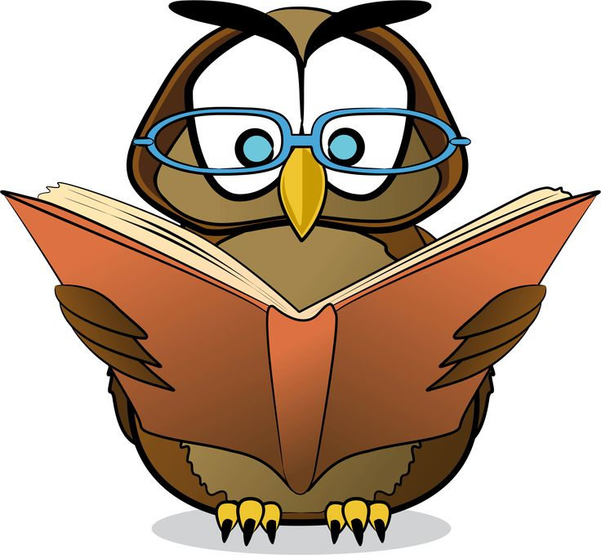

Name of  Book | Date | # of Minutes | Student’s  Initials | Parent’s Initials *required for reward*

