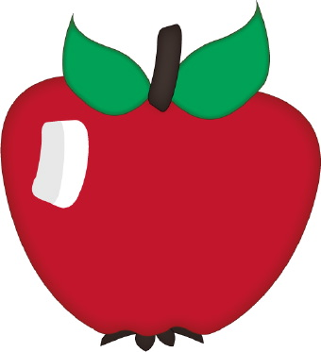



Pike Lake School Supply List for 2021-2022

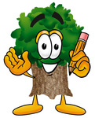

All Classes:

Please label items below with first names.

♥ Backpack

♥ Headphones in a Ziploc bag (no earbuds, please)

♥ Indoor running shoes with white non marking soles\*\*

♥ Water Bottle

♥ Extra set of clothing (pants, top, underwear, socks)

♥ 1 coloring book or fun activity book

All other school supplies will be purchased by the school.

\*\* Please note, when purchasing running shoes, test them (by using the sole edgeof the shoe to scuff the floor) prior to buying them as we have found that labels don’t always hold true.

