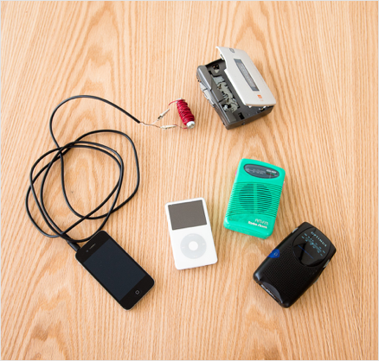
Modulated Coil - Hear the magnet! (Adapted From the Exploratorium)
Transfer the sound from an iPhone, iPod, or radio to the speaker of a cassette-tape player by merely holding a coil of wire near the player when it's running—without a cassette in place.
Subjects:
Engineering & Technology
Real-World Problems & Solutions
Physics
Electricity & Magnetism Sound
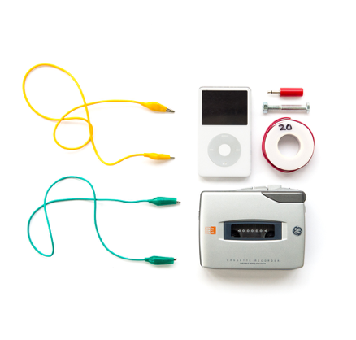
Tools and Materials:
- Wire stripper or knife (or sandpaper if you are using wire with lacquer insulation rather than plastic)
- About 3 feet (1 meter) of insulated copper wire—#20 or #22 solid wire with plastic insulation works well; stranded wire with plastic insulation or thinner solid magnet wire with enamel insulation can also be used (be sure enamel insulation does not get scratched so that bare wire is exposed, except at the ends as noted in step 1 of the Asssembly section)
- Steel bolt, about 1/4 inch in diameter and 2 inches long (nut optional) (the exact size of the bolt isn't critical)
- Two alligator clip leads and a separate 1/8-inch phone plug (pictured) OR a premade audio cable that has a 1/8-inch phone connector on one end and two alligator clip leads on the other
- iPhone, iPod, or small transistor radio
- Portable tape cassette player with speaker (you may need to scour eBay, flea markets, or thrift stores for this)—if the player doesn't have its own speaker, you’ll have to wear the headphones)
Assembly
- Useawirestripperorknifetoremoveabouta1/2inch(1.2cm)ofinsulationfromeachend of the wire. (If you have enamel-insulated wire instead of plastic-insulated wire, use sandpaper to remove the enamel.)
- Ifyouhaveanutforthebolt,screwitontotheendofthebolt(itmayhelpkeepthewirethat you're about to wrap onto the bolt in place, but it isn't essential).
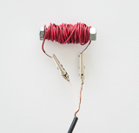
- Leavingabout1inch(2.5cm)ofwirefree,wraptheremaininglengthofwirearoundand around the bolt. Begin as close as you can to one end of the bolt, and proceed toward the other end. When you reach the other end, start another layer and make your way back toward the original end, but keep wrapping in the same direction (i.e., clockwise or counterclockwise, whichever direction you began with). If you reverse the direction, you'll cancel the effect of the wire you wrapped initially. Keep wrapping the wire around the bolt, building up multiple layers if necessary, until you have wrapped the wire around the bolt at least 20 times. When you've finished wrapping, leave another 1 inch (2.5 cm) of wire free.
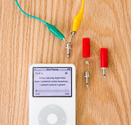
- Ifyouareusingtheseparate1/8-inchphoneplugandalligatorclipleads,unscrewthecover of the phone plug and attach one end of each of the alligator clip leads to the contacts on the phone plug.

- Attachtheotherendsofthetwoalligatorclips(ontheaudiocableorontheclipleads)tothe two ends of the wire wrapped around the bolt.
To Do and Notice
Turn on the iPhone, iPod, or radio and make sure you have a strong, clear signal. Adjust the volume to medium-high. Insert the phone plug at the end of the audio cable into the headphone jack on the iPhone, iPod, or radio. (When you do this, you'll no longer hear the radio, since the signal is being fed to the headphone circuit instead of to the speaker.)
Be sure there is no tape in the tape player, and then press the play button. Adjust the volume control on the tape player to medium-high. Since there is no tape in the player, you should not hear any significant sound.
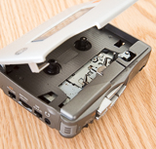
Bring the wire-wrapped bolt near the play head of the tape player (where the exposed portion of the magnetic tape in a cassette would be located if the cassette was in place) . You should hear the sound from the iPhone, iPod, or radio playing through the speaker of the tape player. Remember: if the player doesn’t have its own speaker, you’ll need to have the headphones on.
What’s Going On?
The radio sends an electric current through the audio cable and through the coils of wire wrapped around the bolt. The wire-wrapped bolt becomes an electromagnet, with the strength of its magnetic field determined in part by the size of the current flowing through the coils. Because the current is actually an audio signal, it varies in strength, causing the magnetic field of the electromagnet to vary also.
The head of the tape player is essentially a device for detecting very small variations in a magnetic field. Normally it detects variations in the magnetic field on audio tape as the tape travels by. In this case, however, it senses the fluctuating magnetic field in the coils of wire wrapped around the bolt.
The “T” mode of a hearing aid, which is designed to be used with a telephone, works on the principle of magnetic field coupling demonstrated by this Snack. A telephone has a magnet whose field varies with the oscillations of the sound signal. A hearing aid, like the head of the tape recorder here, detects small variations of the magnetic field. This fluctuating magnetic field induces current in the pickup coils of the hearing aid, and the current is converted to sound. This “T” mode eliminates the annoying high-pitched audio feedback to the hearing-aid microphone that is often present and can be made worse by covering the hearing aid with the telephone headset.
Going Further
Experiment to see how the number of coils wound around the bolt affects the results (e.g., try half the number and twice the number of coils used initially).
In principle you could use the coil of wire alone, without the bolt. You would then have an electromagnet with an air core rather than an iron core. The iron core, however, greatly intensifies the magnetic field. What would you have to do to achieve the same effect with an air core? Check your reasoning by building an air-core electromagnet.

