Beef Jerky Part 1
The Beatles: Multitracking and the 1960’s Counterculture
Adapted from PBSLearningMedia
Grade 9-12

Approximately 60 minutes
- Internet access
- Speakers
- Journal or paper
- Pencil
CP10.1 Investigate techniques (i.e., instrumental, vocal or creative technologies) and the elements of music for solo and/or ensemble performances.
CH2030.3 Examine the work and impact of influential local, Canadian and international musicians.
CH102030.1 Identify characteristics of the different eras, genres and styles through listening to and/or performing the representative music.
Goal: Investigate how The Beatles’ use of cutting edge recording technology and studio techniques both reflected and shaped the counterculture of the 1960s?
- Read the Introduction to Multi-tracking (attached below)
- Watch Les Paul & Sound-on-sound.
- Respond in your journal to the following questions:
What are Les Paul and Mary Ford doing with the tape machines they use in this clip?
Why do you think the host registers surprise? What do you think he was accustomed to seeing musicians do when they performed?
- Read Handout 1: Glossary of Terms (attached below) and in your journal respond to the following questions:
In what ways do you think that multitracking can be different from playing music live or can change our understanding of performance? Can you think of any ways that people might make use of the technology?
Do you think any of the music you listen to currently was made using multitracking? Why or why not?
What do you think the prevalent societal culture is? Where do you think we might find it?
How do you think music might be able to express something counter to the prevalent societal culture?
Do you think there is any current music that is countercultural? If so, what aspects of culture is this music countering?
- Watch Counterculture in the 1960’s US. Then respond in your journal to the following:
What images did you see in this clip?
Both John Lennon and George Harrison express the idea that their generation of the 1960s was pushing toward something culturally new. Judging by what you saw in this clip, what do you think they were pushing away from?
- On Handout 2: Counterculture Timeline (attached below), indicate for each event, whether you think it was a dominant culture event or a counterculture event. Then respond in your journal to the following questions:
Do you see any common themes and ideals expressed in the counterculture of the 1960s? In what ways do you think music might have fit into the counterculture?
How do you think a musician might be able to record music that somehow sounds countercultural?
- To explore the relationship between the 1960’s counterculture and the rise of multitrack recording technology, take a look at the photographs below of The Beatles, first in 1963 and then in 1967.
Respond to the following questions:
What is your impression of the first photo?
Is your impression of the second photo different? Why?
Which photo do you think shows The Beatles in the earlier part of their career? Why?
What are the differences between the photos?
What message do you think The Beatles wish to present with their wardrobes and staging in each photo?

- Share your notes & responses with another student over email, video, or phone, or discuss with another member of your family. Include your findings in your journal. (optional)
- Submit to your teacher photos of any parts of your journal responses you would like to share
- Teacher Feedback (formative)
- Studio Mains – Beef Jerky Part II
- Studio Mains – Chef’s Choice
- Practice Room Desserts – Ice Cream Skillet
- Appreciation Appetizers – Music of the Day

Introduction to Multi-Tracking
From the invention of music recording in the late 19th century through the early 1960s, most artists, producers and listeners conceived of a record as a musical photograph. The recording studio provided a means to capture a brief performance, preserving the moment of a live performance so that others could experience it later. For instance, in 1963 when The Beatles entered Abbey Road Studios with producer George Martin to begin work on their debut album Please Please Me, they quickly replicated a selection of songs culled from their nightly setlist, creating a record that closely resembled their nightclub act. Those who couldn’t see the group’s performance could now buy a recording of it. As The Beatles drummer Ringo Starr explains, “The first album only took us 12 hours. We all knew those songs so well because that was our live show. We were just in there doing the gig.”
In the mid-1960s however, studio recording techniques evolved dramatically. In particular, the introduction of expanded multitrack recording machines allowed musicians to add parts to or remove elements from the recording. Multitracking began to transform the studio from a place for documentation to a playground of creative possibilities. Now, rather than capturing music as a snapshot of a performance, artists began to conceive of the studio as a place where they could build something that was beyond what they could do in live performance.
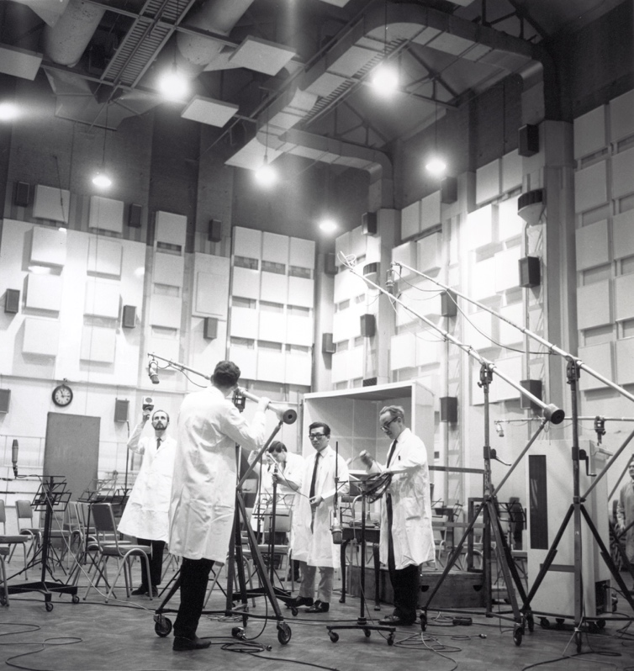
The emerging technologies of the recording studio appealed to The Beatles who, like others of their generation, were involved in a restless pursuit of the new. The Beatles had begun to explore the possibilities of multitrack recording in greater depth with each passing recording. In 1966, with Revolver, they achieved new heights of studio creativity. It affected them to such a degree that after their summer 1966 tour, they chose to cease performing live altogether so they could work in the studio exclusively. “Tomorrow Never Knows,” a densely layered Revolver track featuring tape loops, samples and distorted vocals processed through a rotating Leslie Speaker, showcases The Beatles’ evolving conceptual approach to the recording studio. Rather than playing music, they were now creating it track by track. With “Tomorrow Never Knows” and their following recordings, The Beatles and producer George Martin became the vanguard recording artists of their era, inspiring a surge in experimental recording techniques among Pop and Rock and Roll musicians that would extend for years to come, from Pink Floyd to The Flaming Lips to Jay-Z.
To many, the sense of limitless possibility The Beatles arrived at while working inside Abbey Road Studios was part of a broader pattern of change connected to the 1960s countercultural movement. Political and social events, including student protests against the Vietnam War, a popular interest in the study of Eastern religions, and the publication of books such as 1964’s The Psychedelic Experience, helped to inform The Beatles’ musical decisions as much as the music the group invented fueled the rise of a new youth culture. The Beatles provided the soundtrack to a new experience. As popular icons that challenged social norms and encouraged creative thinking, recording artists like The Beatles began using multitracking technology to make music in the studio that could not be reproduced on the concert stage and that expanded our understanding of what popular music could be and what it could do. The studio was no longer a predictable space for recording live performances; it became a laboratory for constructing sophisticated musical imaginings. As such, it was a perfect reflection of the new youth culture’s spirit.
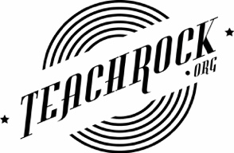
Handout 1 – Glossary of Terms
- Multitracking – A process of sound recording that allows for the separate capture of multiple sound sources and the layering of sources recorded at different times.
Counterculture – A culture that exists in opposition to the behavioral norms and mores of the prevalent societal culture.
- Sound-on-sound / Overdubbing - An audio recording technique in which a performer listens to an existing recorded track and simultaneously plays and records a new performance along with it.
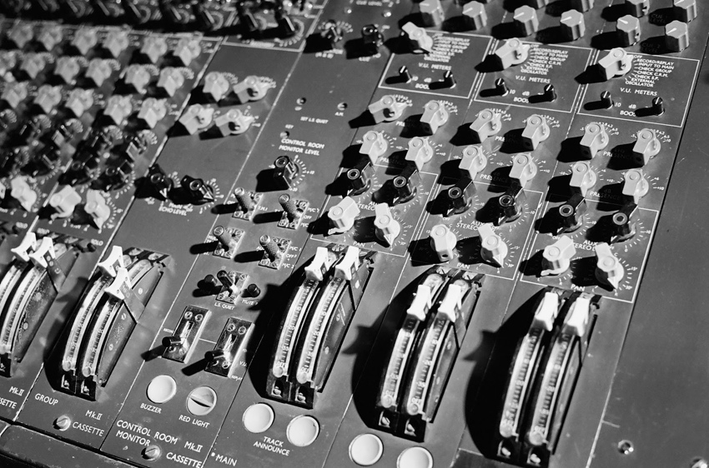
Mixing Board – A device (pictured here) used for combining multiple audio signals and changing various parameters such as the volume, timbre and/or equalization of each. When multitracking, each microphone occupies a “channel” on the mixing board. Using the board, the engineer creates a balanced “mix” of the various signals and then sends that mix out to be recorded on tape.
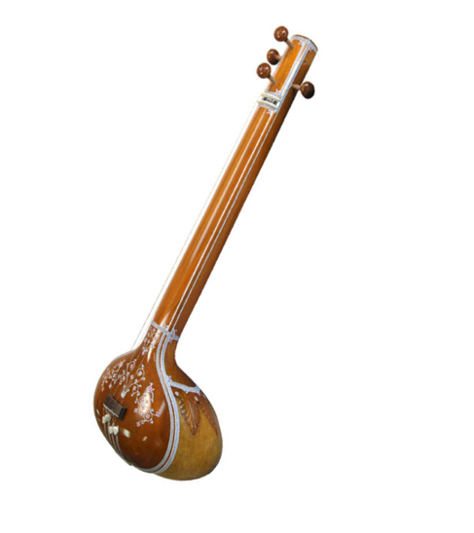
- Tape Loop – A recorded section of sound or music on magnetic tape that is cut and spliced end-to-end. The tape becomes a closed “loop” that plays continuously.
•Drone - A tone that is continually sounded through a piece. In North Indian classical music the drone is a permanent fixture said to represent “Nada Brama,” the divine sound of everything and nothing.
•Tambura - A stringed instrument (pictured left) from India used exclusively for performing a drone. George Harrison used the tambura on “Tomorrow Never Knows.”
•
•
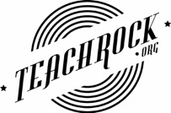
Handout 2 - Counterculture Timeline
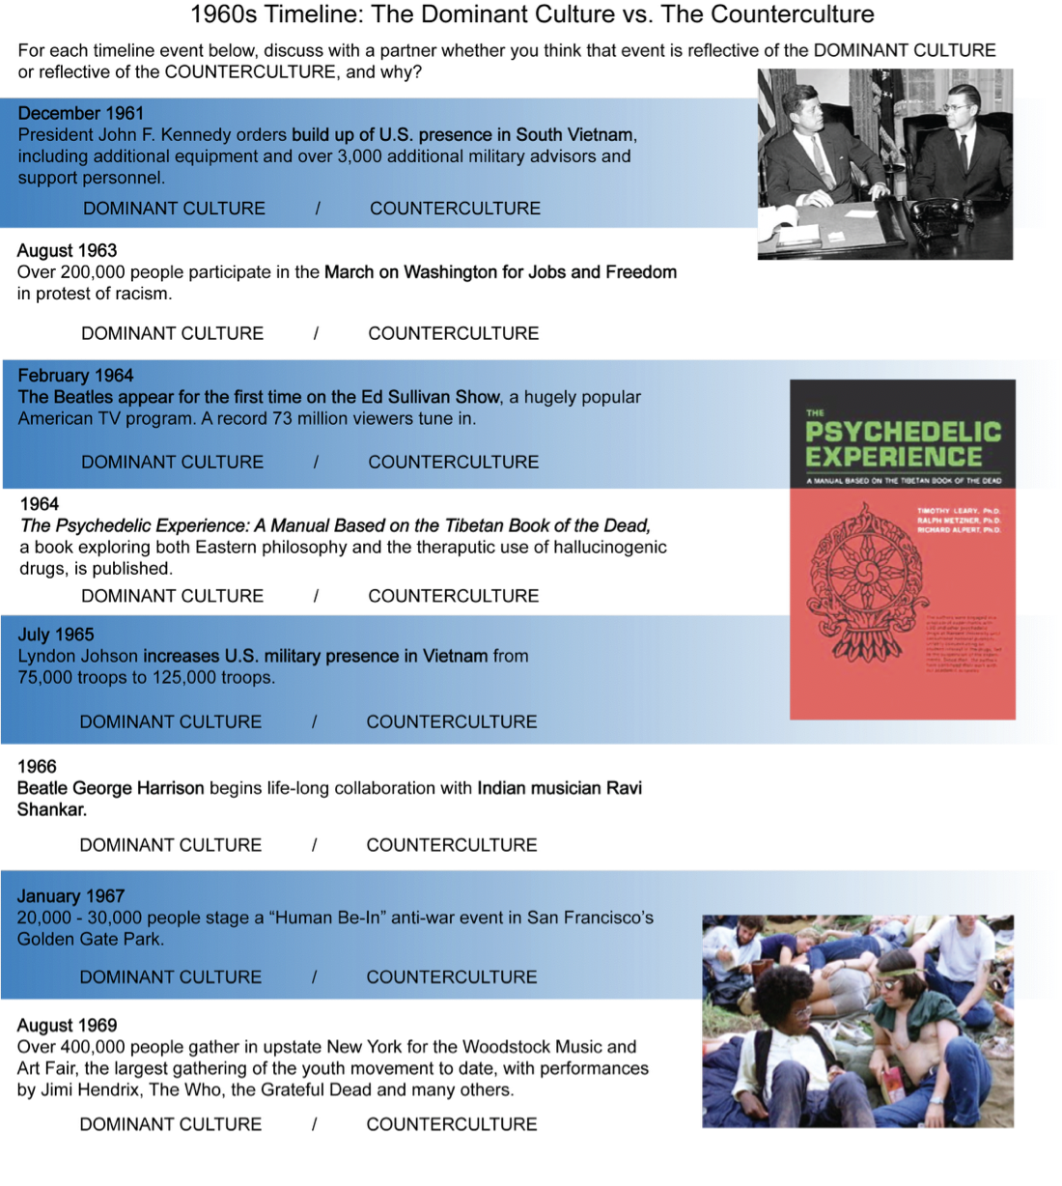

The Beatles in 1963

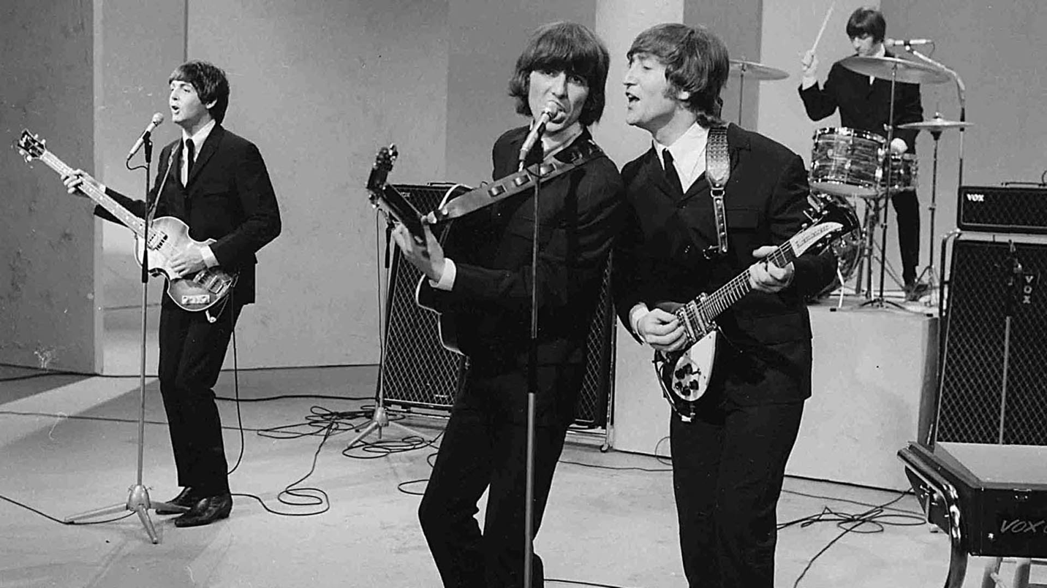

The Beatles in 1967

