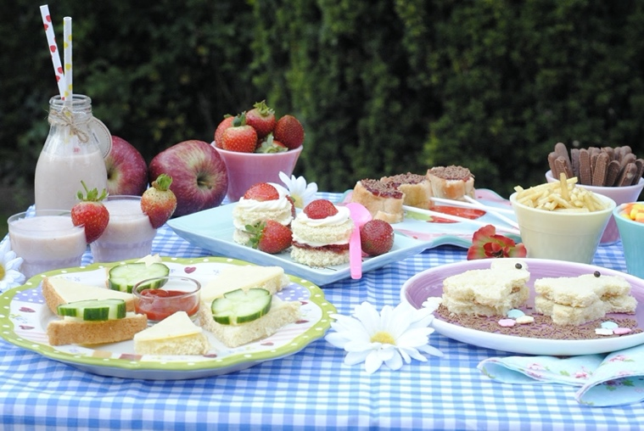  Go for a walk, hike, bike ride, fly a kite, or have a waste-free picnic in our beautiful outdoors. | Read along with “The Lorax” https://youtu.be/EdWesdMfyd4  Watch “The Lorax” – on Netflix.ca  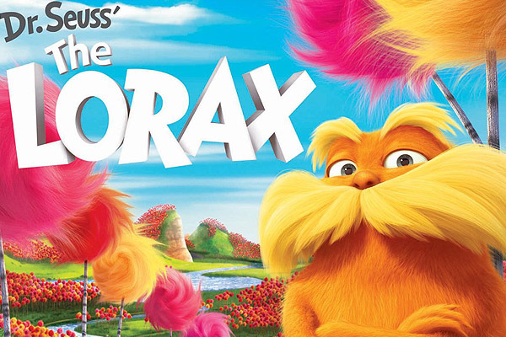
Be inspired by the website,  Run Wild My Child:  https://runwildmychild.com/earth-day-with-kids/ | Choose from 50 kid friendly activities on TinkerLab, depending on what materials you have on hand at home:  https://tinkerlab.com/fifty-earth-day-activities/
Enjoy a few Meewasin Valley Authority activities as a family:

  - Outdoor Bingo https://meewasin.com/wp-content/uploads/2020/04/Backyard-Bingo.pdf
  - Print colouring pages of our local flora, fauna and wildlife:
    - https://meewasin.com/wp-content/uploads/2020/04/Beaver-Monarch-Butterflies-Aspen.pdf
    - https://meewasin.com/wp-content/uploads/2020/04/Canadian-Geese-and-Western-Red-Lily.pdf
    - https://meewasin.com/wp-content/uploads/2020/04/Snowy-Owl-Northern-Harrier-Yarrow-Wildflower.pdf
    - https://meewasin.com/wp-content/uploads/2020/03/Coloring-Pages-01.pdf
    - https://meewasin.com/wp-content/uploads/2020/03/Coloring-Pages-02.pdf
  - Make Cookies for the Birds
    - https://meewasin.com/wp-content/uploads/2020/04/Meewasin-Wild-Bird-Cookie-Recipe.pdf
    - https://www.youtube.com/watch?time_continue=20&v=NnWDNnvtk_0&feature=emb_logo
  - Do an Eco Scavenger Hunt
    - https://meewasin.com/wp-content/uploads/2020/04/Spring-DIY-Eco-Scavenger-Hunt.pdf
Help your parents plant seeds to help prepare for your summer gardens (compostable egg cartons work well). Once the weather is warmer (in about a month), you will be able to help transplant them into the ground. Check out the suggestions below from the Farmer’s Almanac website:
  - Plant wildflowers! Read our article on native wildflowers to plant in your garden. Also, see our video demonstrating how to grow wildflowers!
  - Bring nature into the garden with plants that attract butterflies and plants that attract hummingbirds!
  - Invite native bees to your garden. These are the bees that pollinate your plants for more flowers and food! Perhaps add a native bee house to your backyard.
  - Recycle in the garden! See our videos on how to reuse plant pots and containers, practice plastic-free gardening, and gather other items you can recycle and reuse in the garden.
  - Learn how to reuse in the kitchen and reuse in the home and re-purpose everyday household items!

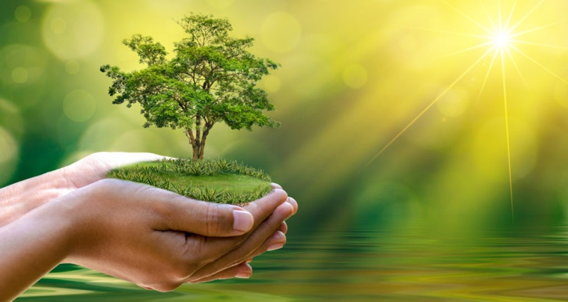
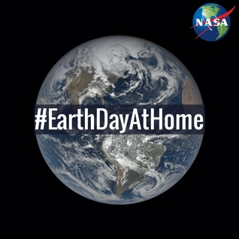
Check out all the cool activities and links available on the NASA website: https://www.nasa.gov/feature/goddard/2020/earthdayathome-with-nasa/

in addition to their 50th Anniversary “Earth Day at Home” Toolkit:
https://www.nasa.gov/content/earth-day-2020-50th-anniversary-toolkit

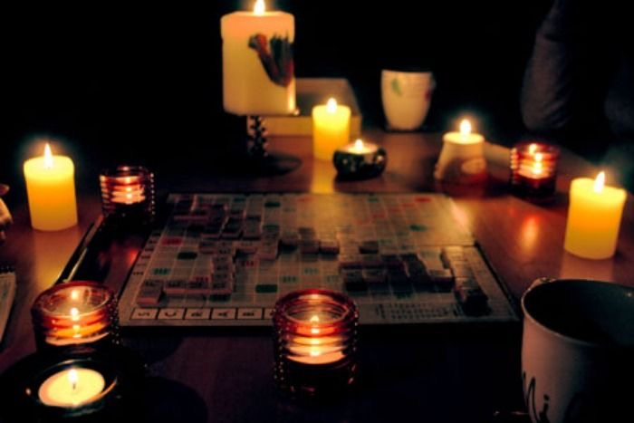
Celebrate one hour with your family with all electrical components in your house turned off – play a board game by candle light, and at the end of the hour, sing happy birthday to mother nature because 2020 marks the 50th anniversary since Earth Day was first celebrated.

Learn more about Earth Day: https://kids.nationalgeographic.com/explore/celebrations/earth-day/

Sharing, Caring, Performance

