Learning Framework April 27-May 1
Grade ½ Social and Science

SCIENCE  Watch the video Parts of a Sunflower. What do you notice about parts of a sunflower? Are they similar or different to other flowers? Complete the labelling handout by either printing it out, drawing a replica, or creating your own!  Look through books, our online resources, and/or outside to try labelling other plants.  Resources:  Parts of a Sunflower  Labelling Handout | EXTENSION POSSIBILITY  Listen to the video Plants Can’t Sit Still. Think about what the author is choosing to repeat on more than one page and why this might be (to emphasize importance this shows us it’s an important fact!).  Feel free to have your child explore writing and drawing to communicate the main idea (main message/point of the book) along with three details they remember from the reading.  Resources  Plants Can’t Sit Still Read Aloud  Main Idea Handout
SOCIAL  Use dictionaries, interview your siblings, and think about how we would define peace and harmony. What do we need to live peacefully with one another? Make a list (or have picture examples) of at least 10 ways we can help to create peace with our families at home.  Examples:  To have peace and harmony in our house we need to…  - Pick up our toys when we are done playing  - Help my brother/sister with his/her reading  - Tell my family “I love you” everyday  Etc. | EXTENSION POSSIBILITY  Look for examples of peace and harmony in your favourite books and movies.  What was the conflict (the problem where they weren’t showing good examples of peace and harmony)?  How did they resolve the issues (make their situation better)?
PLAYFUL INQUIRY  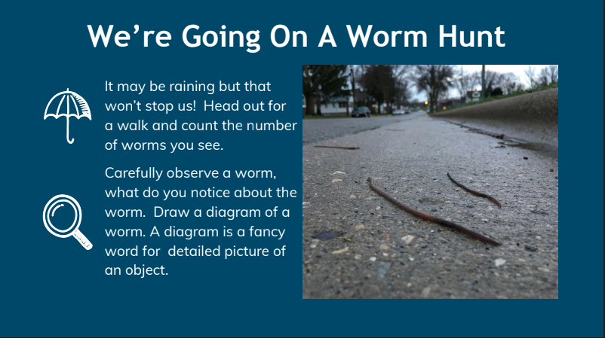 | PICTURE CHALLENGE  Please text or email a picture of your child’s labelled picture of a flower or other plant of their choice  Lisa.nontell@spiritsd.ca  306-514-1414

