Social and Science Learning Framework May 4-8

SOCIAL  This week is the last week before Mother’s Day (Sunday, May 10). Please use the comic templates to create a short comic of SUPER MOM! Our moms are so important in making decisions that keep us happy and safe (everything we are learning in social!), so have fun creating a story to show how important they are. Your story can be pictures, pictures and words, or even mostly words with a few pictures! Here are some ideas to get your own ideas flowing:  - SUPER MOM saves the day from a homework eating monster  - MOM saves the Earth from a huge meteor sent to us from Planet Rotting Potato!  - A story of how Mom always makes you feel better when you are sad  - A lost puppy without a family is found by a family dog who takes her in as her own, protecting her from some big tough alley cats!  Resources:  Printable Comic Strips  *If you don’t have access to a printer feel free to make your own! | EXTENSION POSSIBILITY  Share your story with Mom on Mother’s Day so that she knows how important she is to you.
SCIENCE  Watch the video for Labelling a Stuffy. Have your child choose a special toy or stuffed animal and do their best at sounding out letters they think are in each part of its anatomy. When done:  - Add detailed colouring  - Have someone double check your spelling  Resources:  Labelling Video  Files:  Teddy Anatomy  Try labelling a few different stuffies/toys around the house. Compare them. What parts are similar? What parts are different? | EXTENSION POSSIBILITY  Watch the teaching video for labelling different animals. Do your best to label the animals that are in the Power Point. If you need help, interview a parent/sibling, research on BrainPOP, or look through books you have to find the answers!  Resources:  Labelling Animals  Files:  Animal Power Point
PLAYFUL INQUIRY  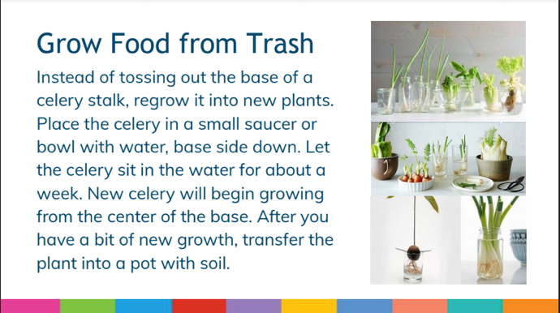 | EXTENSION POSSIBILITY  Record your observations each day drawing pictures/ labelling diagrams of the changes you see each day with roots forming, etc.

