Social and Science June 8-12
https://blogs.spiritsd.ca/mrsnontellskinders/

SOCIAL
Review the difference between needs and wants.
Go through the list of services offered by communities and see which ones apply for your own community.
Complete the reflection handout.
To extend your understanding, go for a drive with an adult and check off what services you see in other communities compared to yours. Which ones are the same? Which ones are different? Why might this be?
Resources:

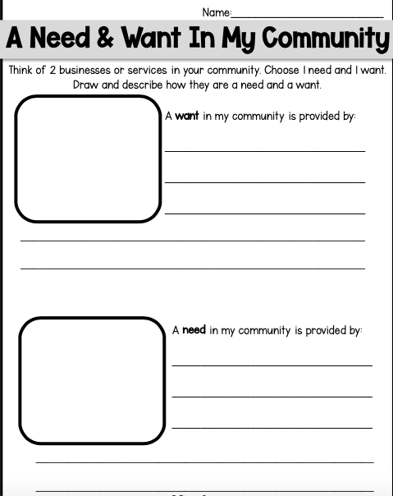
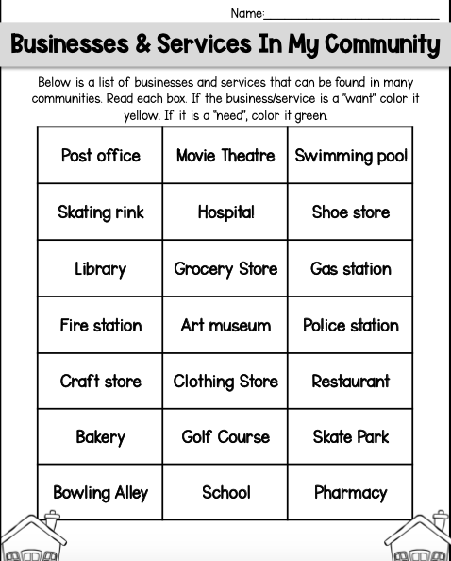
SCIENCE

Go on a nature walk. What do you notice about different types of trees that you see? A lot of times we think about the different shapes of leaves, branches, and height of the trees themselves, but another way to identify the type of tree is by looking at patterns we see in the bark. Can you identify trees in your yard and neighbourhood using this guide?

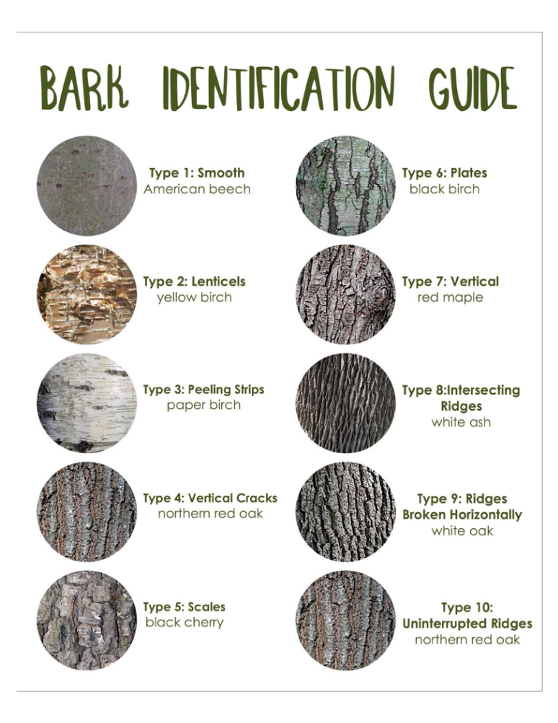

Extension:

Make your own identification guide for something you love and enjoy exploring. This can be anything from classifying different animals, to different pieces of LEGO used to build different sets.

