How Can Parents Support?  The French Immersion Program was designed for students whose first language is not French-  Parents are not expected to have French skills in order for their child to attend a French Immersion program.  “Model a positive attitude  towards school. Research has offered evidence that the  success of a student is largely dependent on the attitude of the parents/caregivers towards education”  Read to your child every day  (in any language)  Engage in your child’s learning through discussions with your child and your child’s teacher.  Provide opportunities from the home for your child to explore French books, shows, songs,  and cultural activities in your community.  Encourage your child and celebrate their hard work and achievements each day. | In French  We learn French as a second language!  We come from a diversity of backgrounds.  We encounter the world in both official languages.  Sometimes we sneak words from one language into the other.  Sometimes we may understand something better in French,  And sometimes we understand something in English because we have already  learned it  In French.  We use all the energy we have  to play,  and hear, and sing,  and question, and listen  and write, and understand  and think,  and speak, and read,  and laugh  In French.  So sometimes we may be tired,  Sometimes it takes us a bit longer  To do what we want to do  In French.  But we want to succeed.  Our second language is part of who we are,  And part of who we will become.  We learn French as a second language,  And we look to you for support!  We will succeed,  In French. | (Source: Handbook for Language Leaders: April 2018) | École Traditions Elementary School  - Together, Empowering Learners  French Immersion Program  2018-2019  Handbook  - 410 Traditions Boulevard  - Warman, Saskatchewan  - S0K 4S5  - (306) 683-5200  - tes@spiritsd.ca

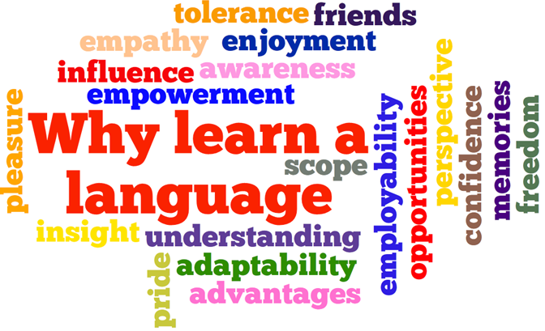  Goals of the French Immersion Program  “French is the language of instruction for a significant part of the school day, in several or all subjects, with the exception of English language arts.”  “Students will become highly proficient in English and functionally fluent in French, capable of pursuing post-secondary education and training and undertaking employment in either language.”  “Students will understand and appreciate Francophone cultures.”  Students will learn “to communicate effectively in Canada’s two official languages” | Dual Track Schools  In a dual-track school, both English and French Programs coexist.  At École Traditions Elementary School, we will be beginning our Journey as a Dual- Track School in the 2018-2019 school year with a Maternelle (Kindergarten) and a 1er Année (Grade 1) program.  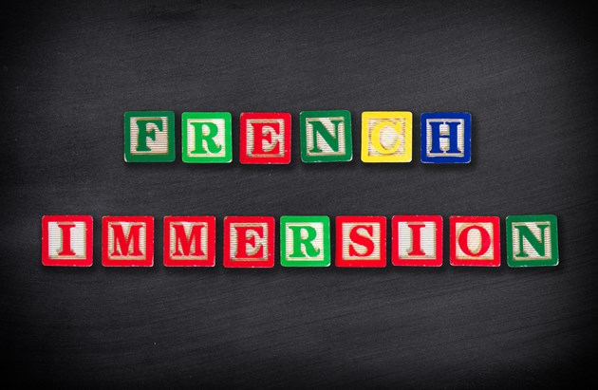  What You May See at Home  -Your child pronouncing French words or Singing French songs  *Note: Some students may not want to speak in French at home as they may be tired at the end of the day and need a break.  -In the early years, children will typically not bring home a lot of homework other than reading or vocabulary practice in French.  Please continue to read home in English as skills do transfer. | K-2 French Language Classrooms and Program Characteristics  -Inderdisciplinary Curriculum  -Inquiry-based Instruction  -Language-rich environment  -Learning is organized by context rather than subject  -Modeling of the French Language  -Students’ interests and questions influence direction of learning contexts  -Authentic communication with an emphasis on oral language  -Actions/ Gestures, Rhymes, Play, Exploration, Stories to increase vocabulary and familiarity with the French language  -Supportive and Encouraging  -Tasks and assessments respond to competencies (Identifying as an Immersion Language Learner, Understanding Meanings of Information, Expressing Oneself to Respond to Needs and Intentions) rather than subject specific outcomes  (www.edonline.sk.ca)  For more resources and information for parents visit:CPF (Canadian Parents for French) Toolbox for Parents https://pei.cpf.ca/wp-content/blogs.dir/1/files/CPF-PEI-Toolbox-for-parents.pdf

